
QUALITY ALERT

Customer: Vision Outdoor Date: Aug 1, 2018
Die: 1146 Colour: Any
Type of Complaint: Vision Outdoor REJECTED

Q.A # Q.I.R # CUSTOMER NCR #
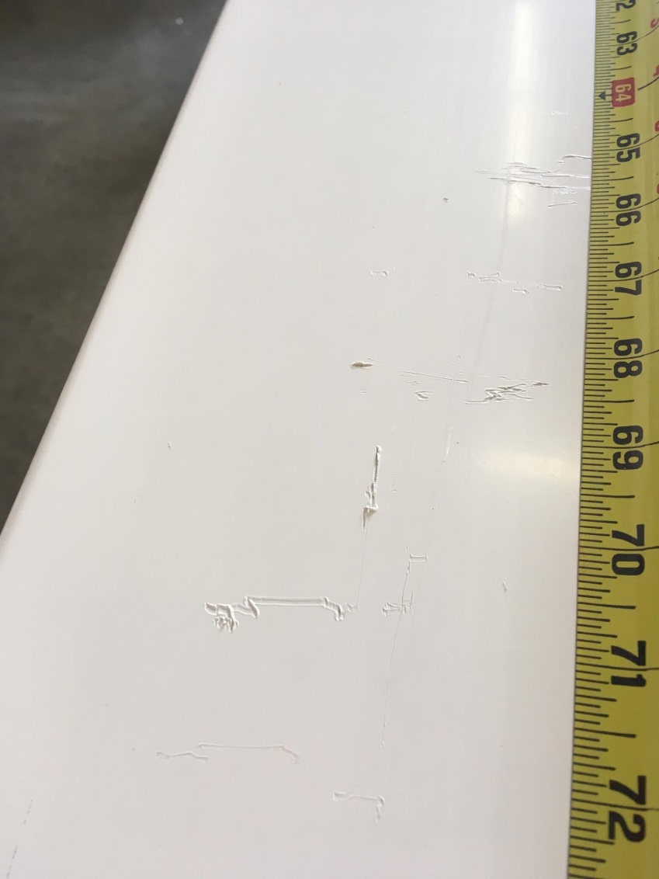
Description: Vision Outdoor REJECTED due to scratch marks on the surface caused by packing and pit marks on the exposed surface.
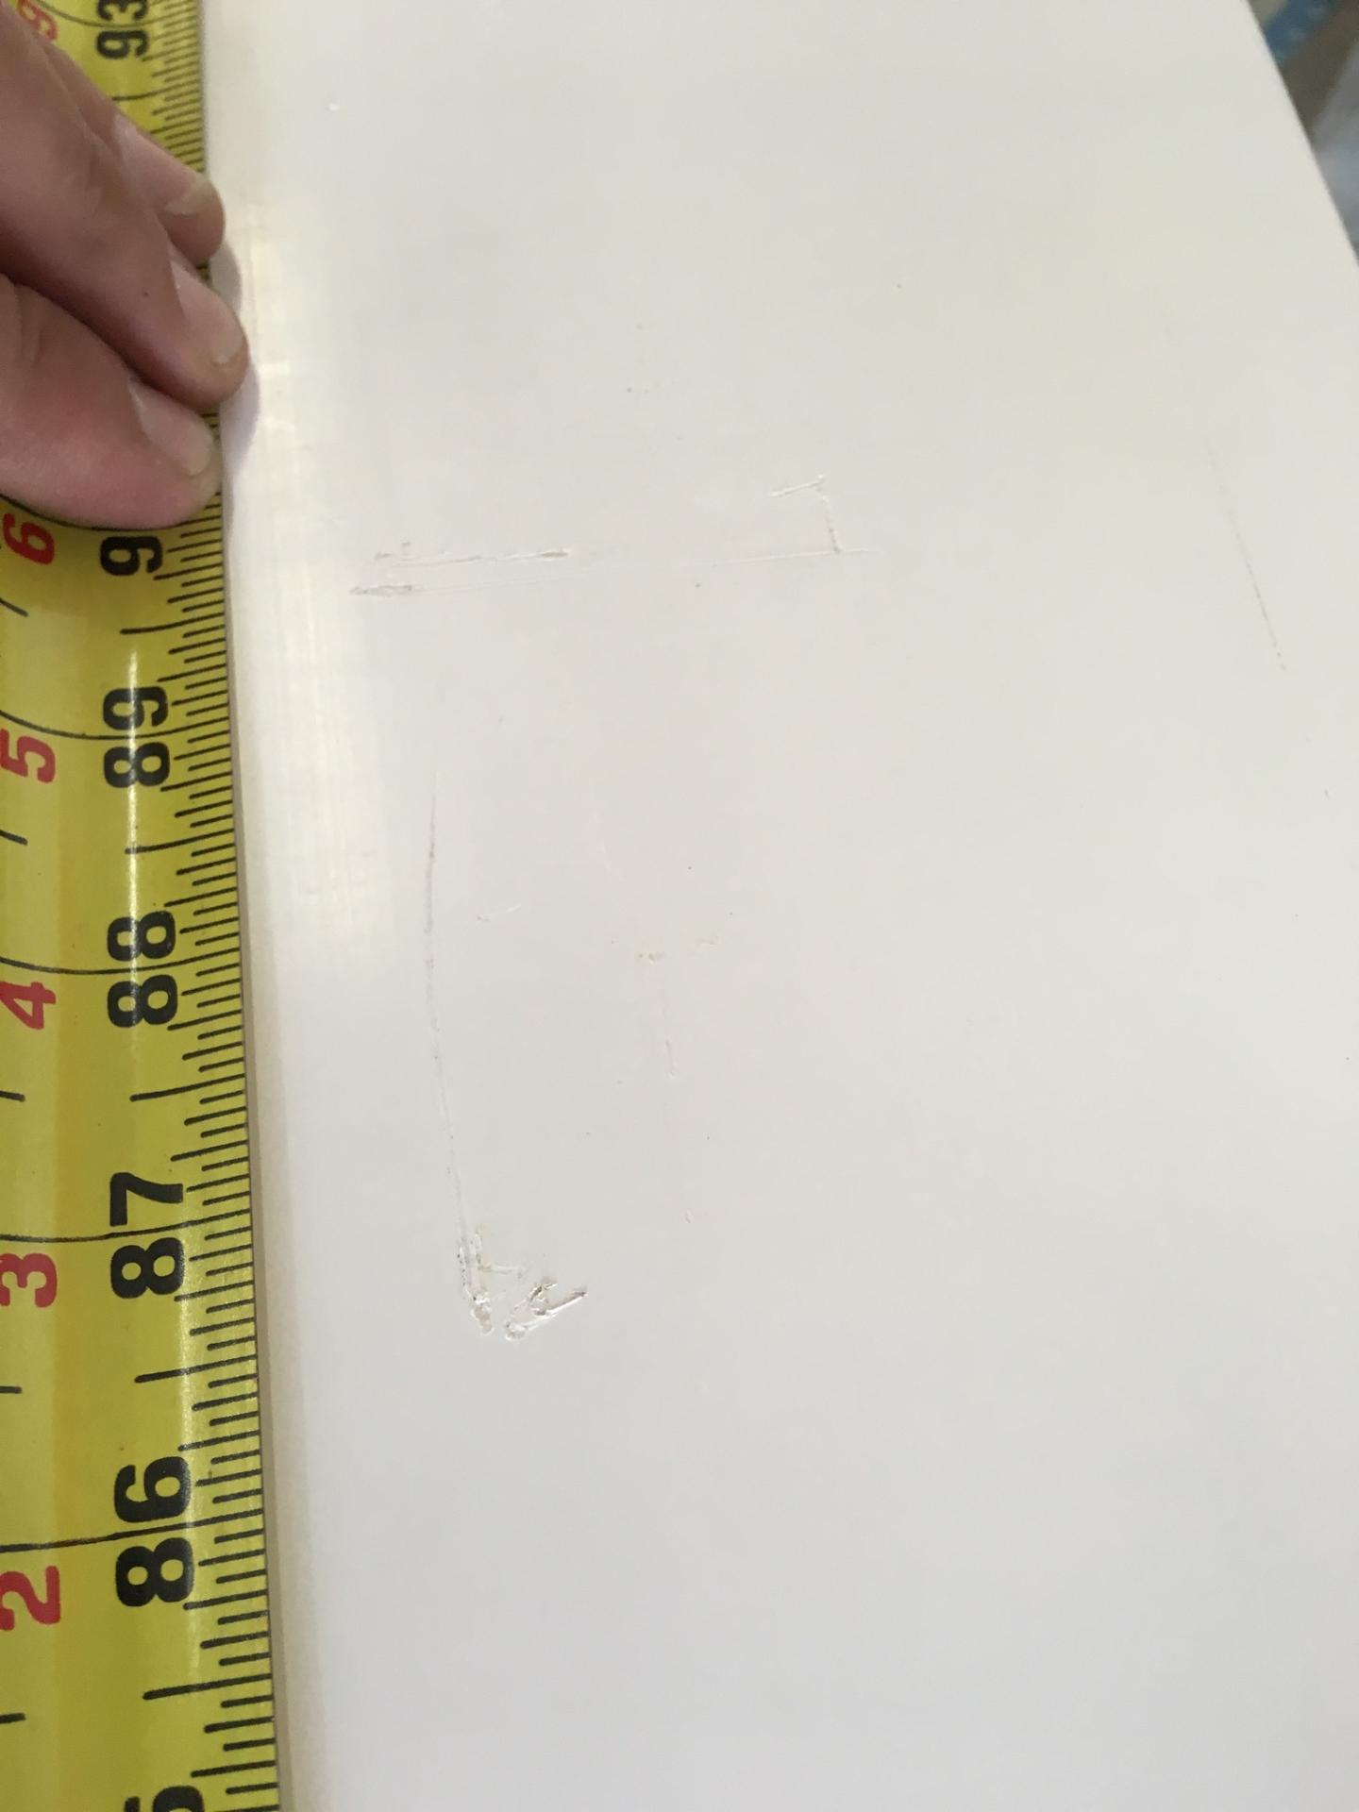
REJECTED PIECES

BY SIGNING BELOW, YOU ACKNOWLEDGE THE PROBLEM ABOVE AND AGREE TO MONITOR THIS ISSUE IN FUTURE PRODUCTION RUNS.
DAY SHIFT |  | AFTERNOON SHIFT |  | NIGHT SHIFT
NAME | SIGNATURE | NAME | SIGNATURE | NAME | SIGNATURE

