
QUALITY ALERT

Customer: Vision Building Products Date: March 1st, 2022
Die: 1147 Colour: Any
Type of Complaint: Rejected

Q.A # Q.I.R # CUSTOMER NCR #

Description: Vision Outdoor REJECTED due to material have deep and visible SCRATCHED LINE on the surface.
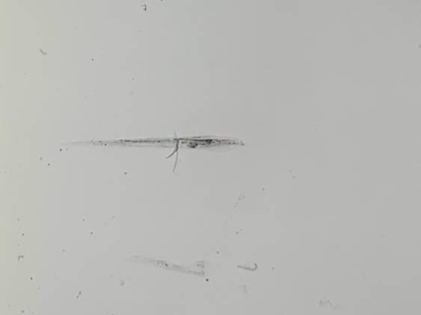
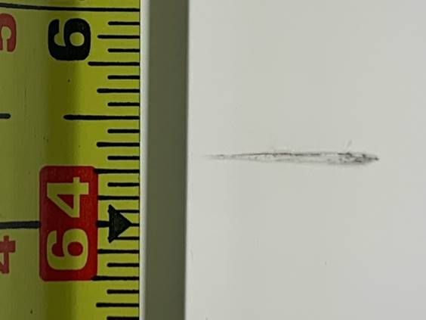

PLEASE MAKE SURE CHECK ALL FOUR SIDE SURFACES BEFORE PACKING

BY SIGNING BELOW, YOU ACKNOWLEDGE THE PROBLEM ABOVE AND AGREE TO MONITOR THIS ISSUE IN FUTURE PRODUCTION RUNS.
DAY SHIFT |  | AFTERNOON SHIFT |  | NIGHT SHIFT
NAME | SIGNATURE | NAME | SIGNATURE | NAME | SIGNATURE

