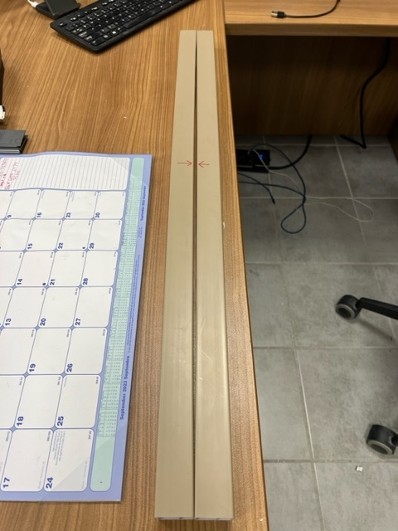

QUALITY ALERT

Customer: Vision Building Products Date: September 25, 2023
Die: 1380 Colour: Any
Type of Complaint: Vision Outdoor REJECTED

Q.A # Q.I.R # CUSTOMER NCR #

Description: Vision Outdoor REJECTED material was bowing / bending

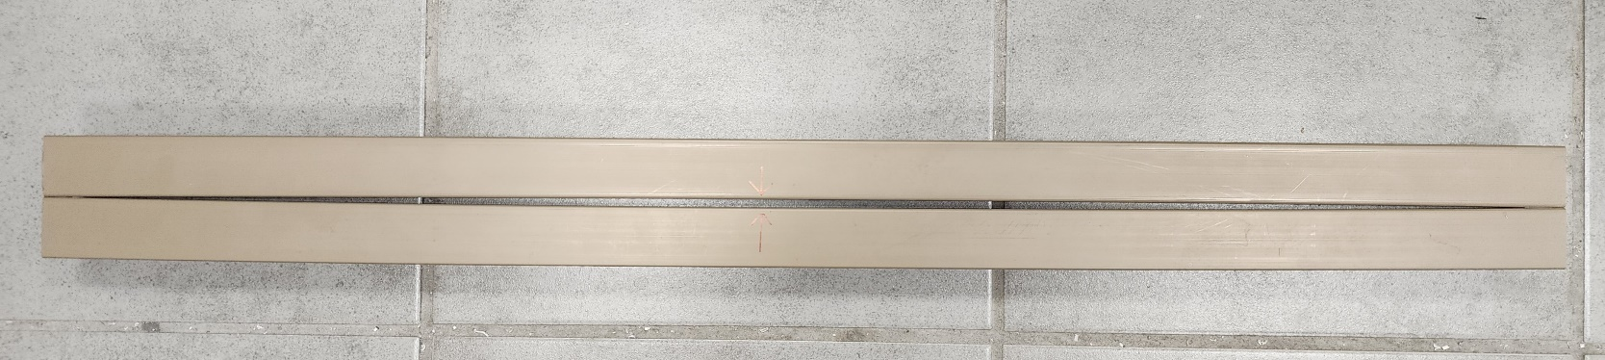

PLEASE CHECK CAREFULLY TO AVOID THE ISSUES
BY SIGNING BELOW, YOU ACKNOWLEDGE THE PROBLEM ABOVE AND AGREE TO MONITOR THIS ISSUE IN FUTURE PRODUCTION RUNS.
DAY SHIFT |  | AFTERNOON SHIFT |  | NIGHT SHIFT
NAME | SIGNATURE | NAME | SIGNATURE | NAME | SIGNATURE

