DIE# 1380 – VISION OUTDOOR
PACK ON SKID AS SHOWN
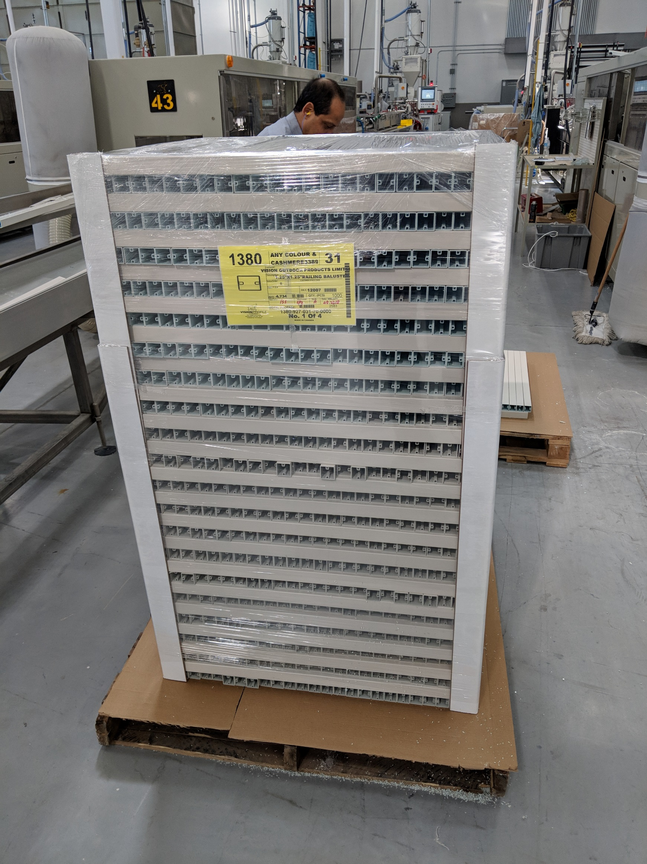
25 PER ROW FOR 31”

