DIE# 15002 – Solar (EXTRUDER SIDE)
Pack on Green Buggy – Wrap arms in cardboard
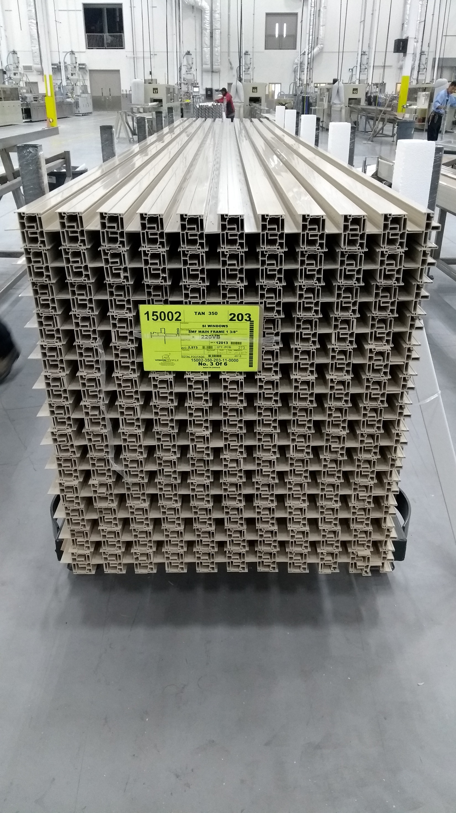
Large Foam on 1 Side

