DIE# 15003 – Solar (EXTRUDER SIDE)
Pack on Green Buggy – Wrap arms in cardboard
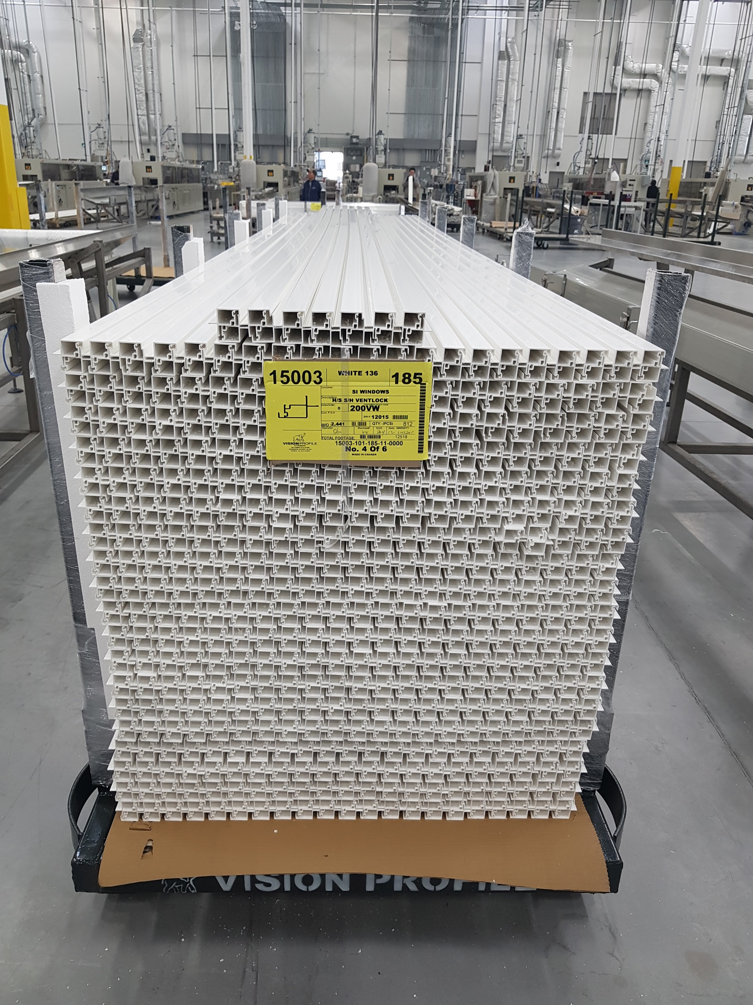
Small Foam on 1 Side

