DIE# 15005 – Solar (EXTRUDER SIDE)
Pack on Green Buggy – Wrap arms in cardboard
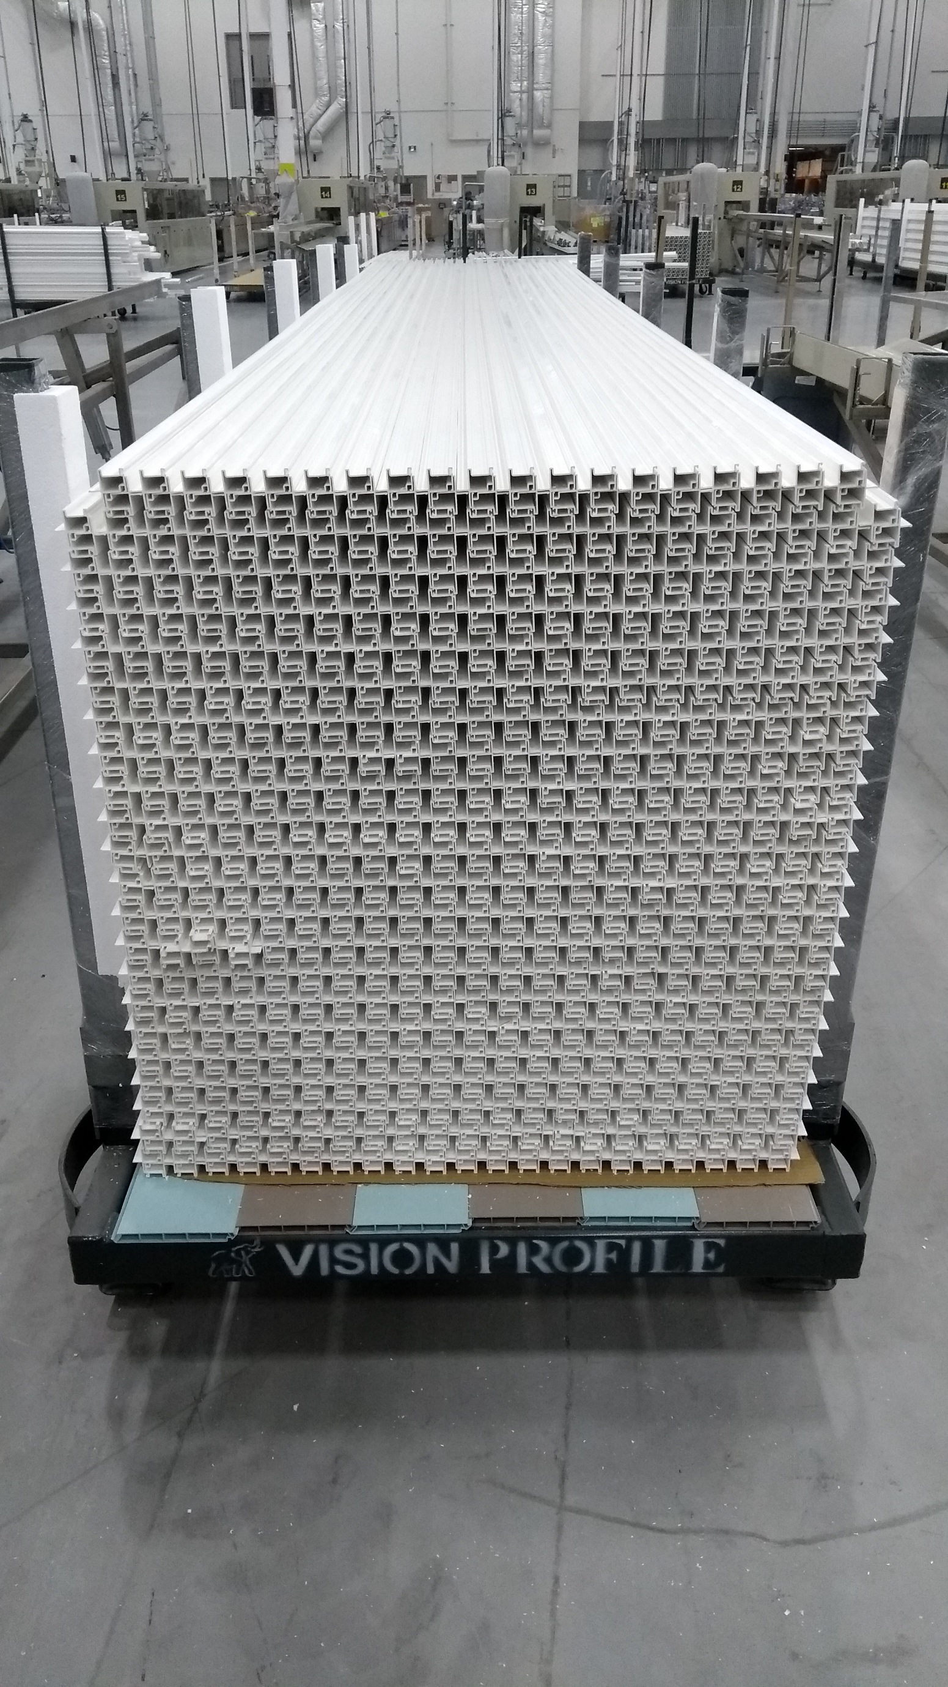
SMALL FOAM ON 1 SIDE

