DIE# 15006 (Mini) – Solar (EXTRUDER SIDE)
Pack on Green Buggy – Wrap arms in cardboard
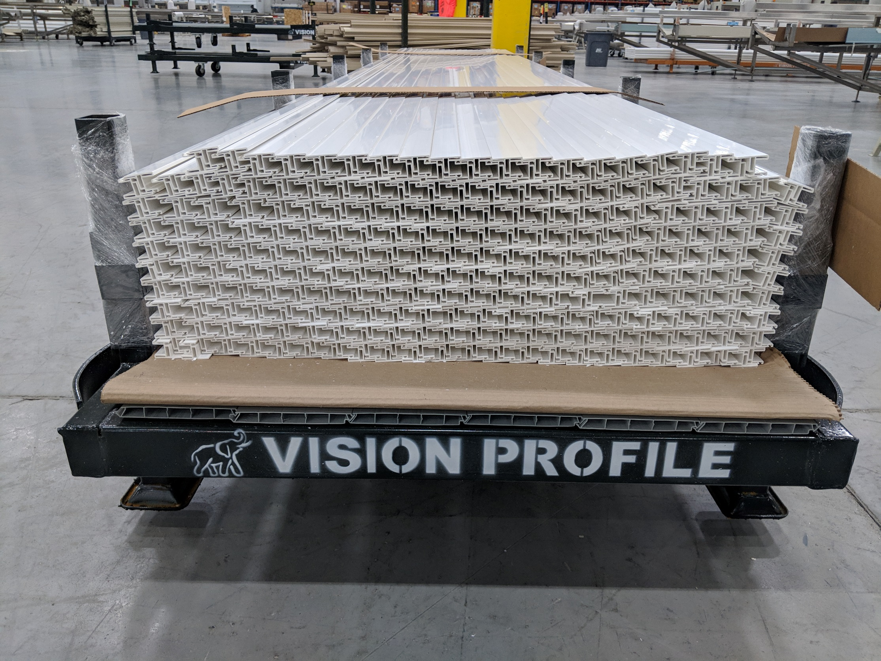
NO FOAM

