DIE# 15007 – Solar (EXTRUDER SIDE)
Pack on Green Buggy – Wrap arms in cardboard
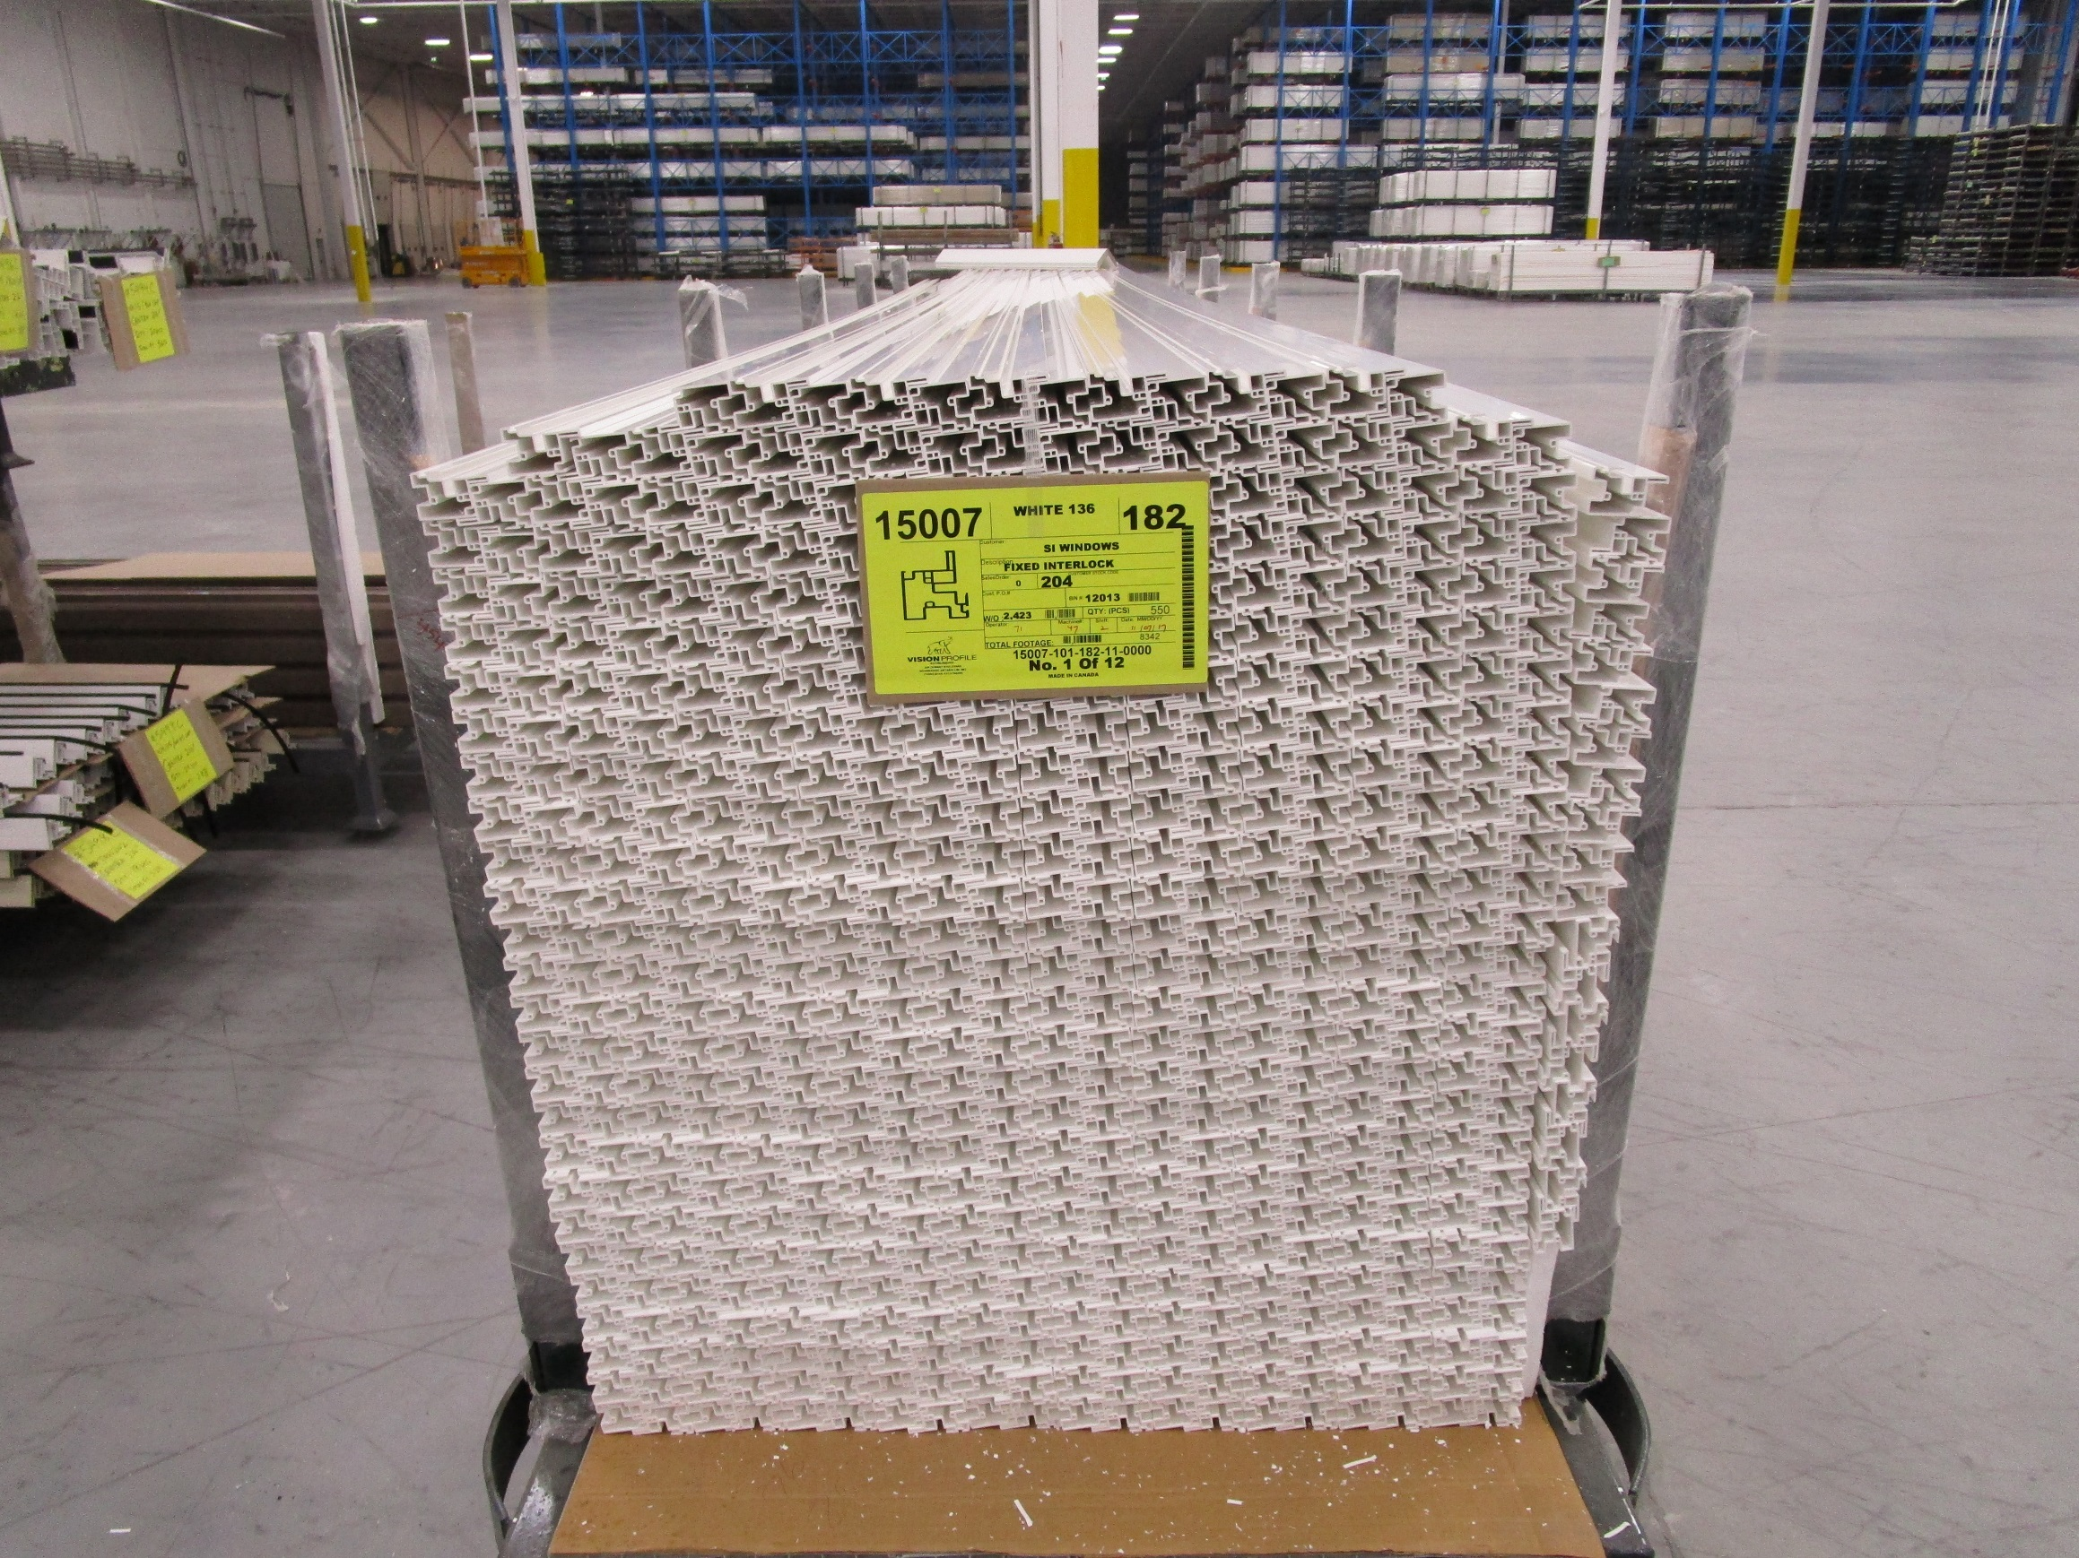
Small piece of Foam to support side piece

