DIE# 15008 – Solar (EXTRUDER SIDE)
Pack on Green Buggy – Wrap arms in cardboard
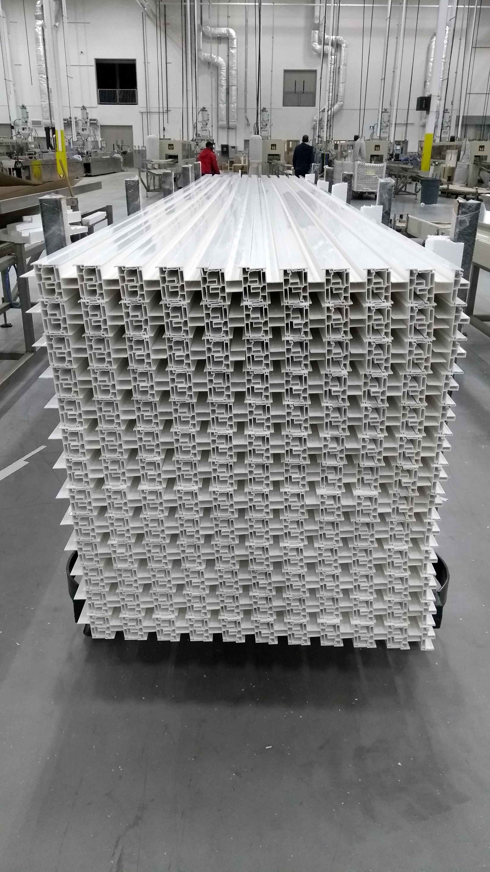
Large foam on 1 side

