
QUALITY ALERT

Customer: SOLAR Date: January 22, 2024
Die: 15009 Colour: ALL
Type of Complaint: Customer REJECTED

Q.A # Q.I.R # CUSTOMER NCR #

Description: Customer REJECTED the wall NOT straight causing the punch make the drain hold is NOT GOOD

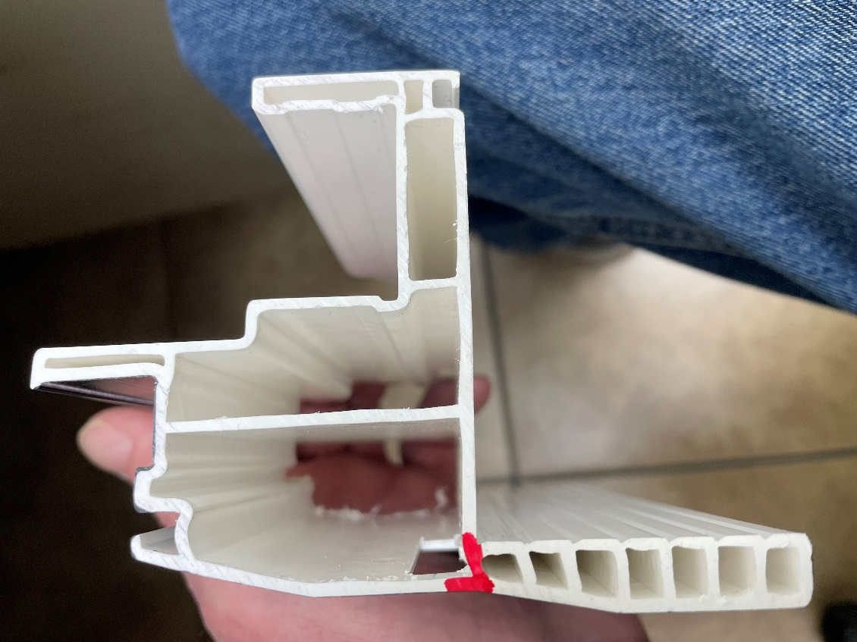
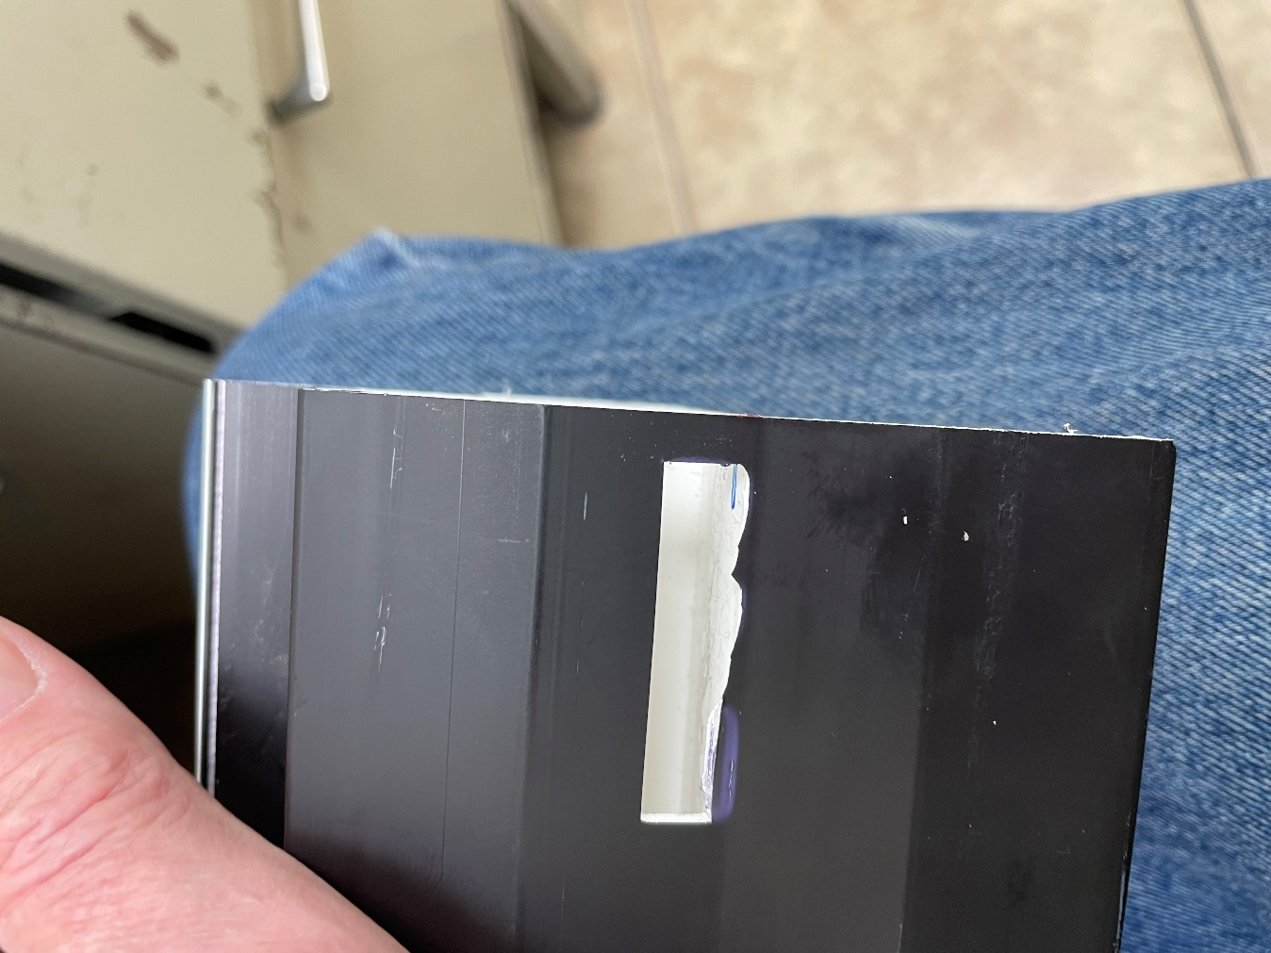

PLEASE MAKE SURE THE WALL AS STRAIGHT AS POSSIBLE

BY SIGNING BELOW, YOU ACKNOWLEDGE THE PROBLEM ABOVE AND AGREE TO MONITOR THIS ISSUE IN FUTURE PRODUCTION RUNS.
DAY SHIFT |  | AFTERNOON SHIFT |  | NIGHT SHIFT
NAME | SIGNATURE | NAME | SIGNATURE | NAME | SIGNATURE

