DIE# 15009 – Solar (EXTRUDER SIDE)
Pack on Green Buggy – Wrap arms in cardboard
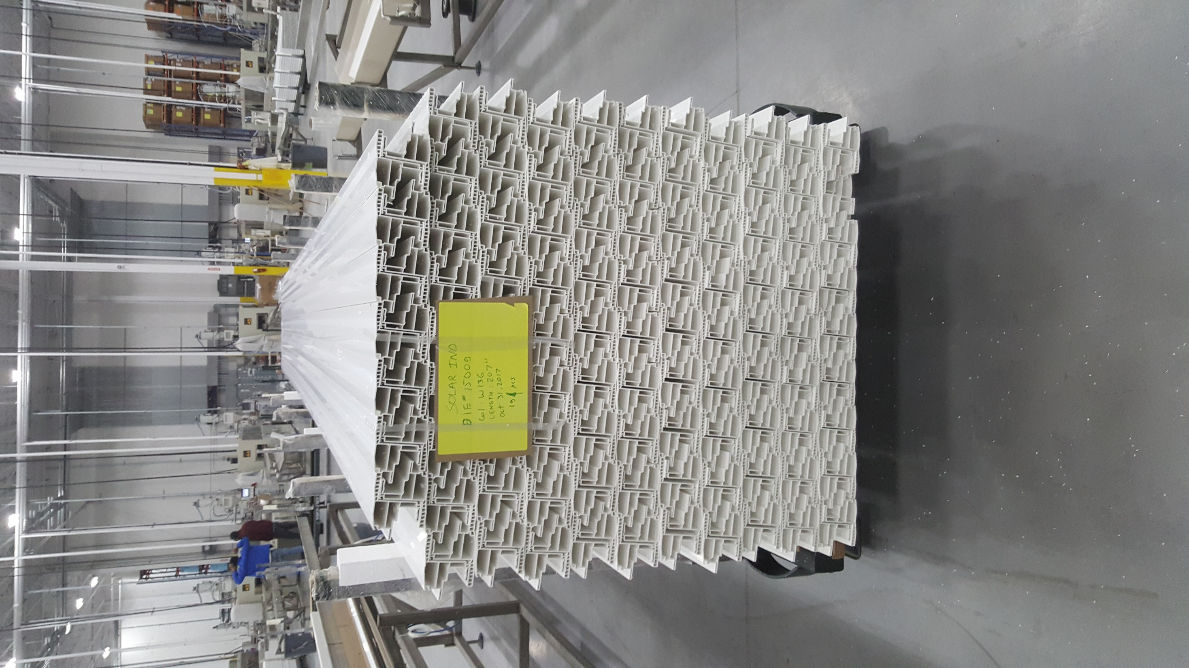
Small foam on 1 side

