DIE# 15010 – Solar (EXTRUDER SIDE)
Pack on Green Buggy – Wrap arms in cardboard
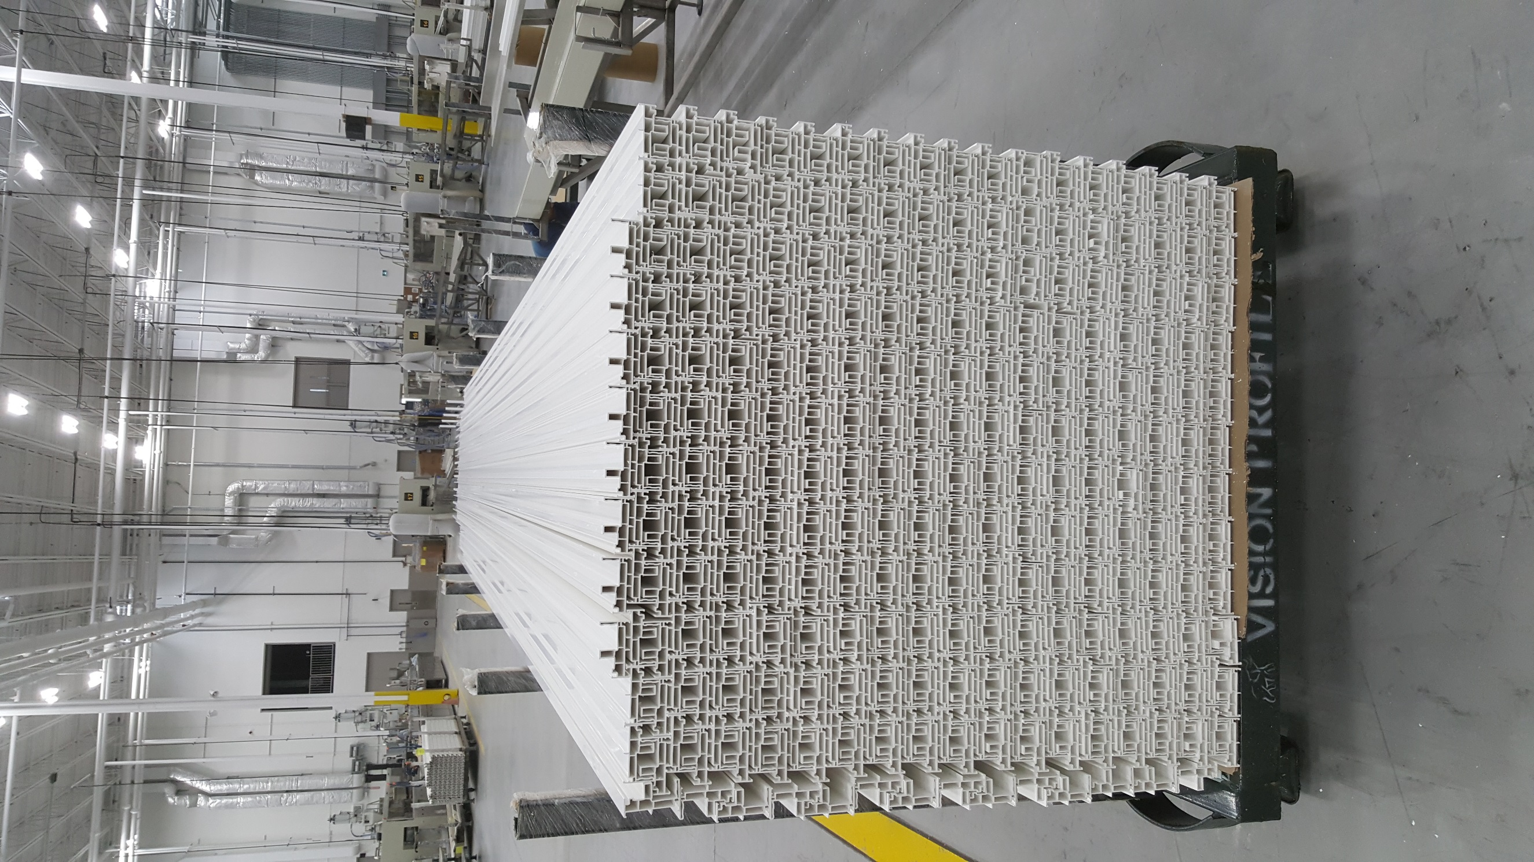
NO FOAM

