DIE# 15030 – ATI (EXTRUDER SIDE)
Pack on Green Buggy – Wrap arms in cardboard
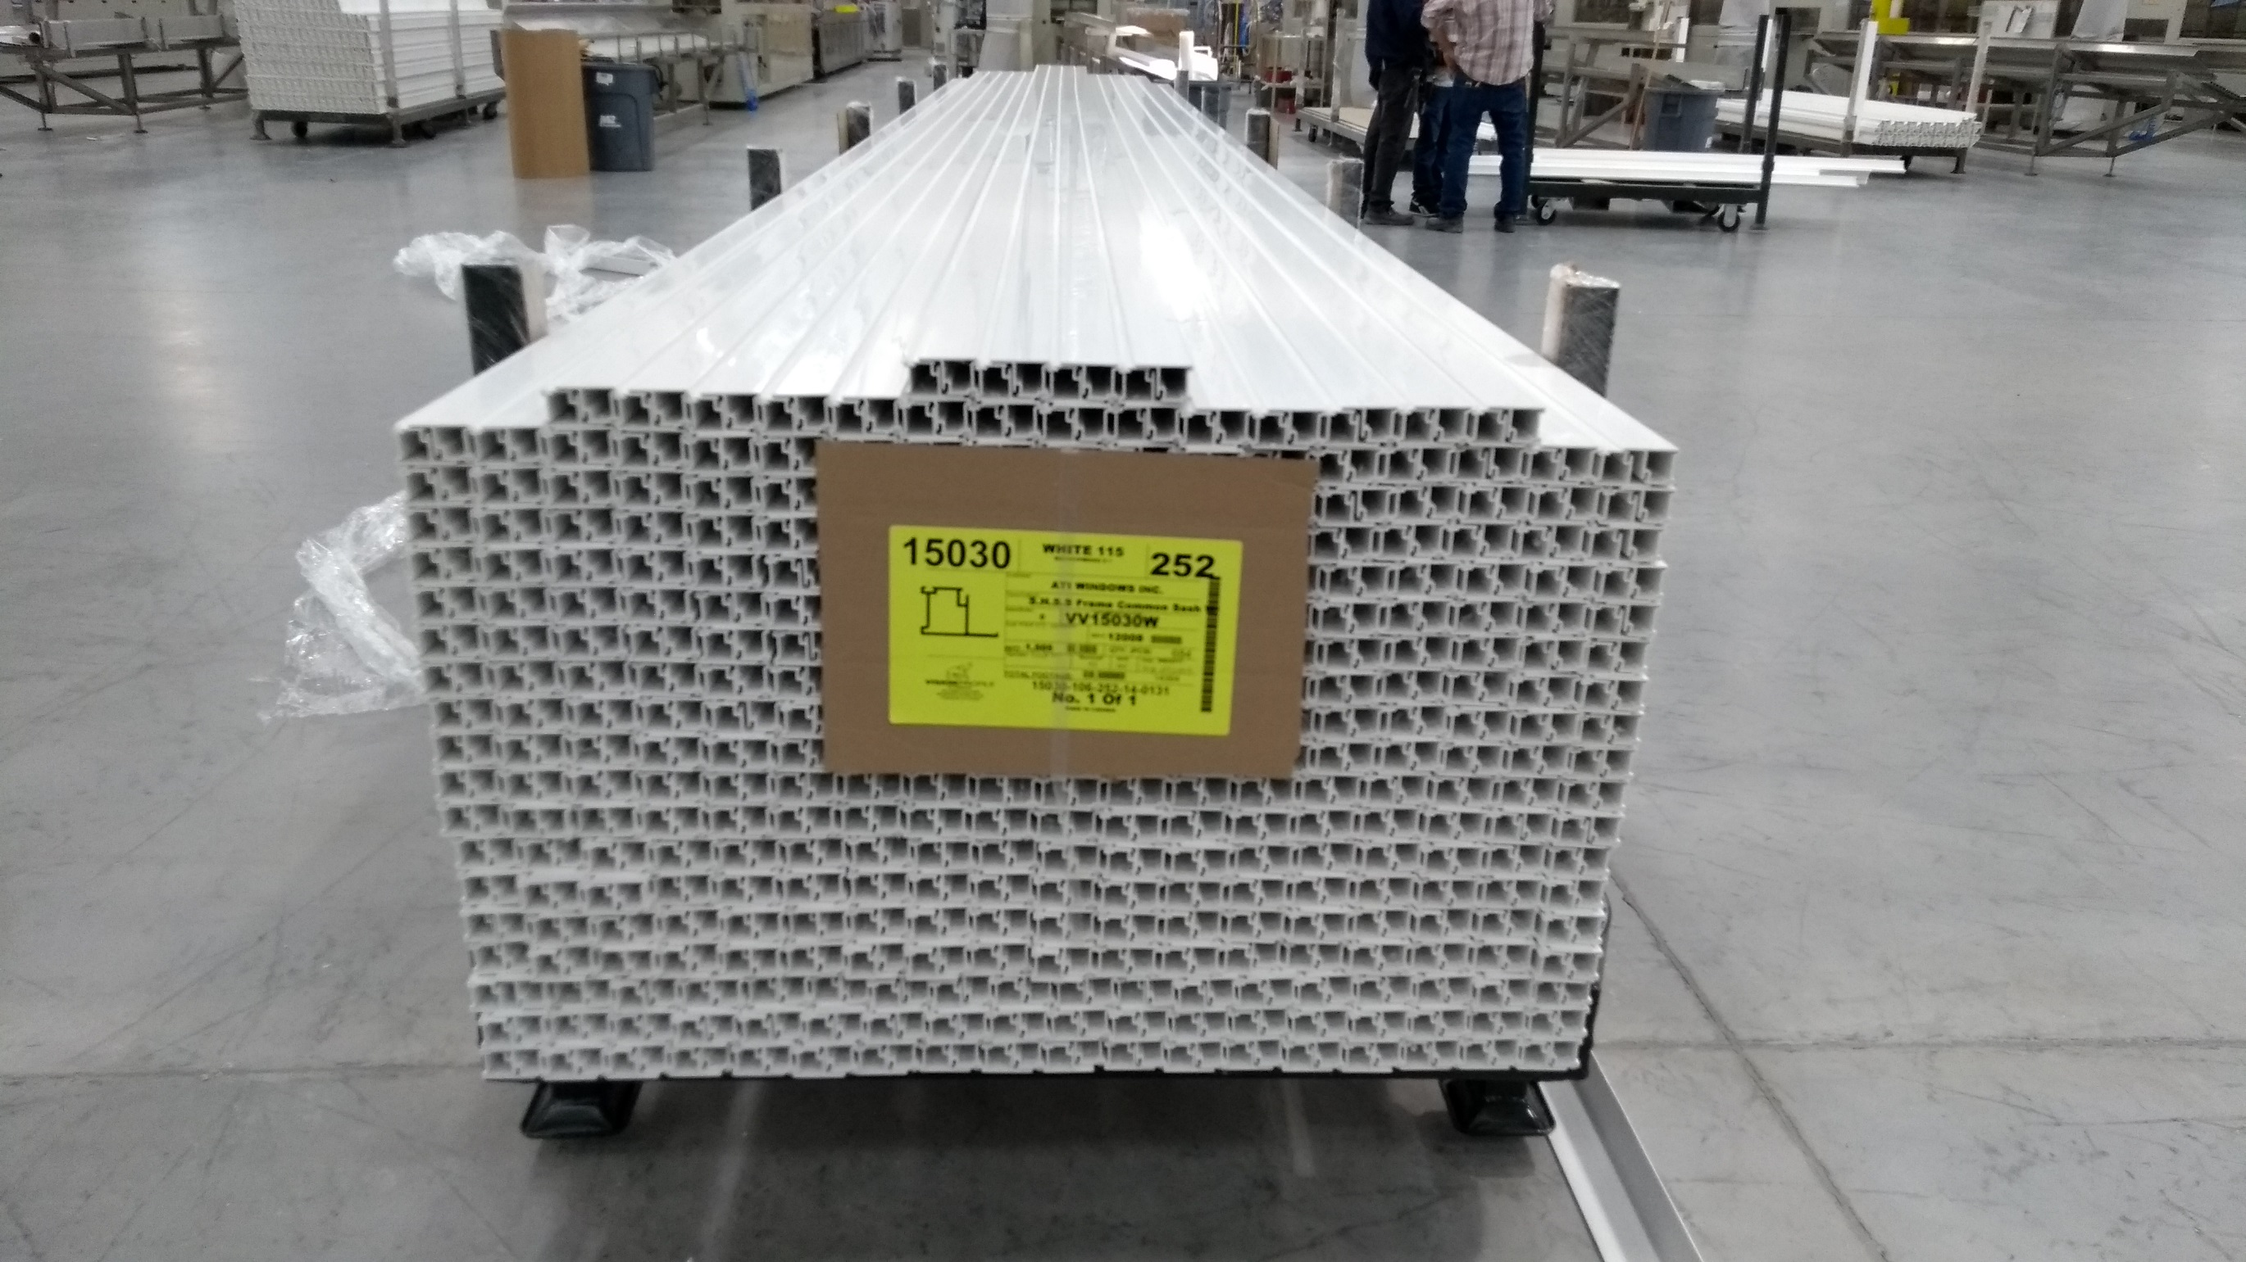
NO FOAM

