DIE# 15031 – ATI (EXTRUDER SIDE)
Pack on Green Buggy – Wrap arms in cardboard
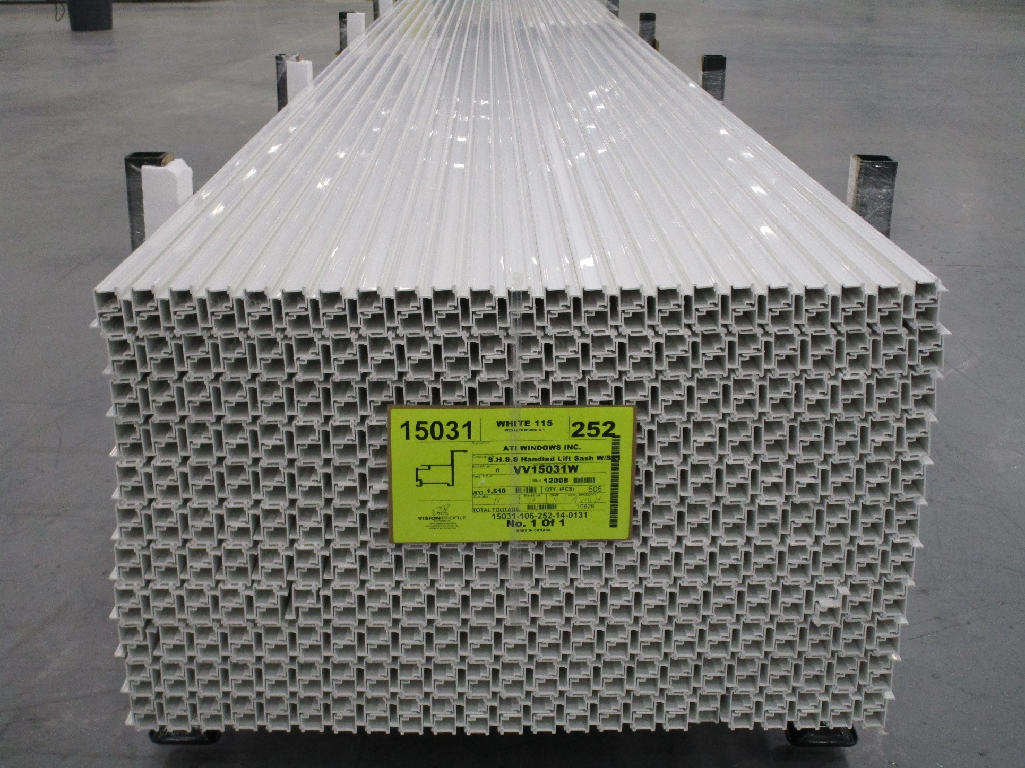
Small foam on 1 side

