DIE# 15032 – ATI (Extruder Side)
Pack on Green Buggy – Wrap arms with cardboard
Small foam on 1 side
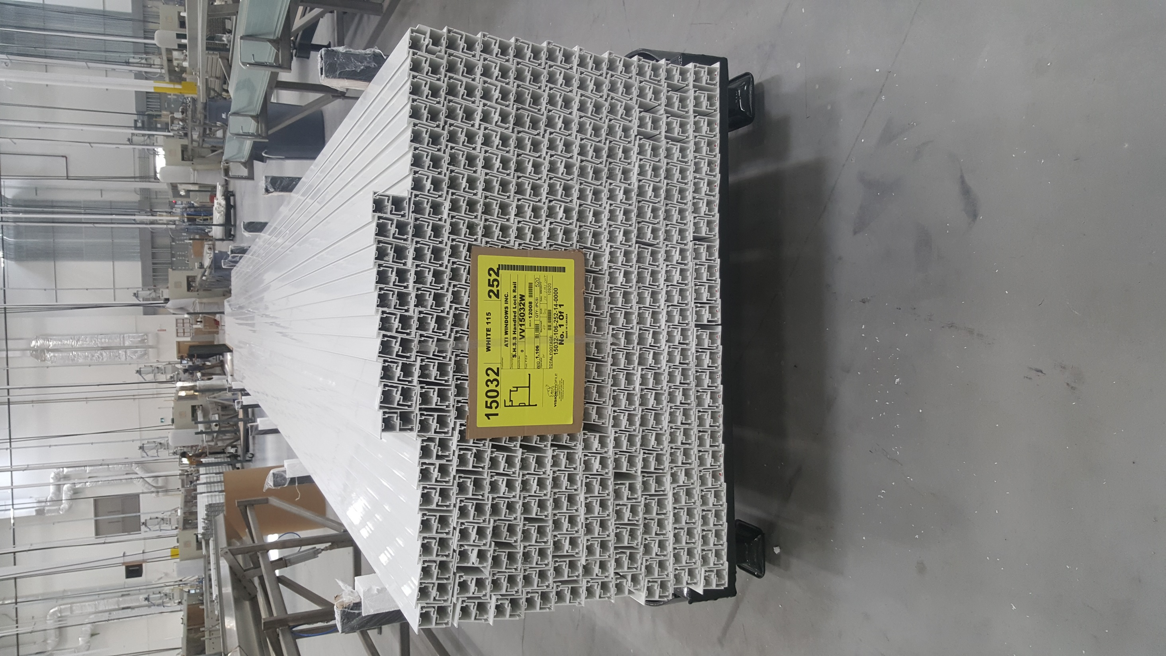
COUNT HOW MANY PIECES TO PUT ON TOP

TRY TO PUT 50 PER ROW

