
QUALITY ALERT

Customer: Avanti Date: Jan 8, 2025
Die: 15033 Colour: Any
Type of Complaint: Customer REJECTED

Q.A # 25-084 NCR: 537 RMA#: 465

Description: Customer REJECTED due to material on the high side wall not sitting flat, showing visible bowing/warping. This affects fit and alignment when assembly.
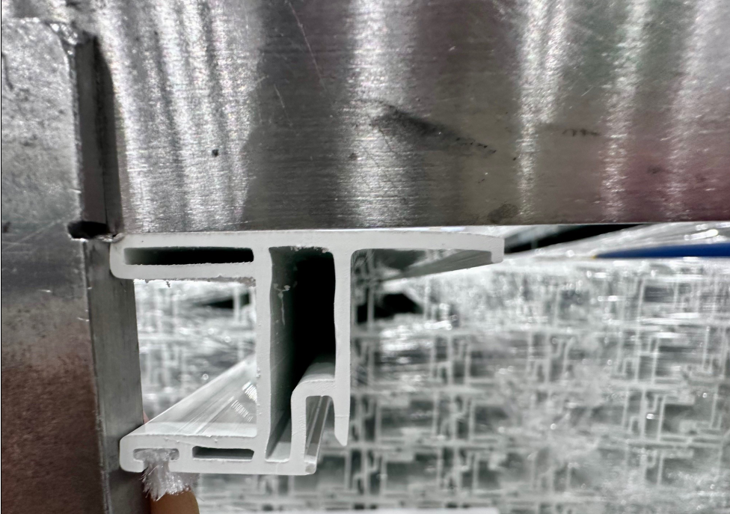
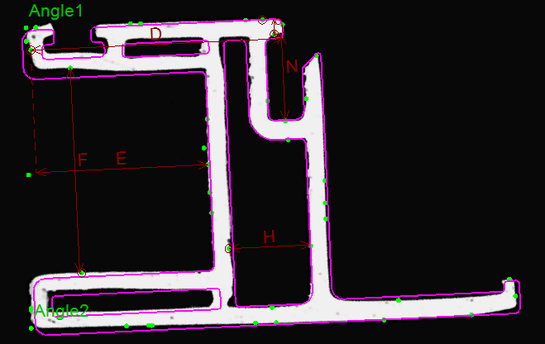

ENSURE HIGH SIDE WALL MATERIAL REMAINS FLAT AND STRAIGHT—NO BOWING OR WARPING ALONG THE LENGTH.

BY SIGNING BELOW, YOU ACKNOWLEDGE THE PROBLEM ABOVE AND AGREE TO MONITOR THIS ISSUE IN FUTURE PRODUCTION RUNS.
DAY SHIFT |  | AFTERNOON SHIFT |  | NIGHT SHIFT
NAME | SIGNATURE | NAME | SIGNATURE | NAME | SIGNATURE

