DIE# 15033 – ATI (EXTRUDER SIDE)
Pack on Green Buggy – Wrap arms in cardboard
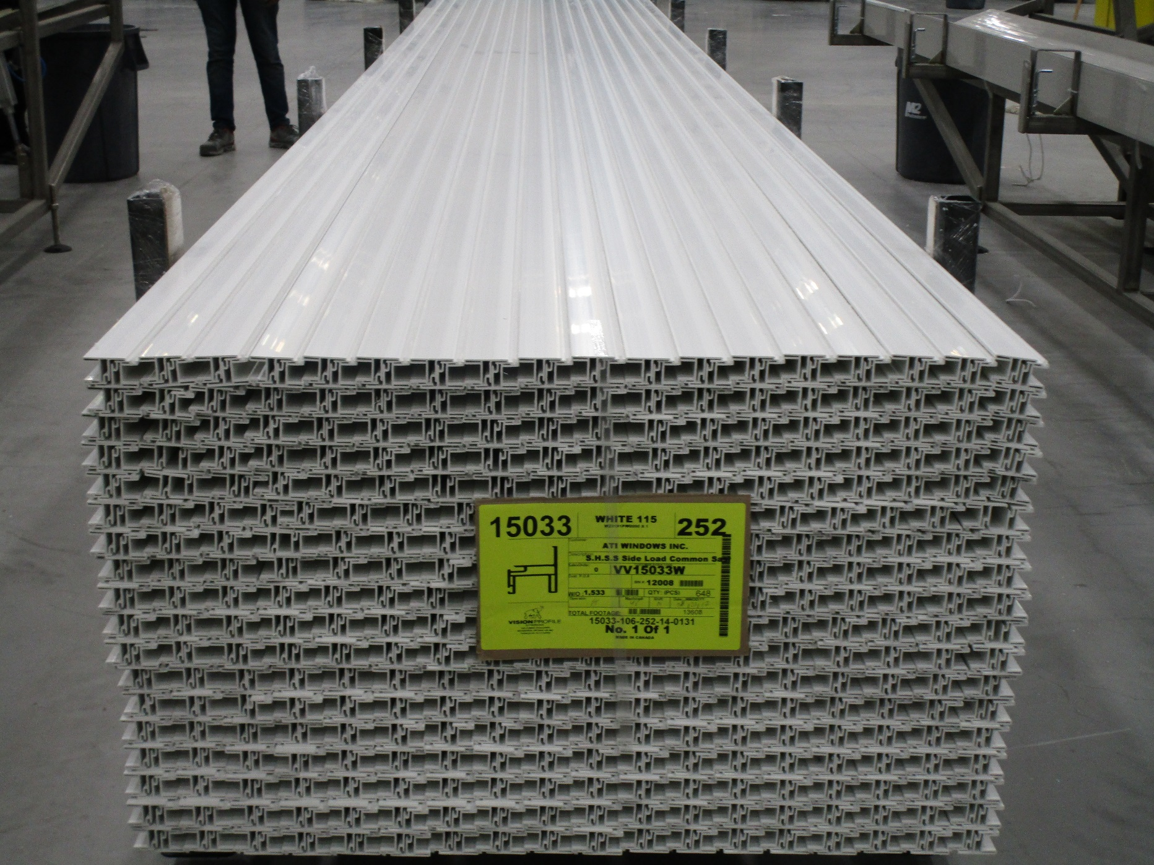
NO FOAM

