
FIT & FUNCTION

Customer: Avanti Date: Sep 8, 2025
Die: 15036 Quantity from QC: 2

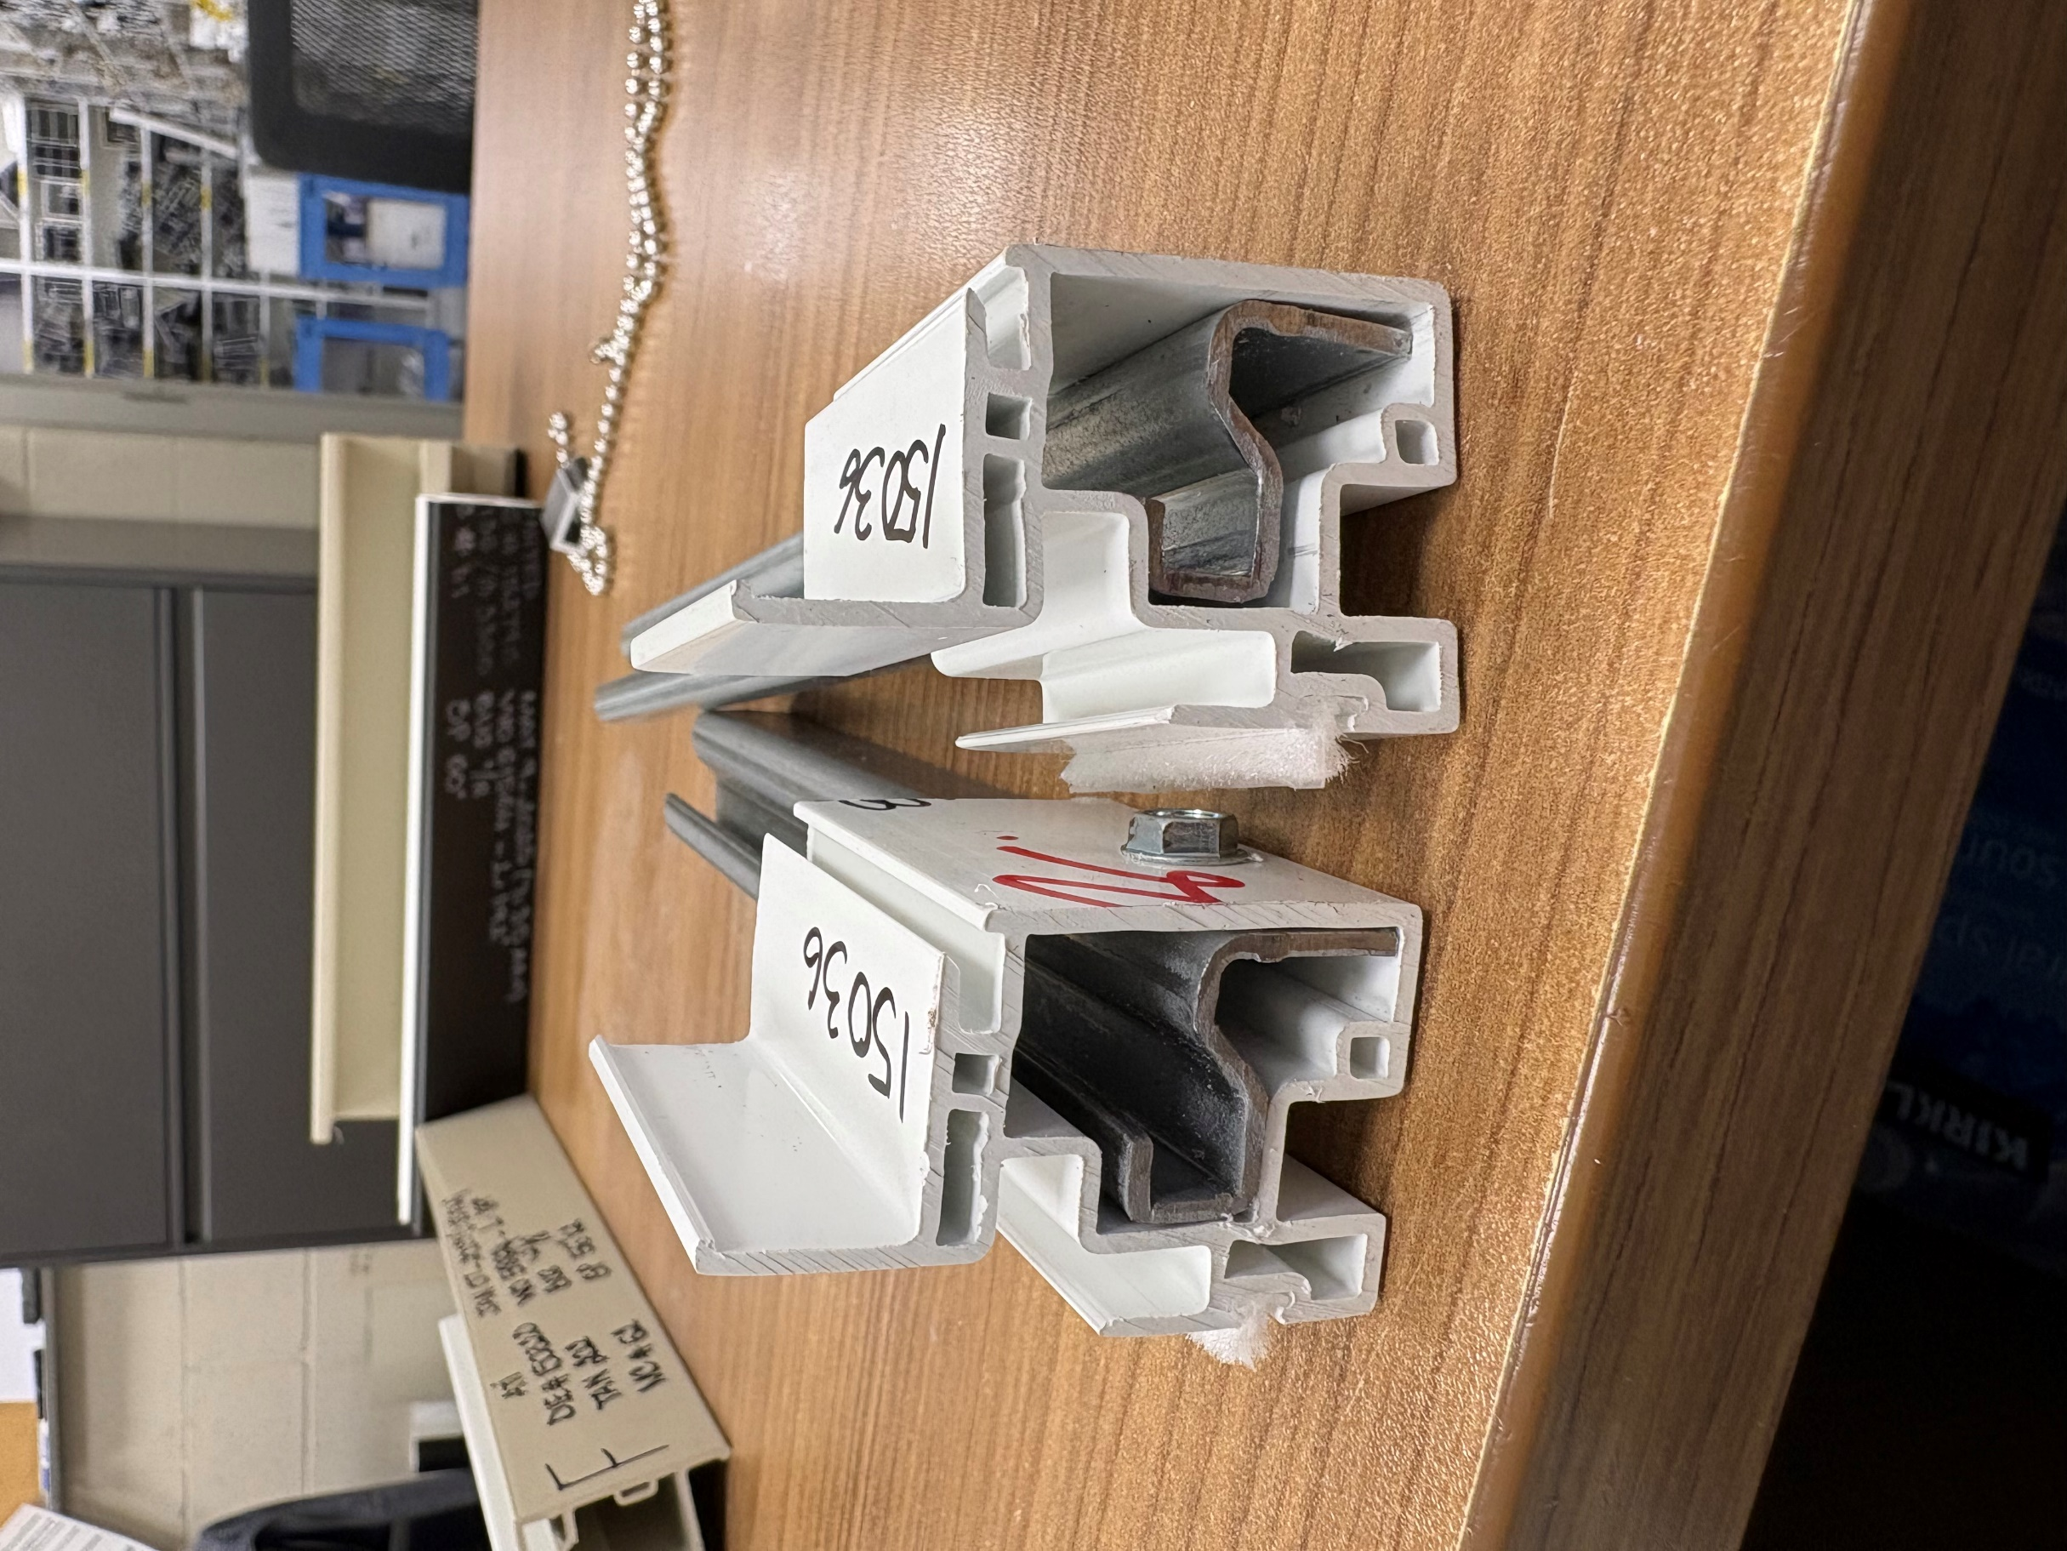
F-F: 023

Description: Aluminium must fit loose

