DIE# 15063 – AVANTI (EXTRUDER SIDE)
Pack on Green Buggy – Wrap arms in cardboard
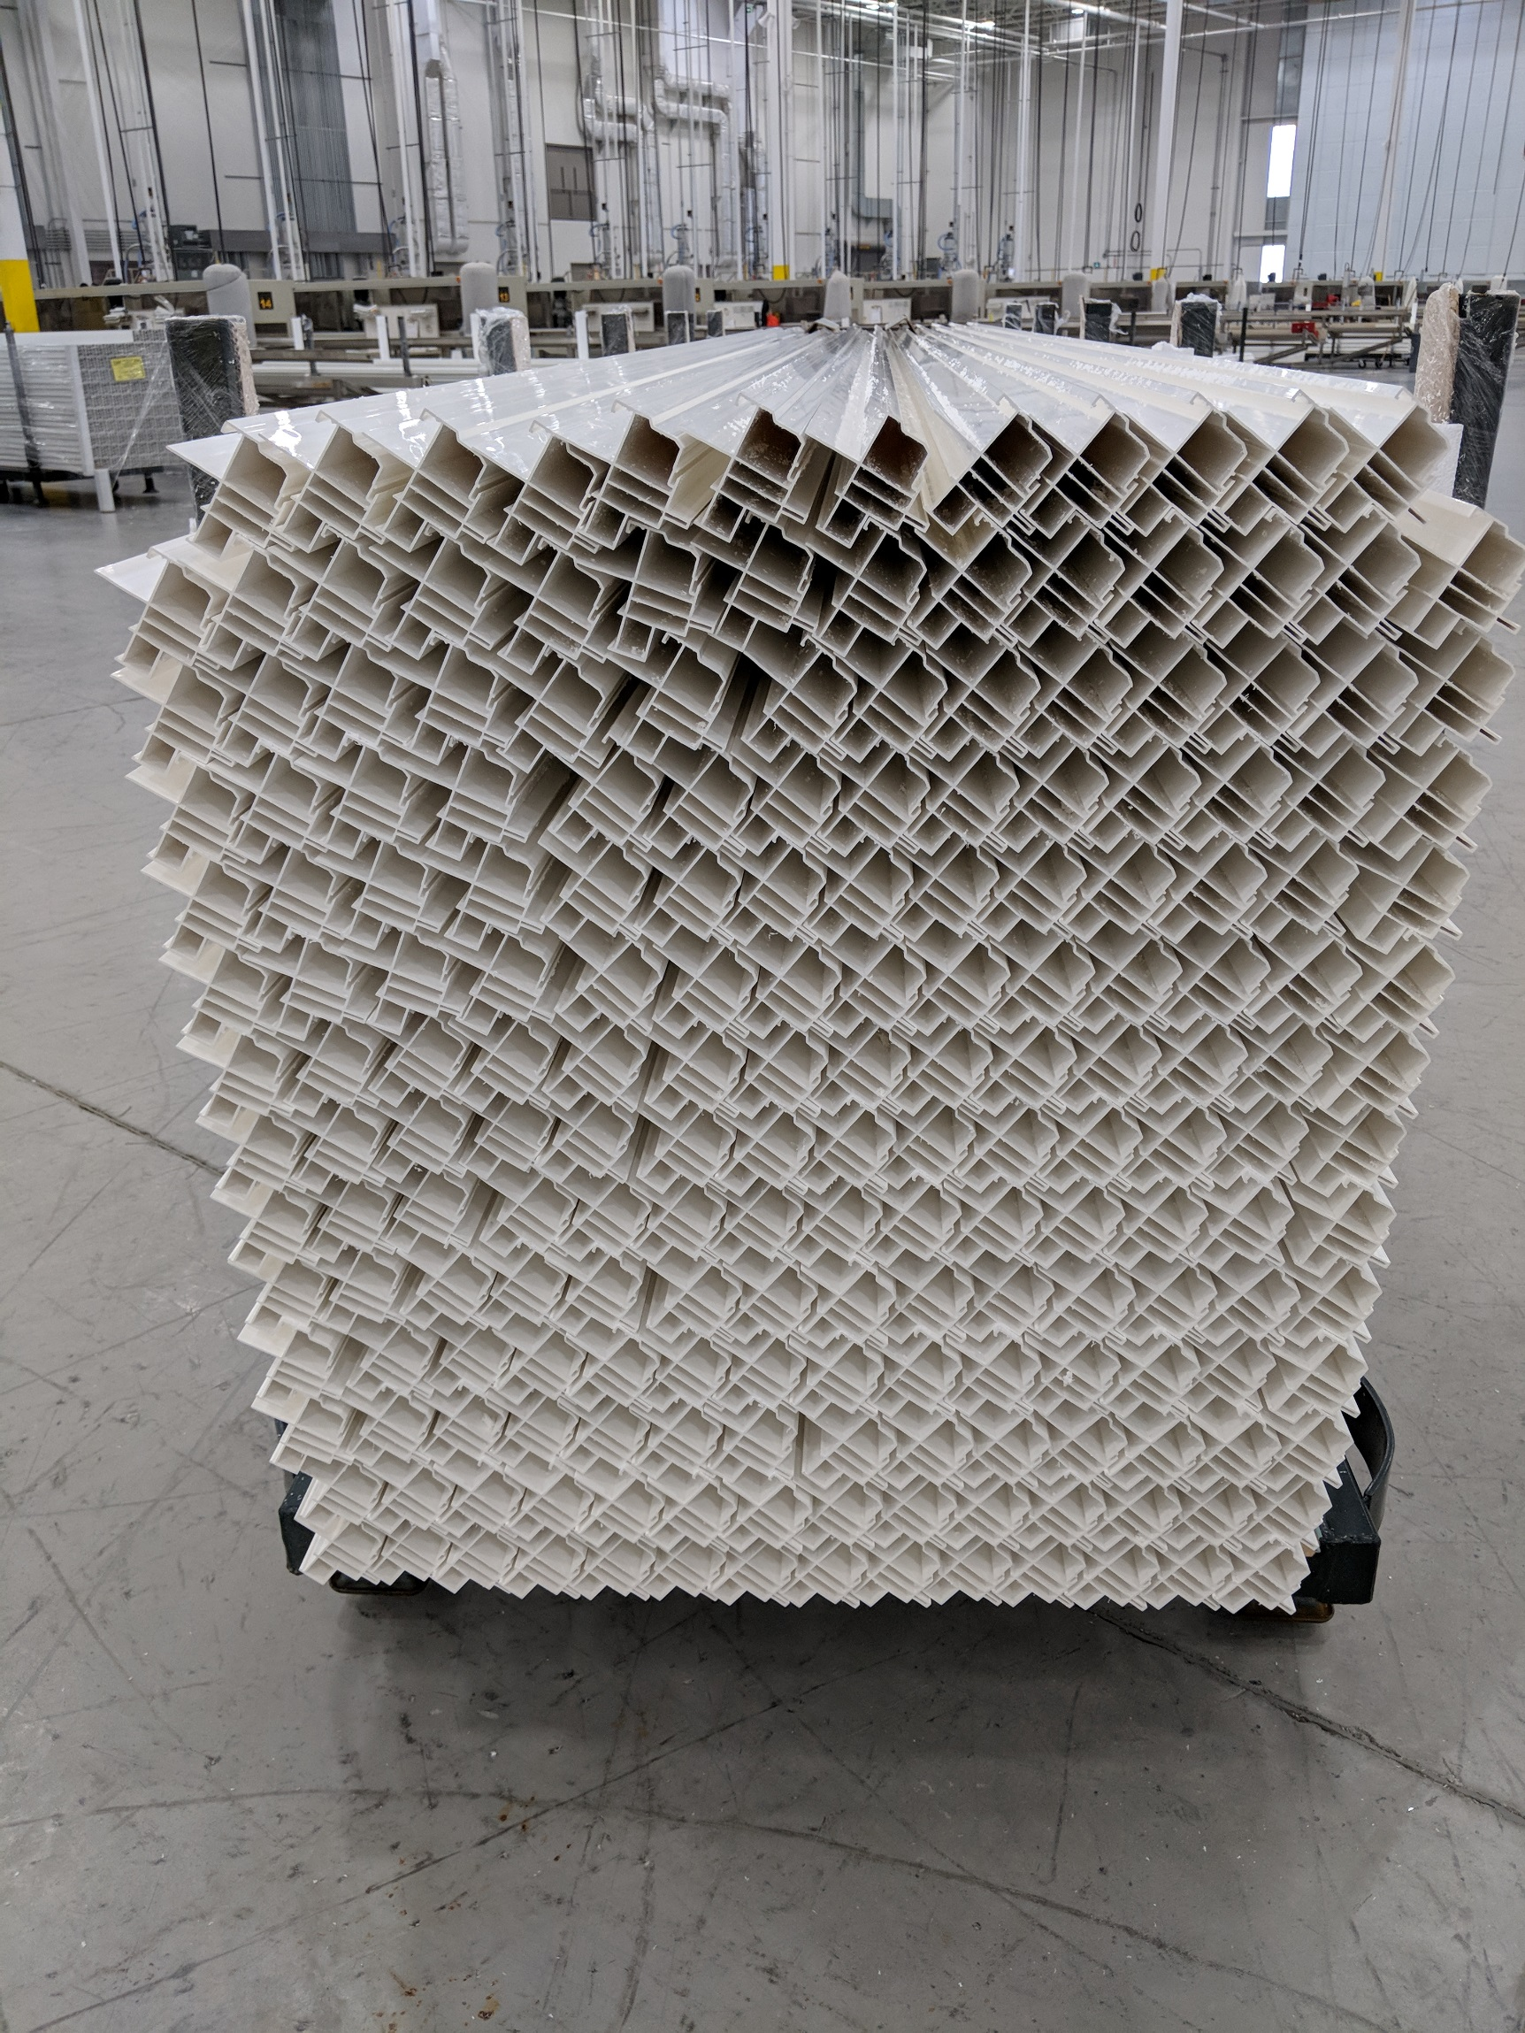
NO FOAM

