
QUALITY ALERT

Customer: Soft-Lite Date: May 31, 2018
Die: 15078 Colour: ALL
Type of Complaint: Customer REJECTED

Q.A # Q.I.R # CUSTOMER NCR #

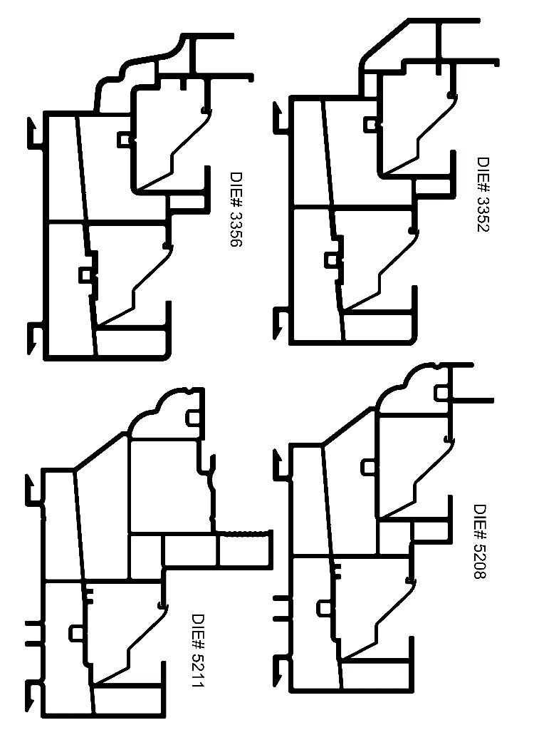
Description: Customer REJECTED – Overall width small and shape/angle causing it to be loose in the pocket in frame and falls out. Surface finish is rough like “orange peel”

OVERALL MUST BE IN TOLERANCE MUST FIT SNUG IN ALL FRAMES
CHECK SURFACE FINISH AND ANGLE
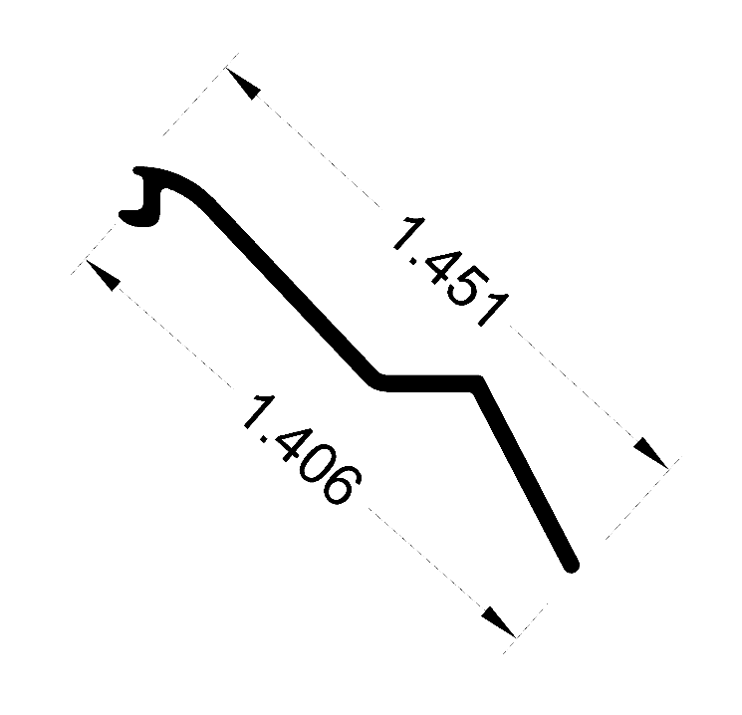

BY SIGNING BELOW, YOU ACKNOWLEDGE THE PROBLEM ABOVE AND AGREE TO MONITOR THIS ISSUE IN FUTURE PRODUCTION RUNS.
DAY SHIFT |  | AFTERNOON SHIFT |  | NIGHT SHIFT
NAME | SIGNATURE | NAME | SIGNATURE | NAME | SIGNATURE

