DIE# 15097 - CENTRA
Pack on Orange Long arm Buggy
Small Foam on 1 side
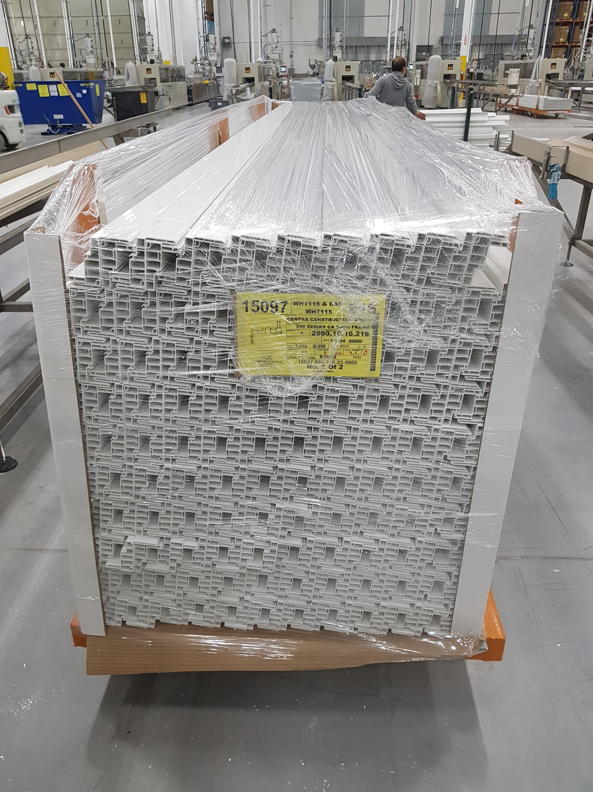
BLACK CAPSTOCK ONLY - Poly Sheet must cover ALL Capstock area

