
FIT & FUNCTION

Customer: Jones Date: Aug 20, 2025
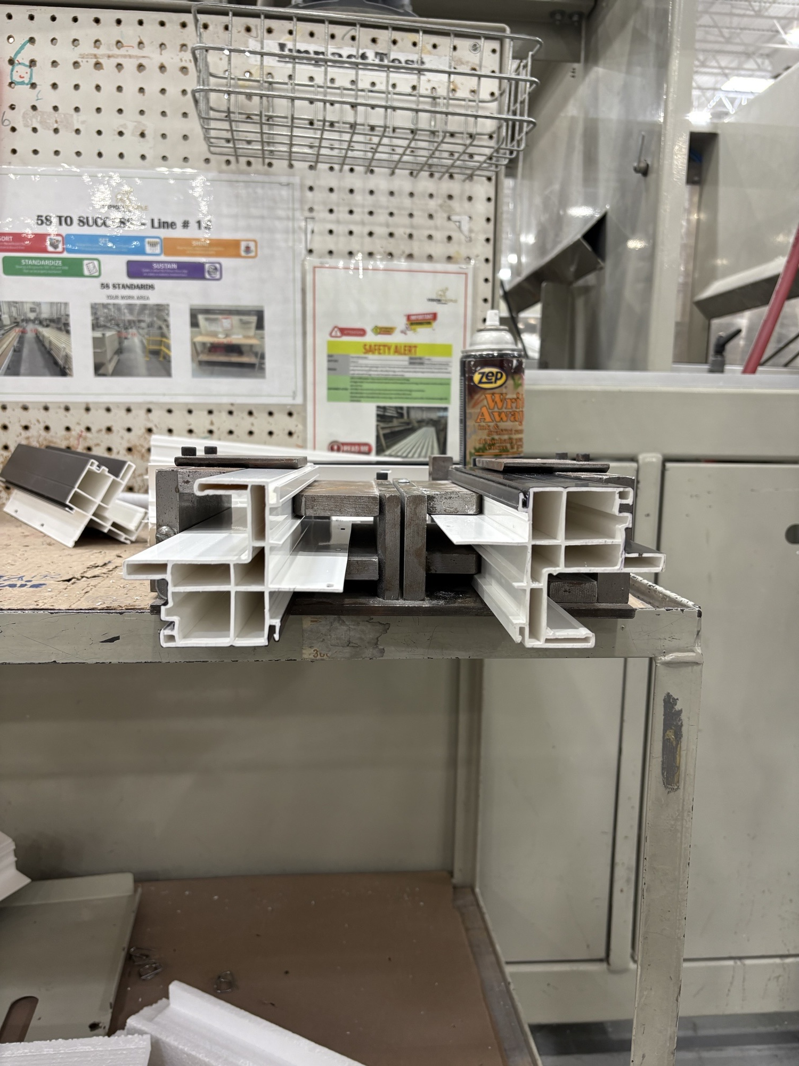
Die: 15100 Quantity from QC: 2 punches

F-F: 007

Description: Material must fit loose in punch
