
QUALITY ALERT

Customer: Jones Paint & Glass Date: March 6, 2024
Die: 15101 Colour: All
Type of Complaint: Jones P&G REJECT

Q.A # Q.I.R # CUSTOMER NCR #

Description: Jones REJECT material does NOT fit the punch.
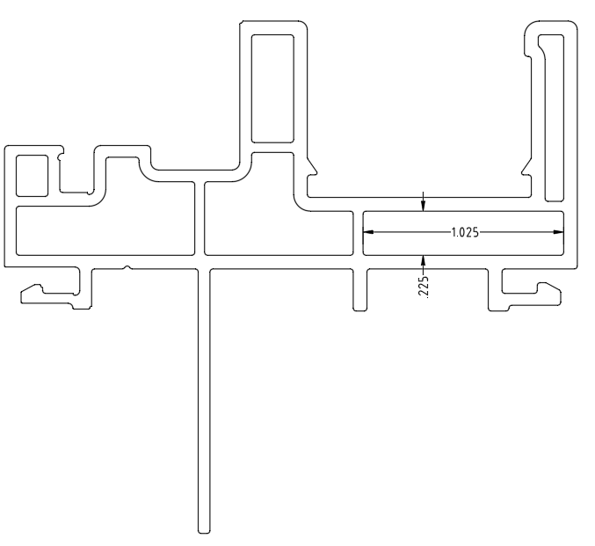
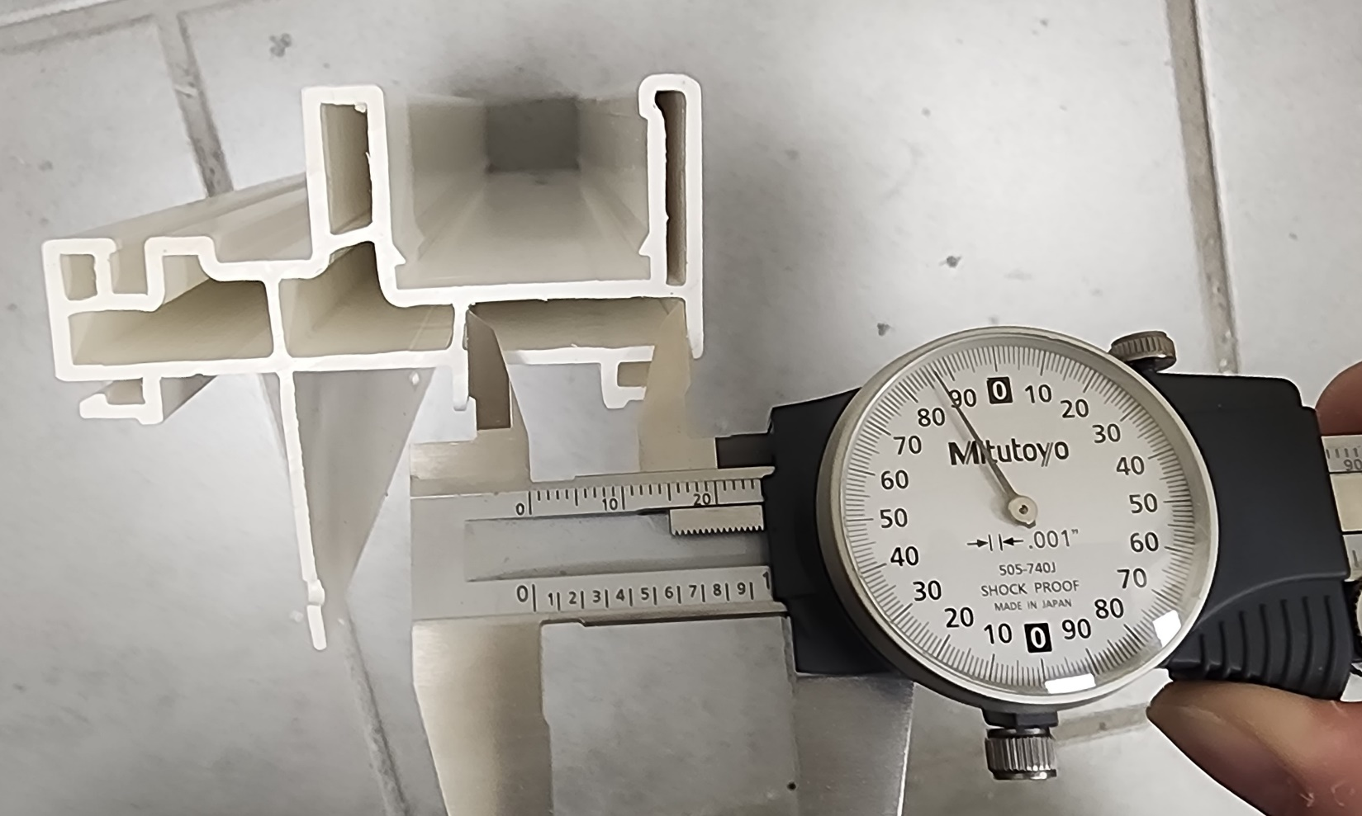

PLEASE MAKE SURE POCKET MUST BE IN TOLERANCE 1.025 ± 0.015”

BY SIGNING BELOW, YOU ACKNOWLEDGE THE PROBLEM ABOVE AND AGREE TO MONITOR THIS ISSUE IN FUTURE PRODUCTION RUNS.
DAY SHIFT |  | AFTERNOON SHIFT |  | NIGHT SHIFT
NAME | SIGNATURE | NAME | SIGNATURE | NAME | SIGNATURE

