DIE# 15112– Jones (EXTRUDER SIDE)
Pack on Green Buggy – Wrap arms in cardboard
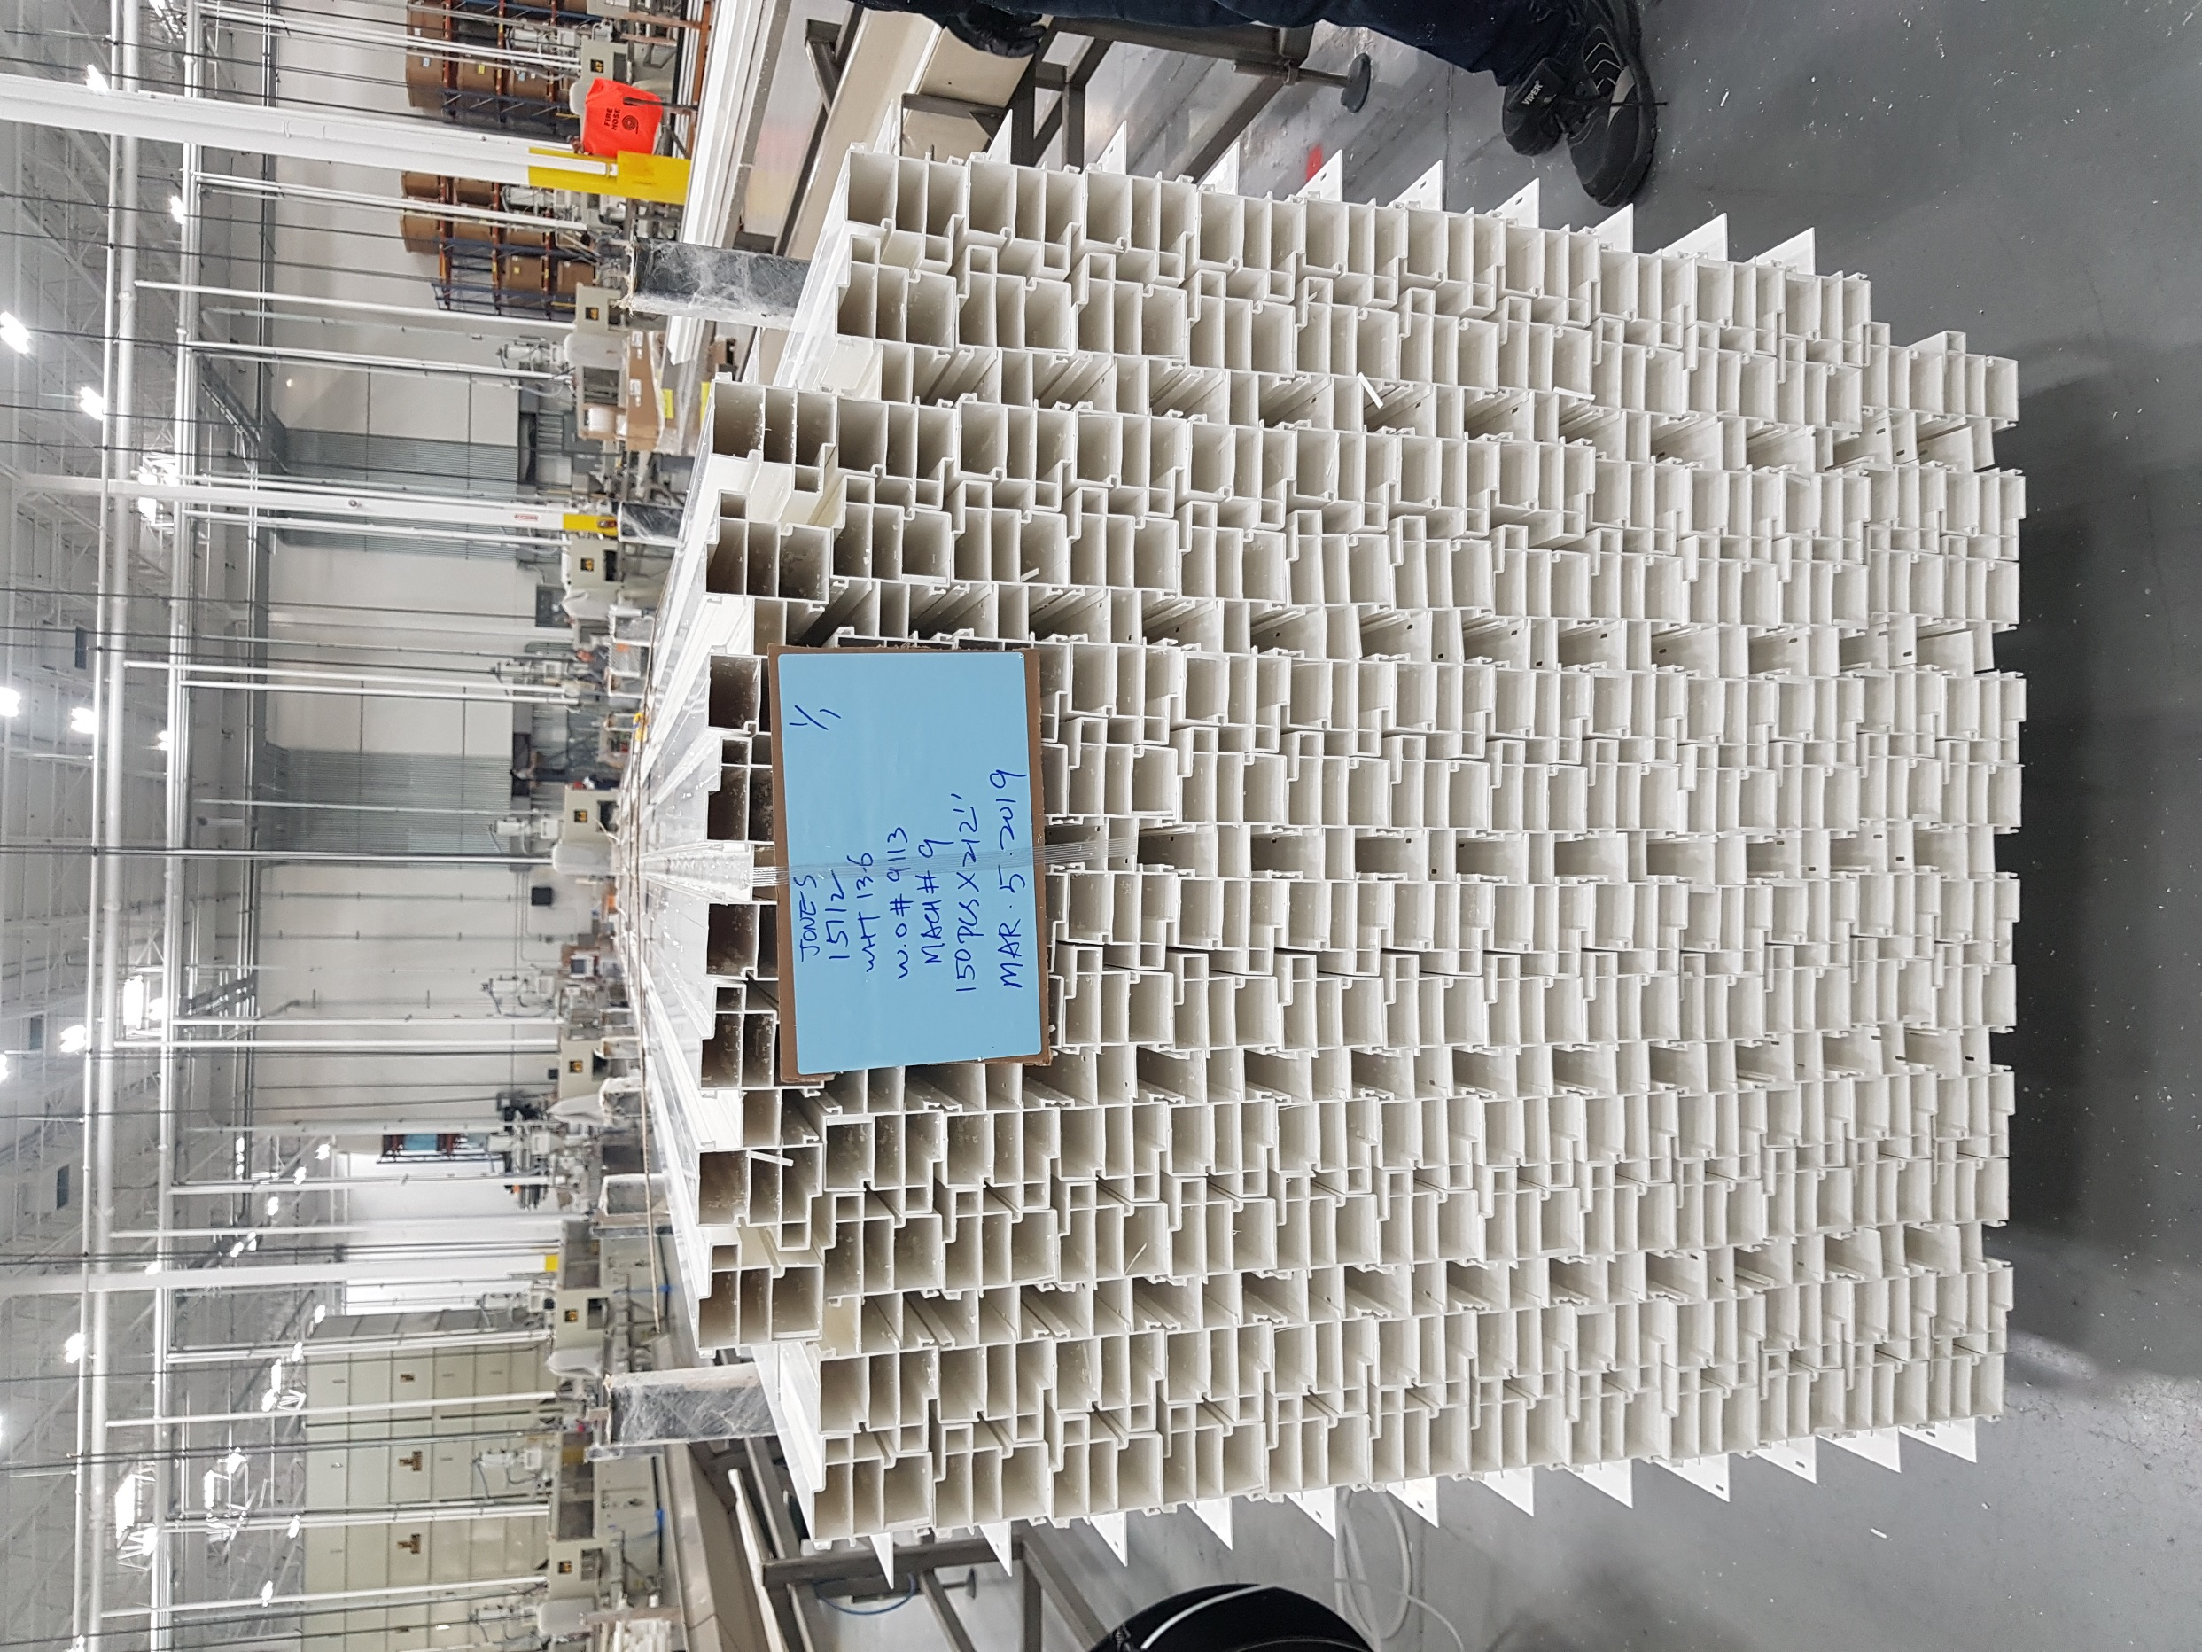
No Foam

