
QUALITY ALERT

Customer: United Date: Feb 13, 2019
Die: 15137 Colour: ALL COLOURS
Type of Complaint: United Complaint

Q.A # Q.I.R # CUSTOMER NCR #

Description: United Complaint – Leg breaking and tearing during fabrication – Tool is revised
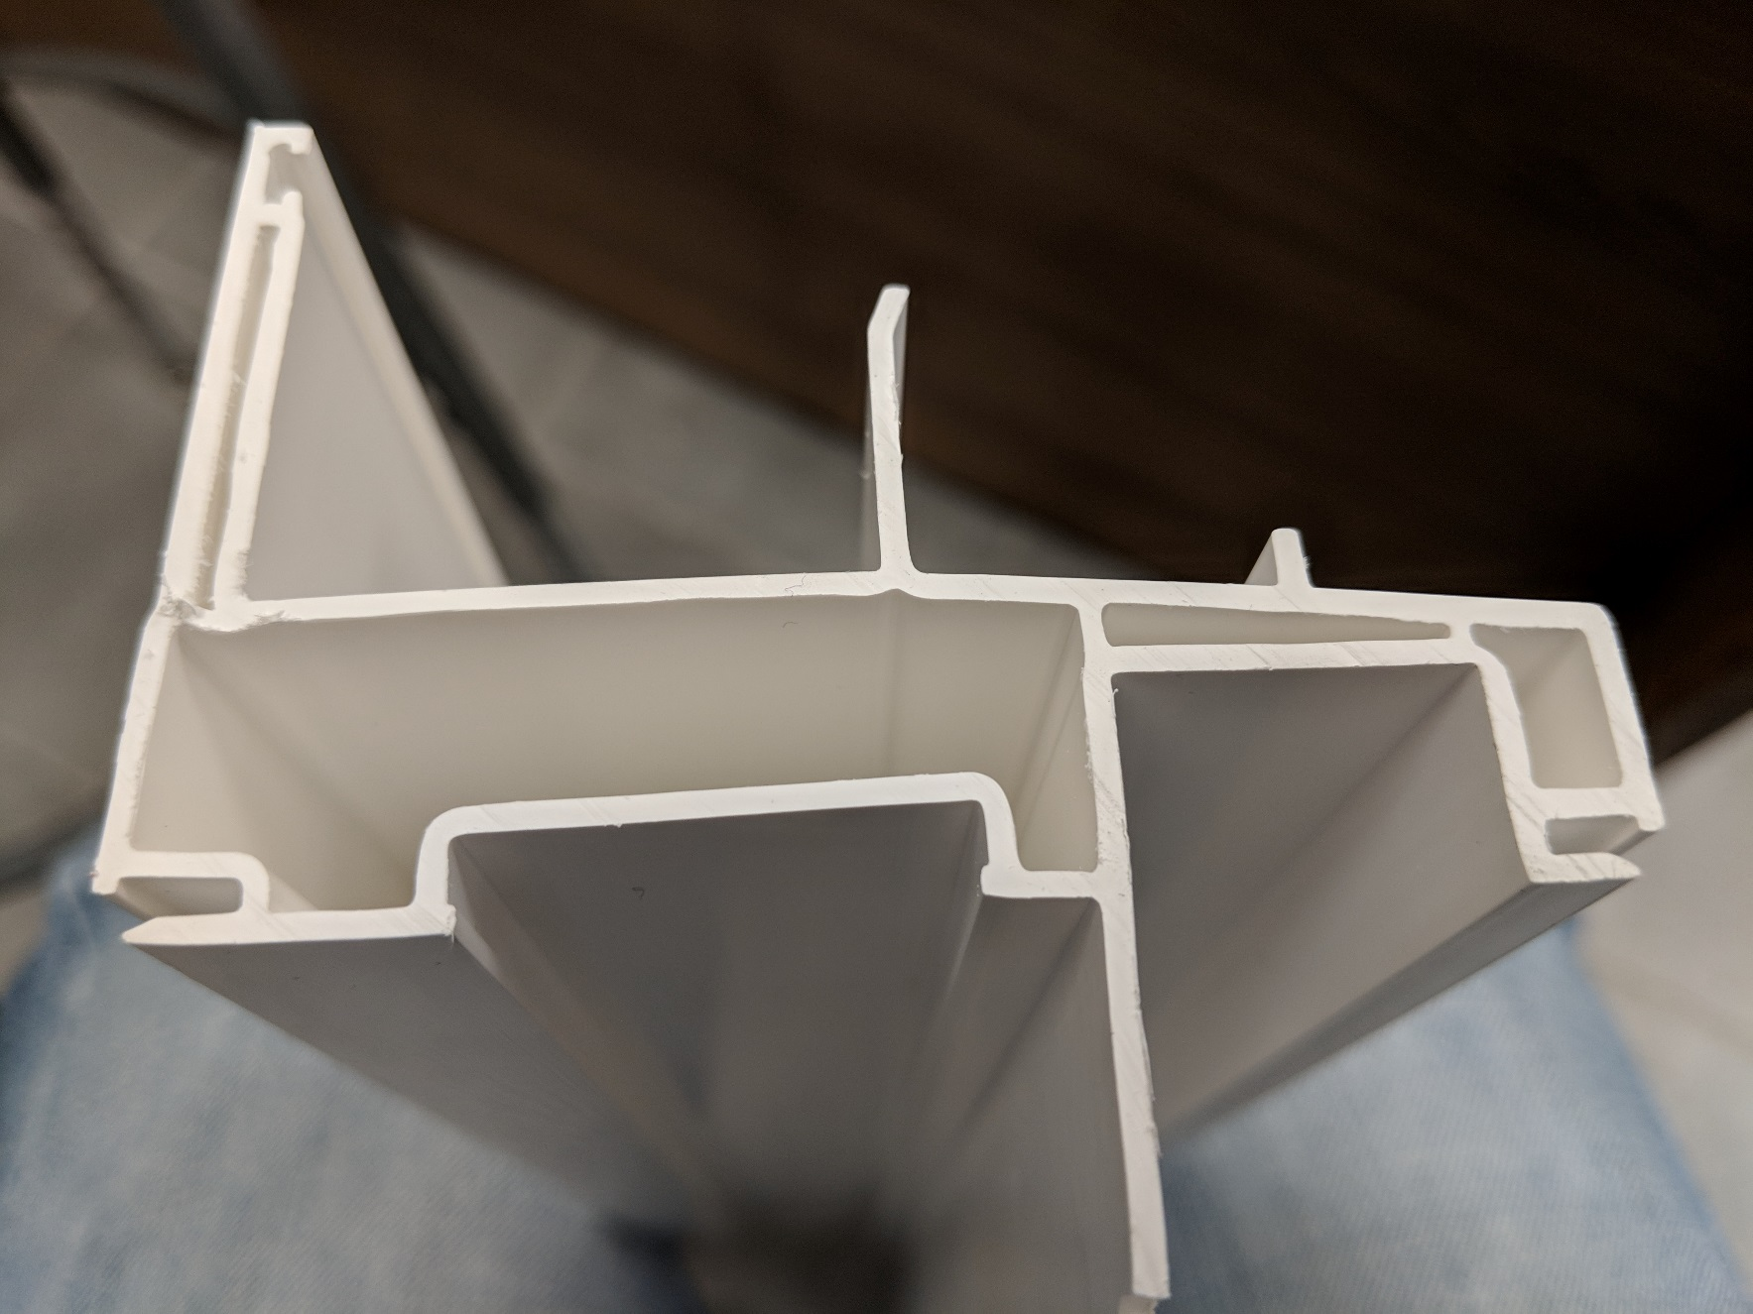
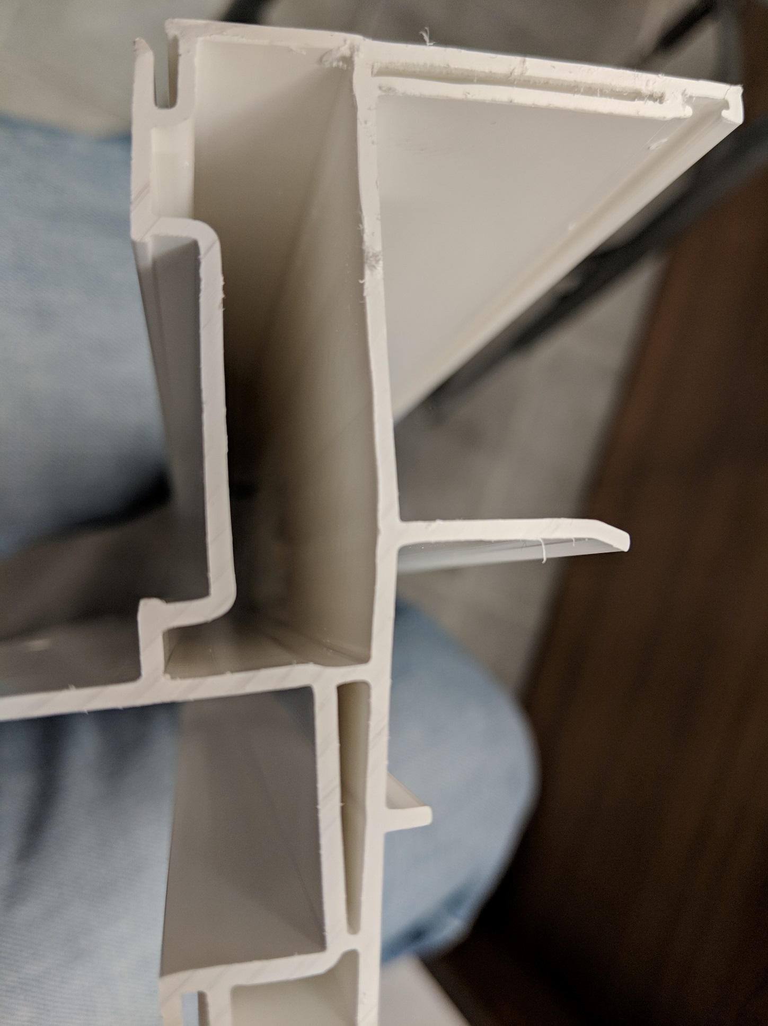

OLD REVISION NEW REVISED SAMPLE
BY SIGNING BELOW, YOU ACKNOWLEDGE THE PROBLEM ABOVE AND AGREE TO MONITOR THIS ISSUE IN FUTURE PRODUCTION RUNS.
DAY SHIFT |  | AFTERNOON SHIFT |  | NIGHT SHIFT
NAME | SIGNATURE | NAME | SIGNATURE | NAME | SIGNATURE

