DIE# 15137 (Short) – UNITED (EXTRUDER SIDE)
Pack on Green Buggy – Wrap arms in cardboard
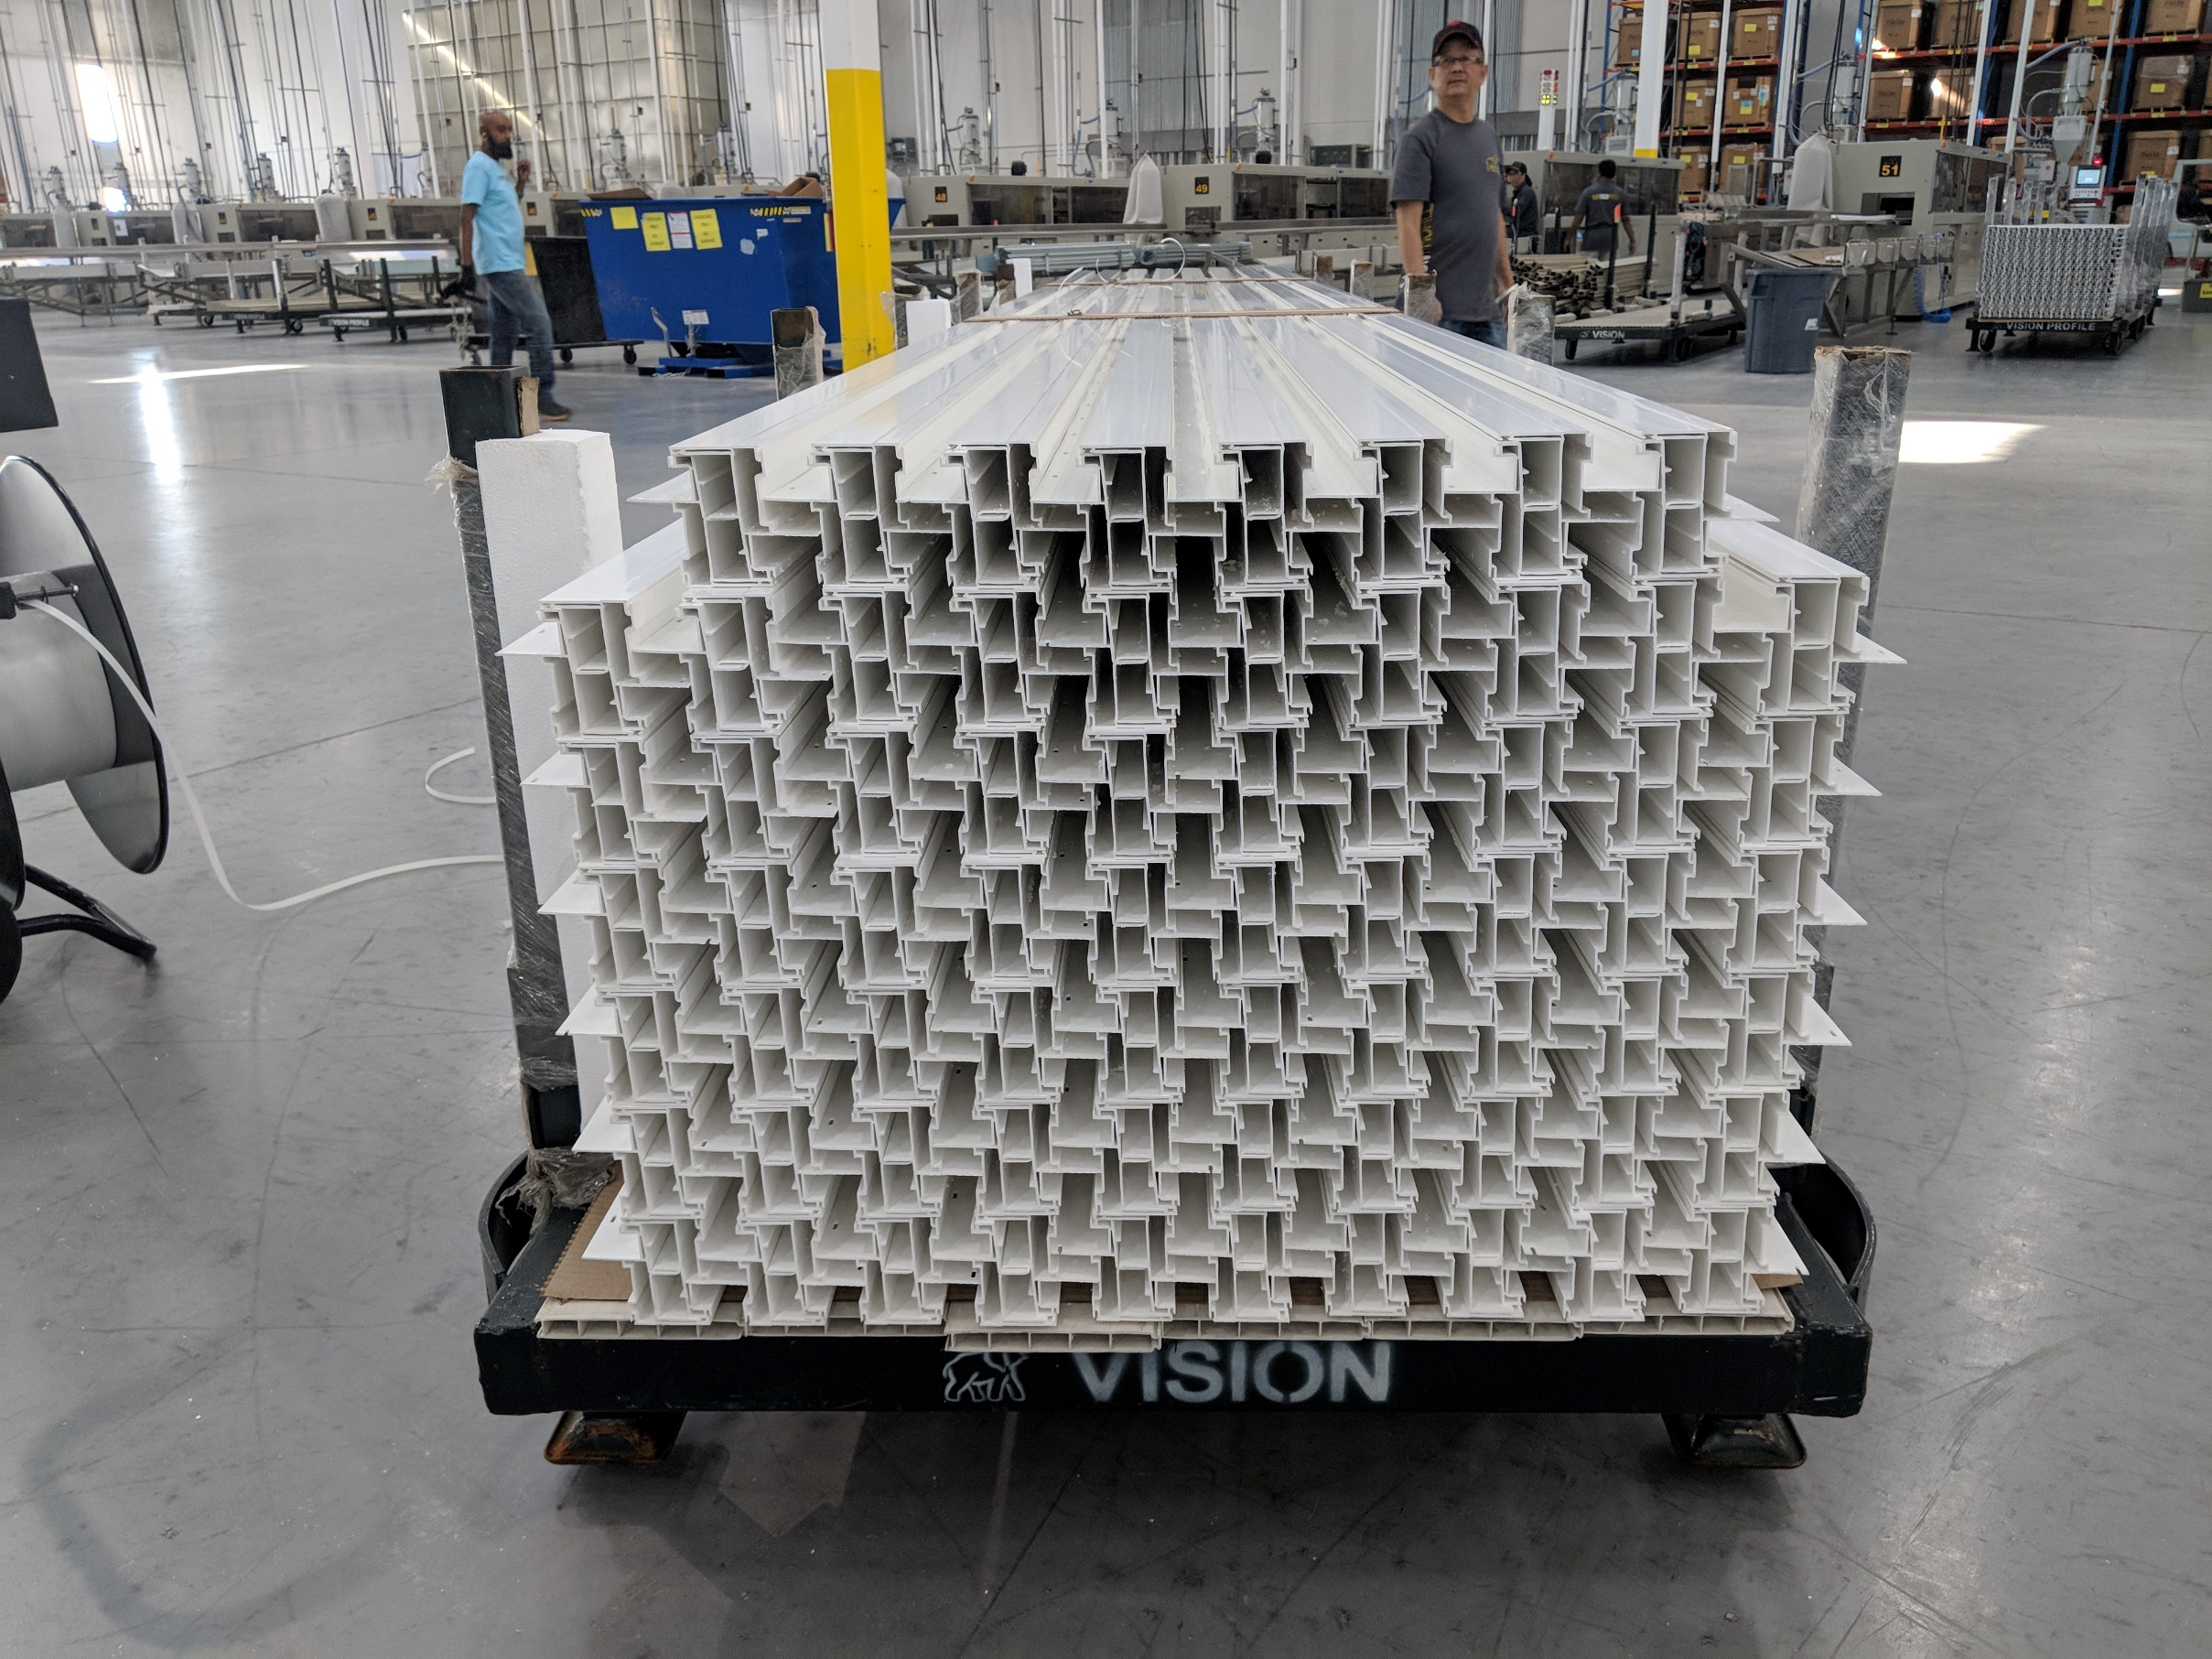
Big Foam on 1 side

