
QUALITY ALERT

Customer: United Date: April 02, 2022
Die: 15138 Colour: ALL COLOURS
Type of Complaint: United Complaint

Q.A # Q.I.R # CUSTOMER NCR #

Description: United Complaint – Pieces are OUT OF SHAPE causing the balance shoes difficult to operate
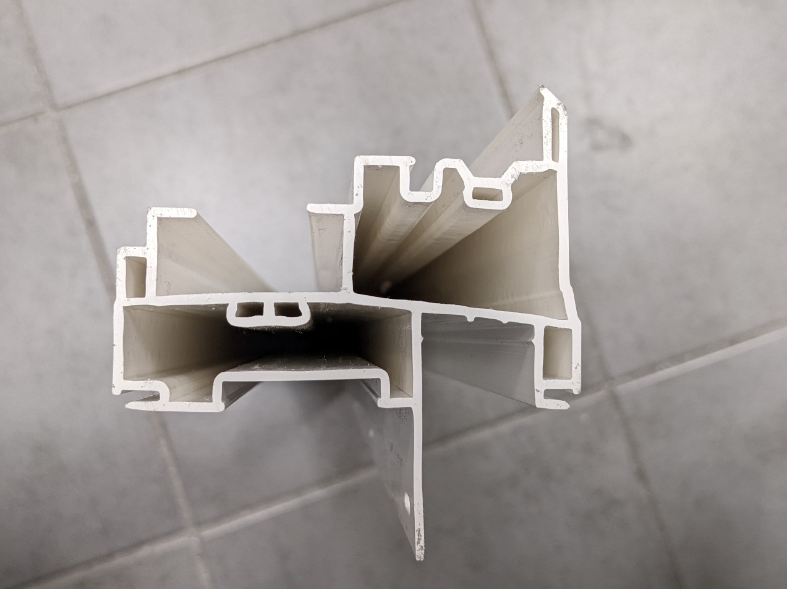
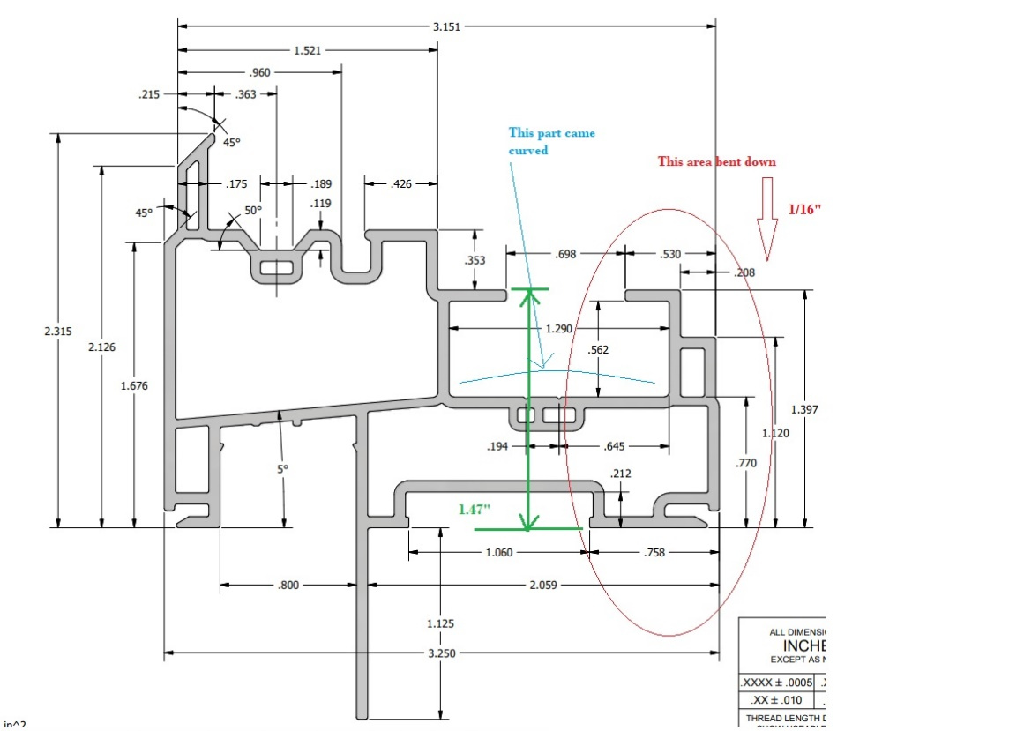

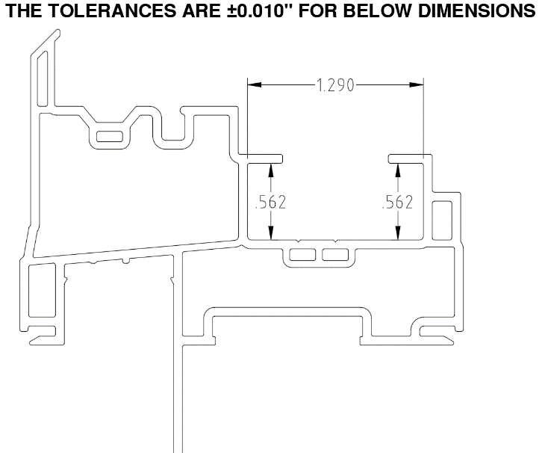

PLEASE MAKE SURE MATERIAL ARE GOOD SHAPE
AND
THE DIMENSIONS ARE IN TOLERANCES

BY SIGNING BELOW, YOU ACKNOWLEDGE THE PROBLEM ABOVE AND AGREE TO MONITOR THIS ISSUE IN FUTURE PRODUCTION RUNS.
DAY SHIFT |  | AFTERNOON SHIFT |  | NIGHT SHIFT
NAME | SIGNATURE | NAME | SIGNATURE | NAME | SIGNATURE

