DIE# 15140 – UNITED (EXTRUDER SIDE)
Pack on Green Buggy – Wrap arms in cardboard
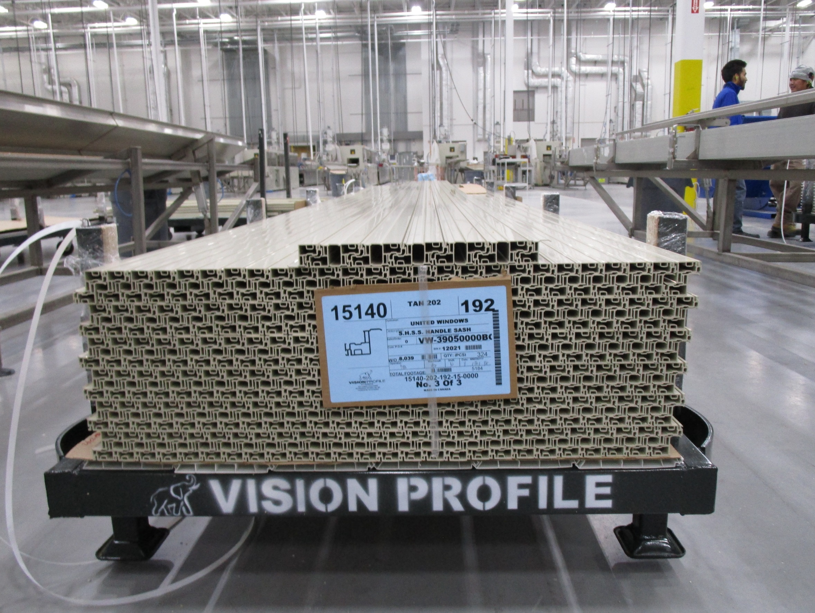
NO FOAM

