DIE# 15141-Weatherstrip – UNITED (EXTRUDER SIDE)
Pack on Green Buggy – Wrap arms in cardboard
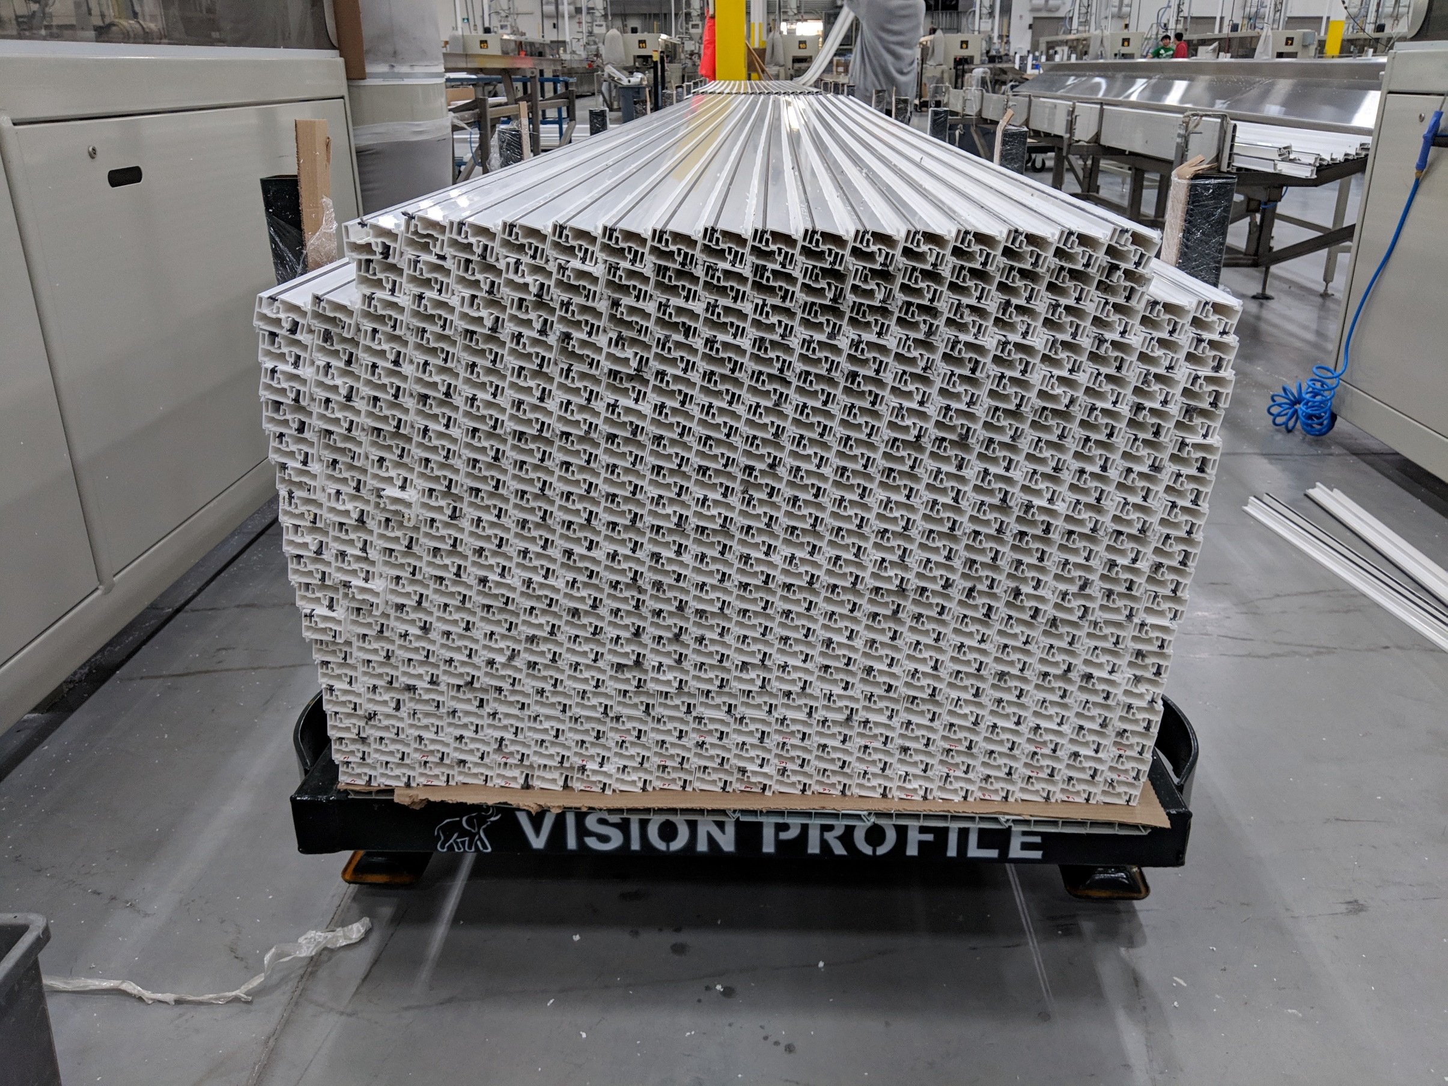
No Foam

