DIE# 15141 – UNITED (EXTRUDER SIDE)
Pack on Green Buggy – Wrap arms in cardboard
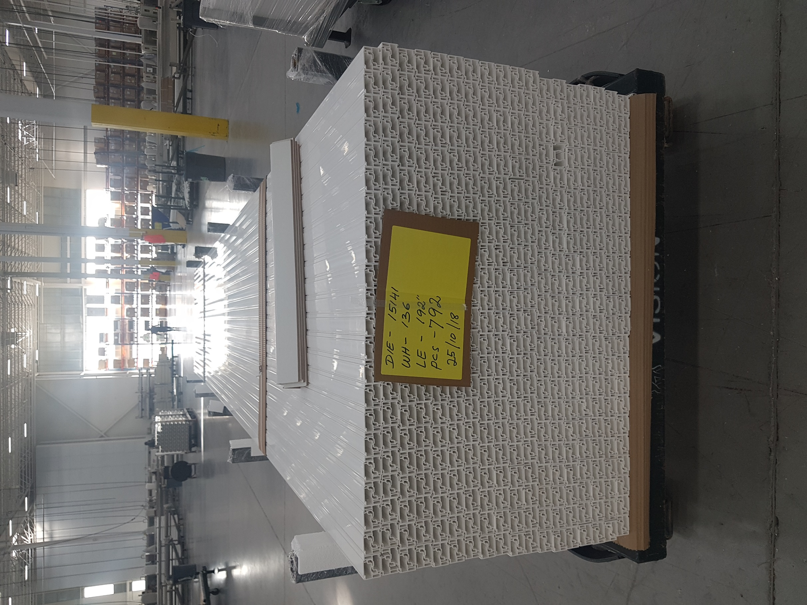
Small Foam on 1 Side

