
QUALITY ALERT

Customer: United Date: July 8, 2019
Die: 15142 Colour: Any
Type of Complaint: United REJECTED

Q.A # Q.I.R # CUSTOMER NCR #

Description: United REJECTED due to sharp corner breaking the material when router.
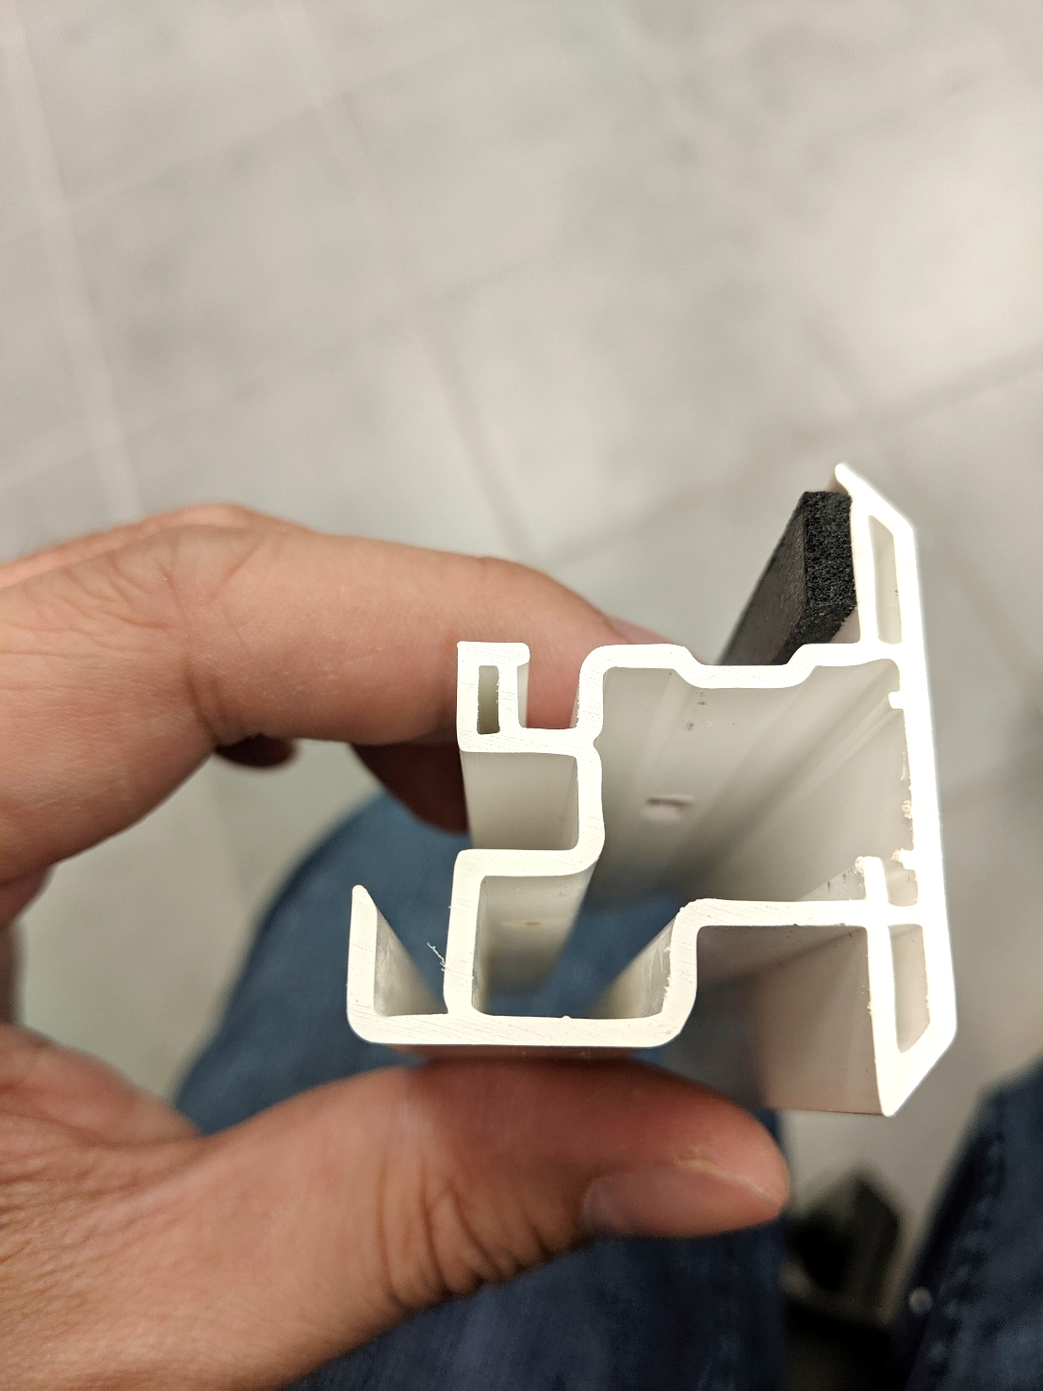
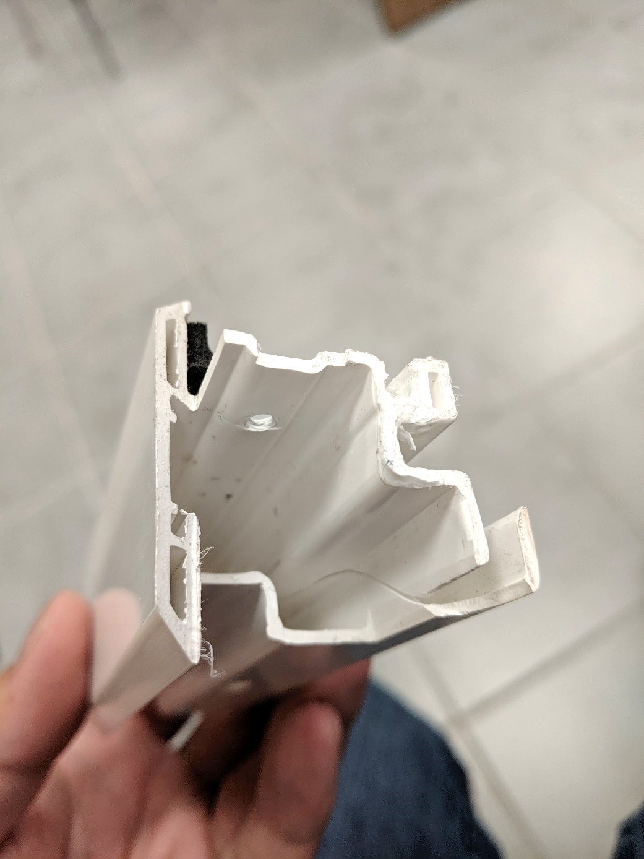
REJECTED PIECES – PLEASE WATCH & CHECK IF IT BREAKS

BY SIGNING BELOW, YOU ACKNOWLEDGE THE PROBLEM ABOVE AND AGREE TO MONITOR THIS ISSUE IN FUTURE PRODUCTION RUNS.
DAY SHIFT |  | AFTERNOON SHIFT |  | NIGHT SHIFT
NAME | SIGNATURE | NAME | SIGNATURE | NAME | SIGNATURE

