
QUALITY ALERT

Customer: United Date: February 08, 2022
Die: 15143 Colour: Any
Type of Complaint: United REJECTED
Q.A # Q.I. R # CUSTOMER NCR #

Description: United REJECTED due to Sharp corner or brittle material causing the interlock to crack
REJECTED PIECES
- CHECK WITH PLIER BY PULLING BACK INTERLOCK
- MAKE SURE TO CHECK IMPACT
- AVOID STRIPS IN THE CIRCLE AREA MAKING IT WEAK

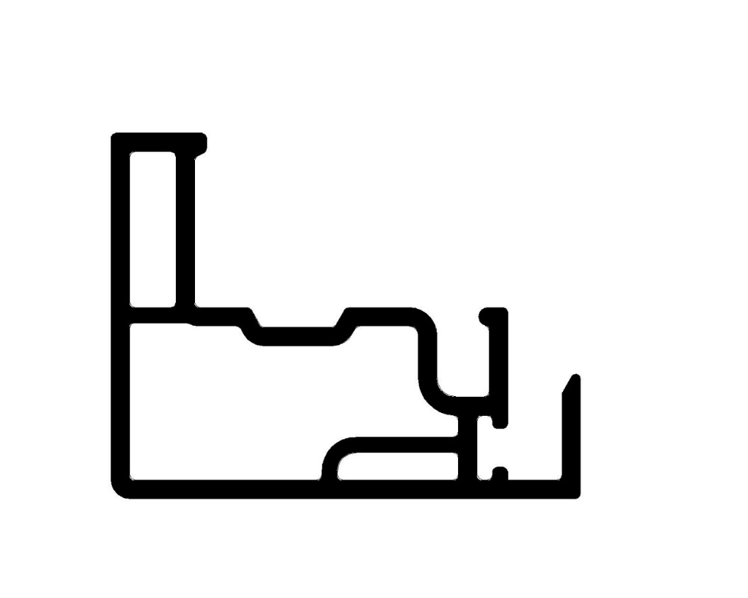
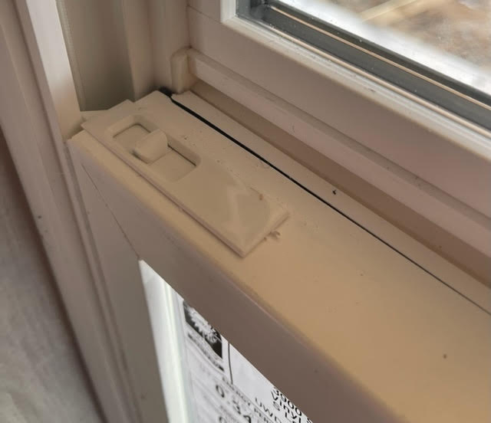

NO AIR

NO AIR

NO ANY SHARP CORNERS IN THIS AREA

NO AIR

BY SIGNING BELOW, YOU ACKNOWLEDGE THE PROBLEM ABOVE AND AGREE TO MONITOR THIS ISSUE IN FUTURE PRODUCTION RUNS.
DAY SHIFT |  | AFTERNOON SHIFT |  | NIGHT SHIFT
NAME | SIGNATURE | NAME | SIGNATURE | NAME | SIGNATURE

