
QUALITY ALERT

Customer: Panes Date: March 9, 2023
Die: 15153 Colour: Any colour
Type of Complaint: Customer REJECTED

Q.A # Q.I.R # CUSTOMER NCR #

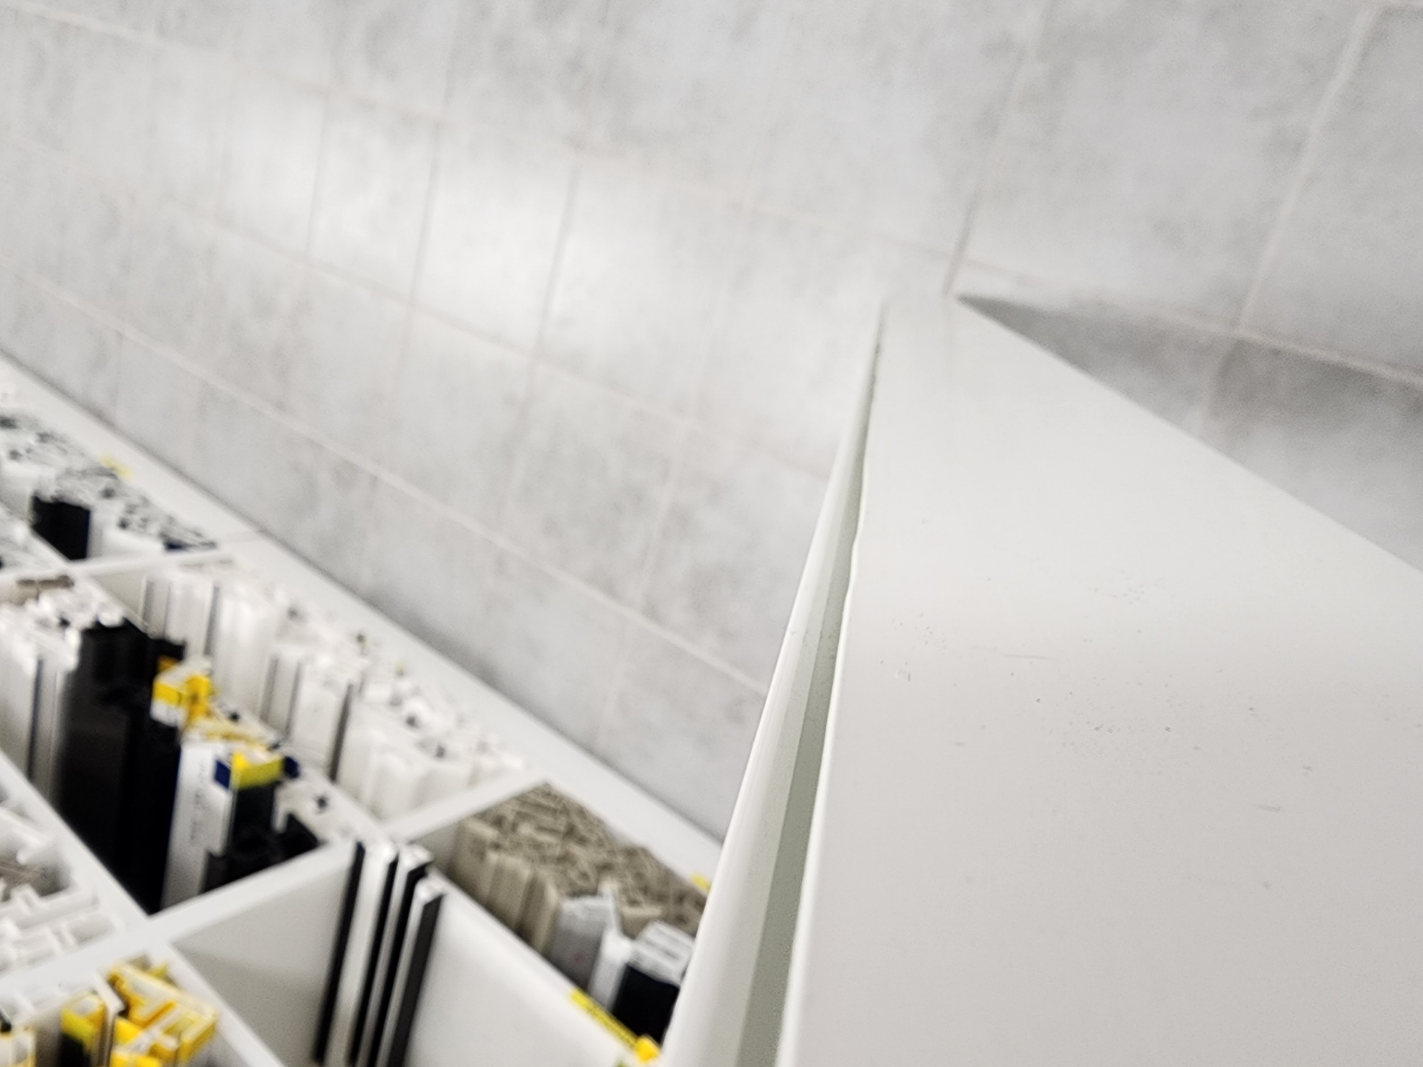
Description: Panes REJECTED due to the material is moving at both side.
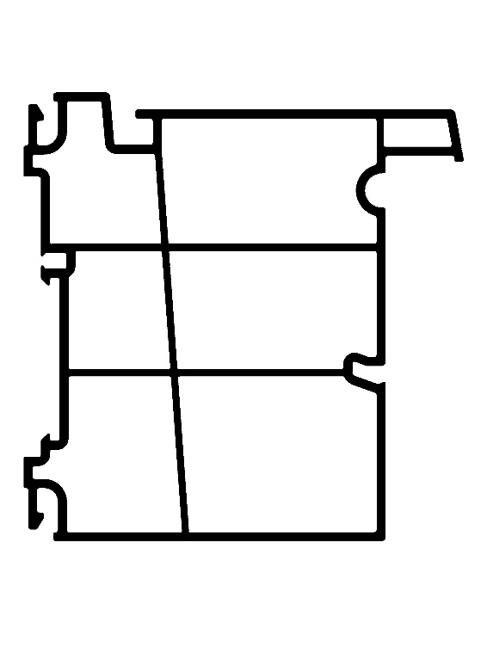

PLEASE CHECK CAREFULLY AVOID THIS ISSUE

BY SIGNING BELOW, YOU ACKNOWLEDGE THE PROBLEM ABOVE AND AGREE TO MONITOR THIS ISSUE IN FUTURE PRODUCTION RUNS.
DAY SHIFT |  | AFTERNOON SHIFT |  | NIGHT SHIFT
NAME | SIGNATURE | NAME | SIGNATURE | NAME | SIGNATURE

