DIE# 15156– Panes (EXTRUDER SIDE)
Pack on Green Buggy – Wrap arms in cardboard
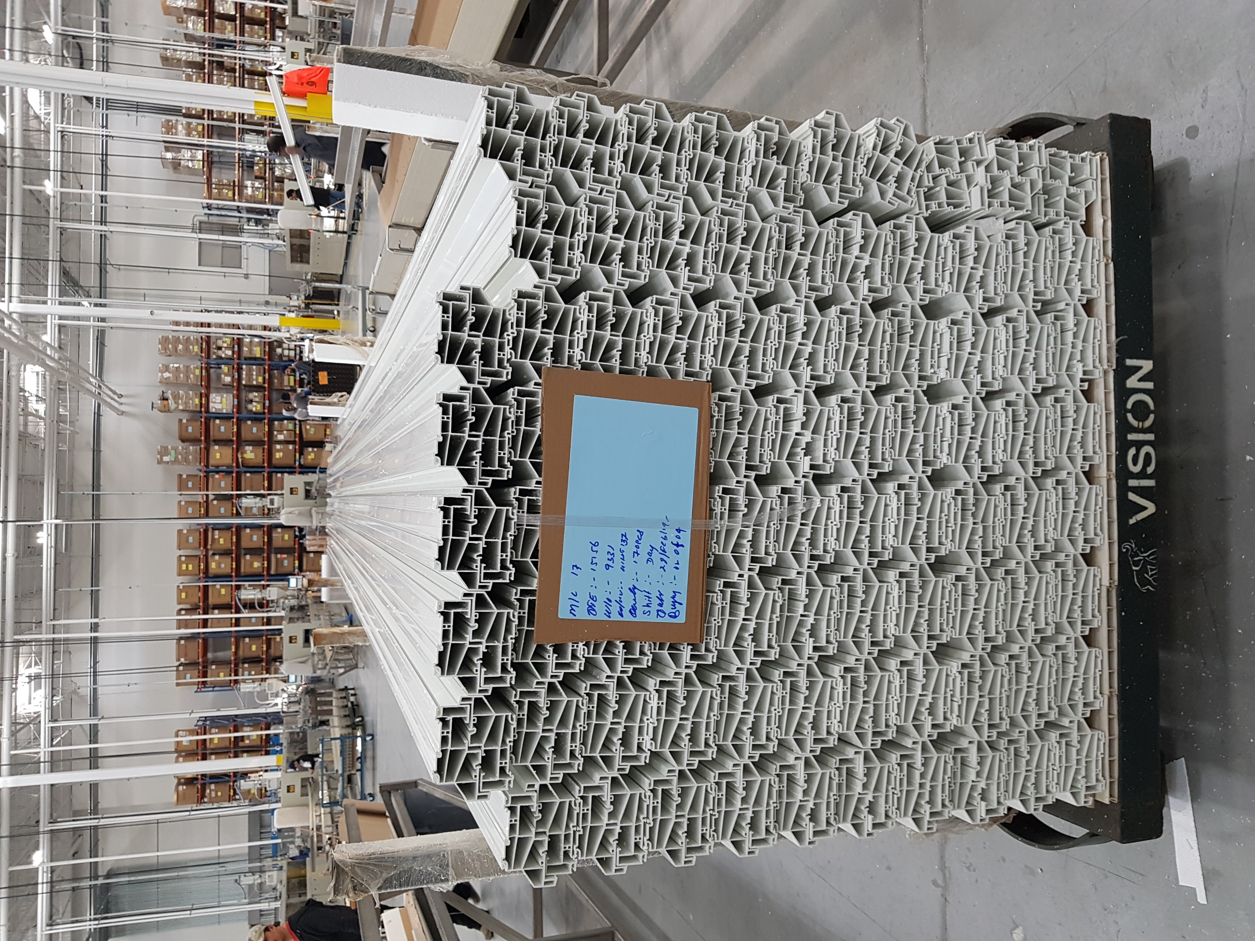
Small Foam on 1 side

