
QUALITY ALERT

Customer: Panes Date: May 9, 2022
Die: 15157 Colour: Any colour
Type of Complaint: Customer REJECTED

Q.A # Q.I.R # CUSTOMER NCR #

Description: Panes REJECTED due to the material has the flex is HIGH that can NOT come throught the punch.
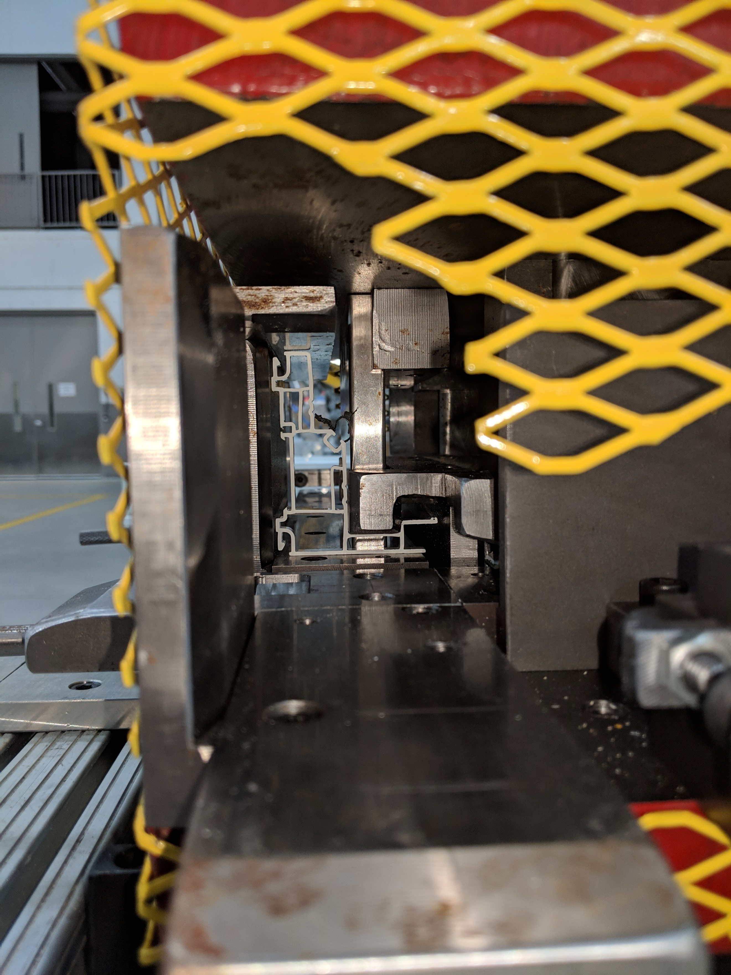
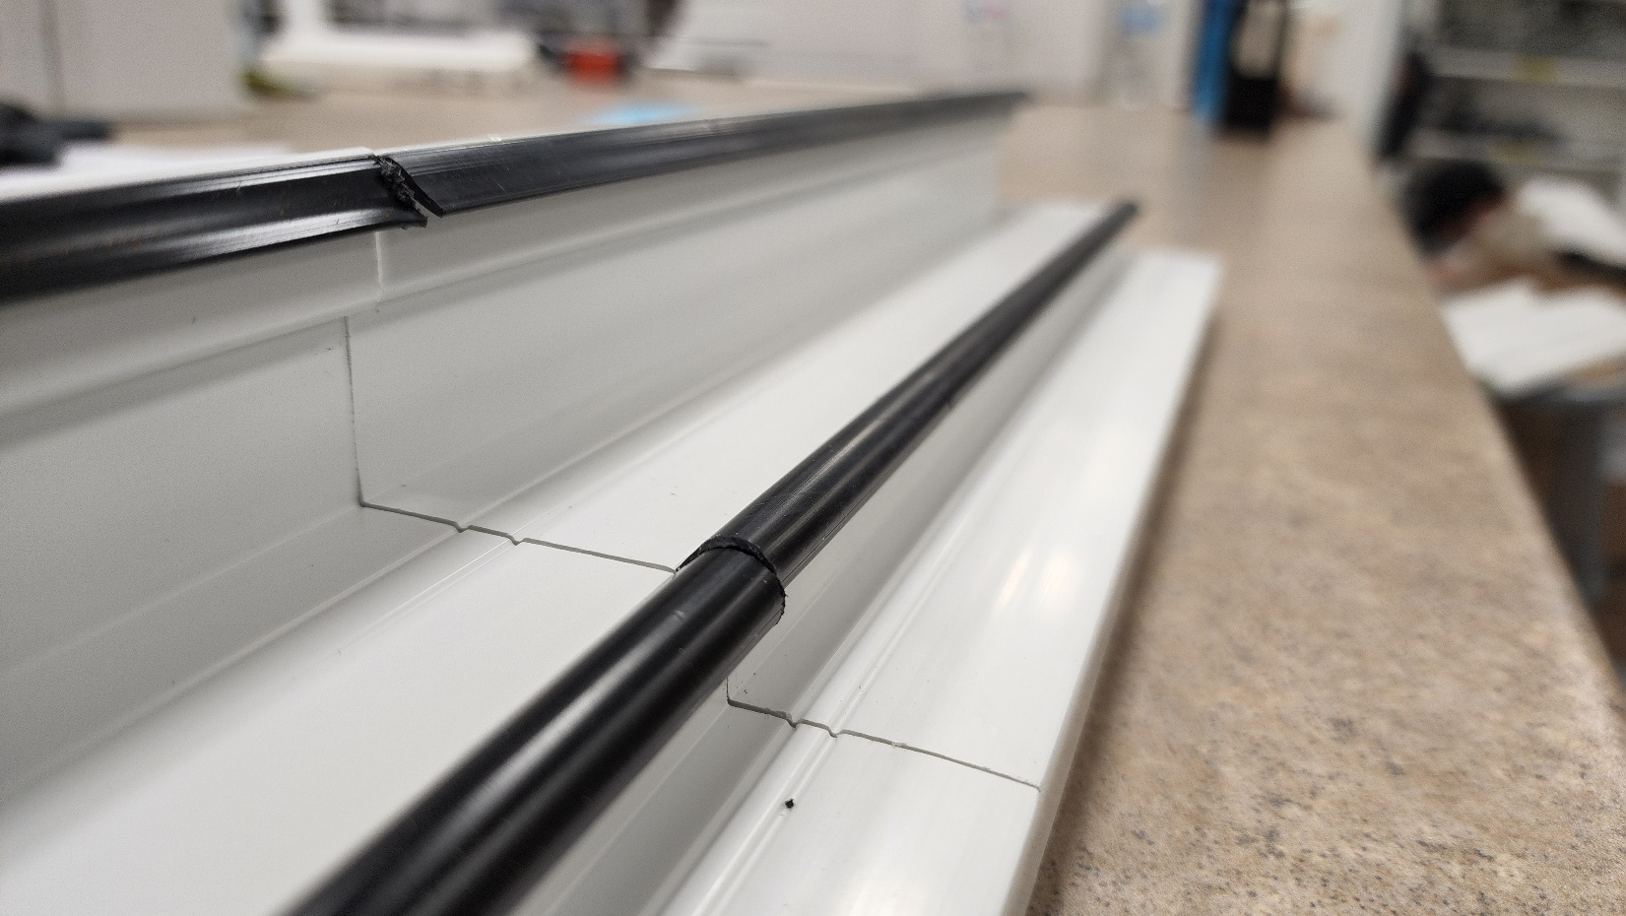

PLEASE CHECK CAREFULLY WITH MASTER SAMPLE

BY SIGNING BELOW, YOU ACKNOWLEDGE THE PROBLEM ABOVE AND AGREE TO MONITOR THIS ISSUE IN FUTURE PRODUCTION RUNS.
DAY SHIFT |  | AFTERNOON SHIFT |  | NIGHT SHIFT
NAME | SIGNATURE | NAME | SIGNATURE | NAME | SIGNATURE

