DIE# 15157– Panes (EXTRUDER SIDE)
Pack on Green Buggy – Wrap arms in cardboard
No Foam
MATERIAL ORIENTATION REQUIREMENT:
- Must double check side of the buggy has the UNLOCKED wheels (should be the ones at SAW SIDE).
- As shown in the image, material must be packed front to back — with the front defined as the side with LOCKED wheels, and the back as the side with UNLOCKED wheels.
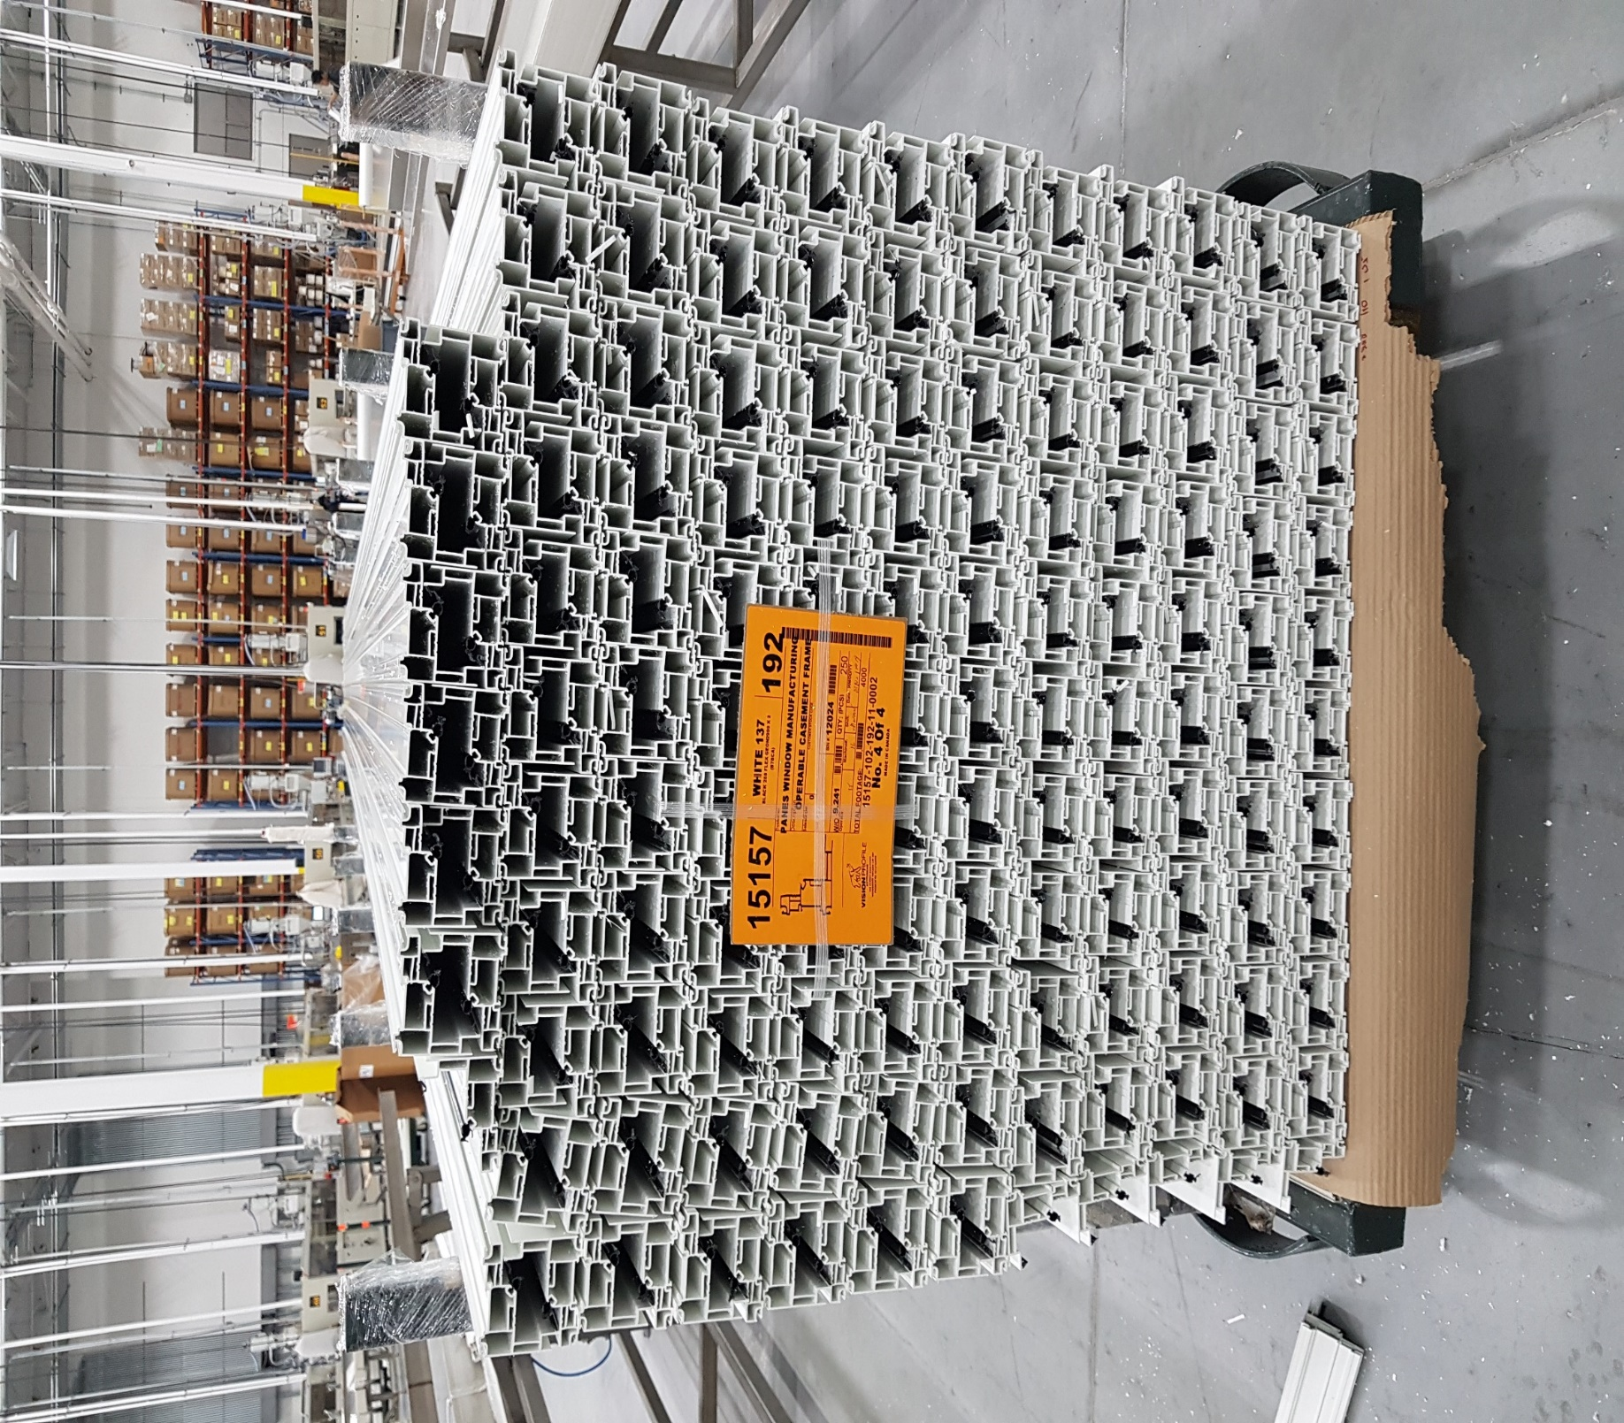
UNLOCKED WHEELS
UNLOCKED WHEELS

