
QUALITY ALERT

Customer: AMERILUX Date: Oct 24, 2024
Die: 15191 Colour: All
Type of Complaint: Customer REJECTED

Q.A # Q.I.R # CUSTOMER NCR #

Description: Customer REJECTED material due to bending

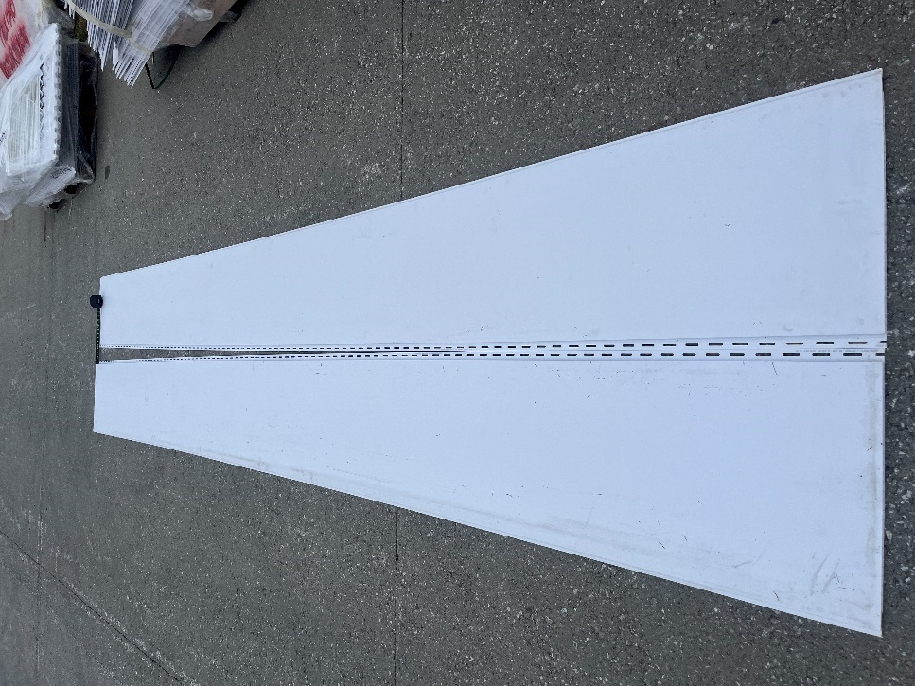
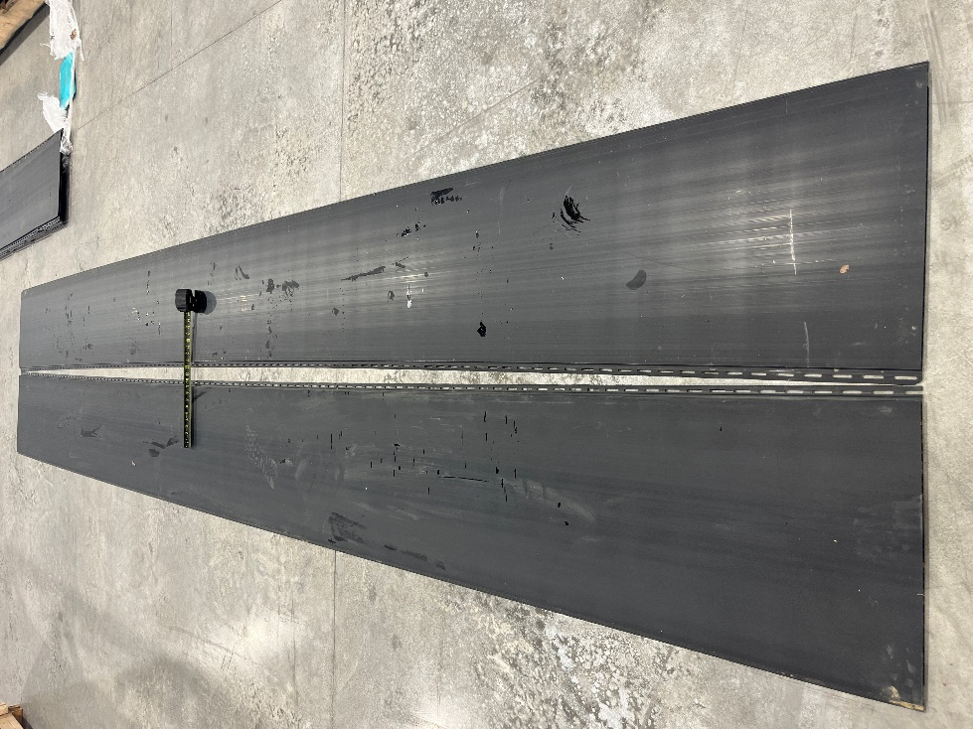

PLEASE MAKE SURE PANELS ARE NOT BENDING

BY SIGNING BELOW, YOU ACKNOWLEDGE THE PROBLEM ABOVE AND AGREE TO MONITOR THIS ISSUE IN FUTURE PRODUCTION RUNS.
DAY SHIFT |  | AFTERNOON SHIFT |  | NIGHT SHIFT
NAME | SIGNATURE | NAME | SIGNATURE | NAME | SIGNATURE

