
QUALITY ALERT

Customer: EZ PVC - Amerilux Date: October 18, 2023
Die: 15191 / 15192 Colour: ALL
Type of Complaint: EZ PVC - AmeriLux REJECETED

Q.A # Q.I.R # CUSTOMER NCR #

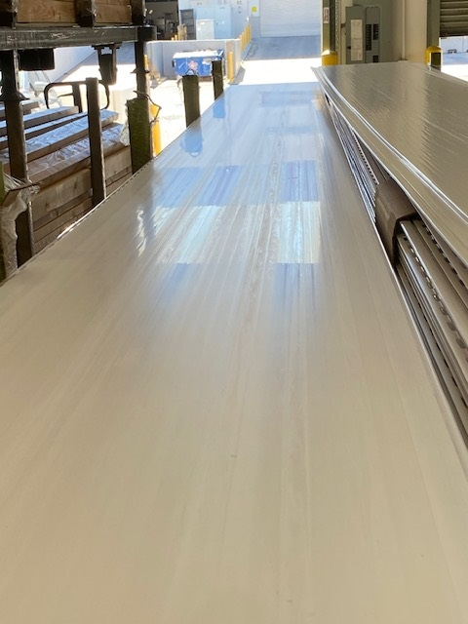
Description: Customer REJECTED panels have the marks on top visible surface
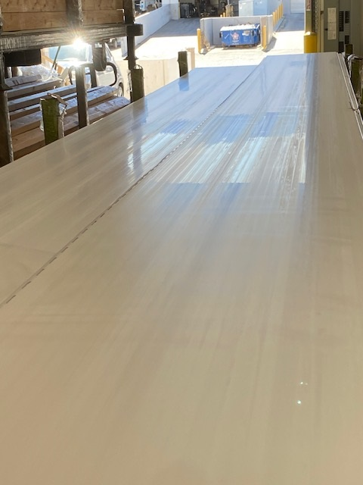

THE ABOVE MARKS ARE NOT ACCEPTABLE
BY SIGNING BELOW, YOU ACKNOWLEDGE THE PROBLEM ABOVE AND AGREE TO MONITOR THIS ISSUE IN FUTURE PRODUCTION RUNS.
DAY SHIFT |  | AFTERNOON SHIFT |  | NIGHT SHIFT
NAME | SIGNATURE | NAME | SIGNATURE | NAME | SIGNATURE

