
QUALITY ALERT

Customer: Amerilux Date: Nov 4, 2025
Die: 15191-15192 Colour: Any
Type of Complaint: QUALITY REQUIREMENT

Q.A # 25-062 NCR: N/A RMA#: N/A

Description: This test is required to verify engagement dimensions and ensure panels lock properly within specified tolerances.
FOR BEST RESULT, PLEASE USE PANELS 3-4FT (48”) IN LENGTH TO PERFORM THE ENGAGEMENT TEST
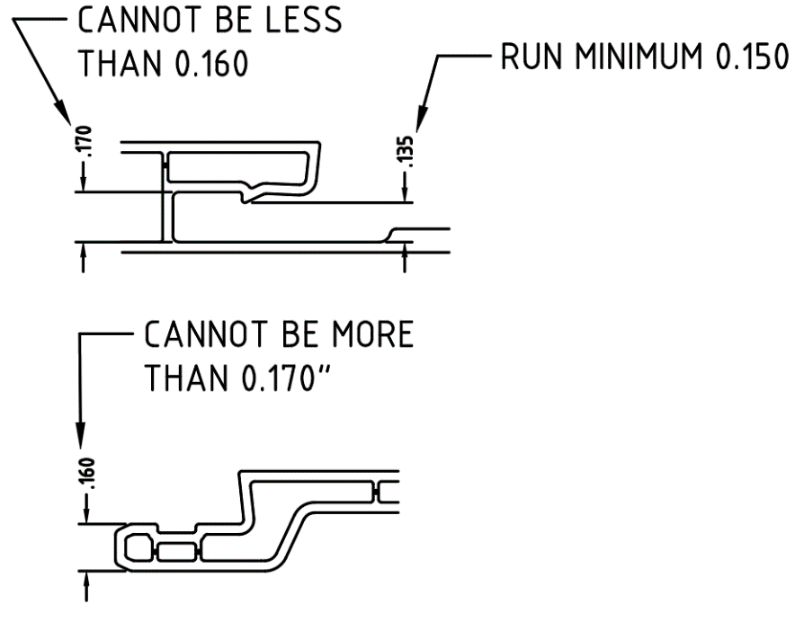

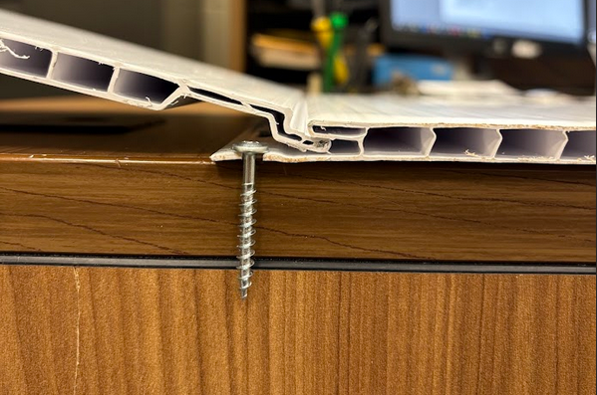
STEP 1: Hold one panel at a 30° angle, aligning the male edge with the female groove of the other panel.



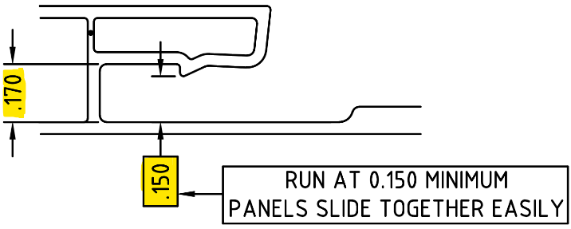
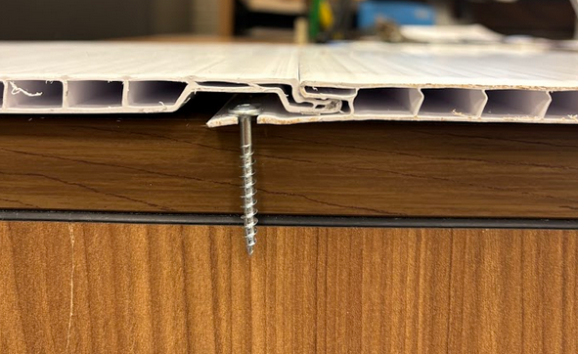
STEP 2: Push firmly to engage both panels until they are fully locked together.

CHECK ENGAGEMENT FIT WITH 3–4FT PANEL TEST. DIMENSIONS MUST MEET SPECIFIED TOLERANCE RANGE BEFORE PACKING

BY SIGNING BELOW, YOU ACKNOWLEDGE THE PROBLEM ABOVE AND AGREE TO MONITOR THIS ISSUE IN FUTURE PRODUCTION RUNS.
DAY SHIFT |  | AFTERNOON SHIFT |  | NIGHT SHIFT
NAME | SIGNATURE | NAME | SIGNATURE | NAME | SIGNATURE
F-006: Quality Alert | Eff.Date: 05/03/2025 | CC# 25-046 | Rev.0

