
QUALITY ALERT

Customer: Amerilux Date: Dec 01, 2025
Die: 15191-15192 Colour: Any
Type of Complaint: Customer REJECTED

Q.A # 25-076 NCR: 522 RMA#: N/A

Description: Customer REJECTED due to inner wall not forming correctly (under-formed) during extrusion. This might cause cracking during assembling/laminating process.

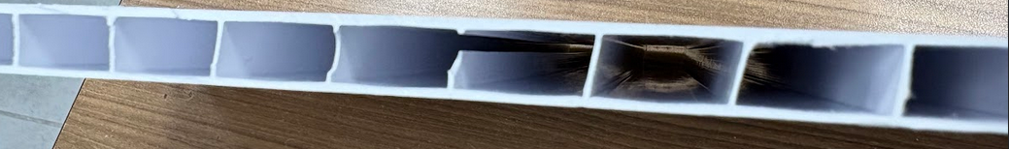

ENSURE THE INTERNAL WALL FORMS FULLY AND MAINTAINS SHAPE BEFORE PACKING

BY SIGNING BELOW, YOU ACKNOWLEDGE THE PROBLEM ABOVE AND AGREE TO MONITOR THIS ISSUE IN FUTURE PRODUCTION RUNS.
DAY SHIFT |  | AFTERNOON SHIFT |  | NIGHT SHIFT
NAME | SIGNATURE | NAME | SIGNATURE | NAME | SIGNATURE

