
QUALITY ALERT
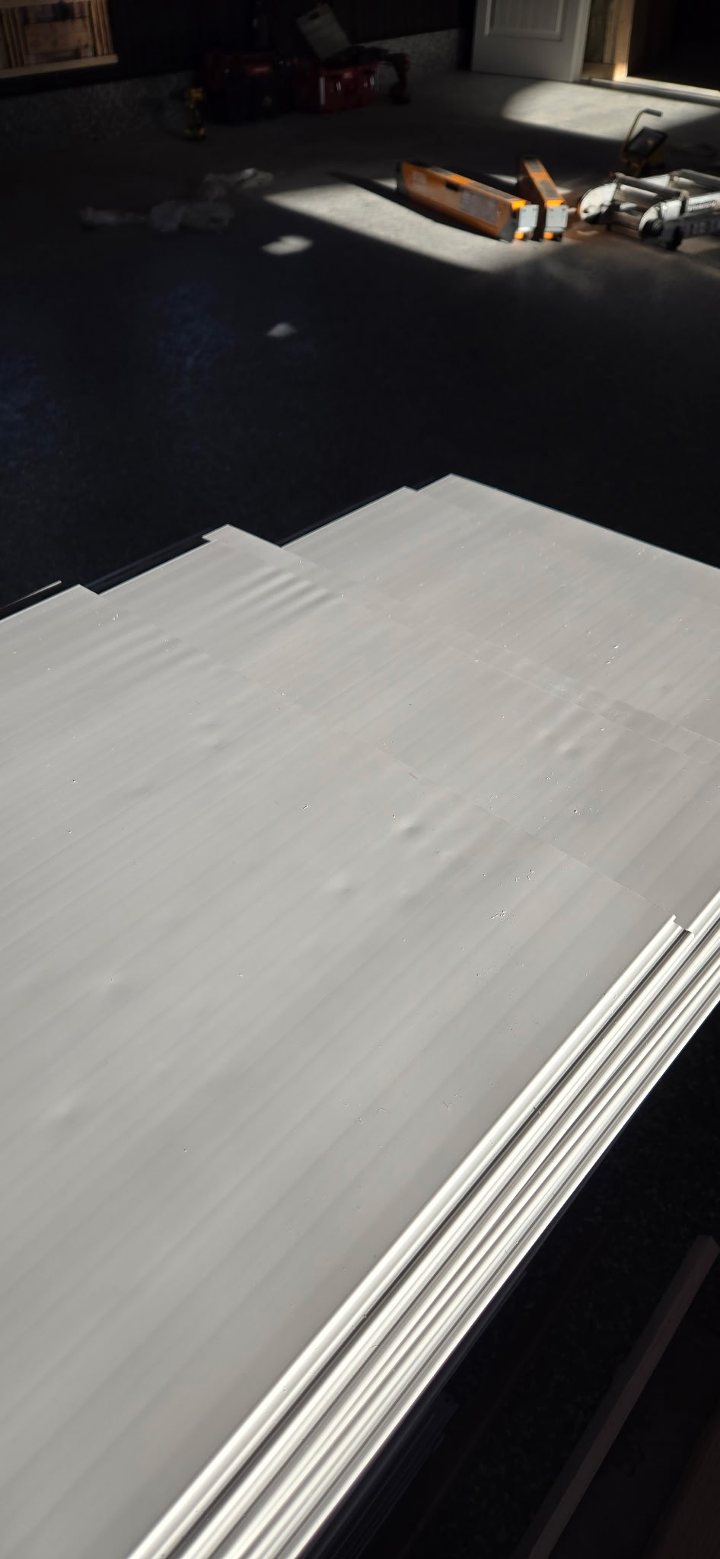
Customer: H-PAC/Amerilux Date: Jan 5, 2025
Die: 15191 Colour: Any
Type of Complaint: Customer REJECTED

Q.A # 25-082 NCR: 552 RMA#: N/A

Description: Customer REJECTED due to visible surface damage on panels consistent with contact or abrasion occurring during packaging. Panels show dents/marks on the surface, affecting appearance and acceptability.

PACKAGING PRACTICES MUST PREVENT PANEL SURFACE DAMAGE. PANELS SHALL BE PACKAGED IN A MANNER THAT MAINTAINS SURFACE CONDITION AND PREVENTS MARKS OR DENTS DURING HANDLING AND TRANSPORT.

BY SIGNING BELOW, YOU ACKNOWLEDGE THE PROBLEM ABOVE AND AGREE TO MONITOR THIS ISSUE IN FUTURE PRODUCTION RUNS.
DAY SHIFT |  | AFTERNOON SHIFT |  | NIGHT SHIFT
NAME | SIGNATURE | NAME | SIGNATURE | NAME | SIGNATURE

