
QUALITY ALERT

Customer: Amerilux Date: Jan 30, 2026
Die: 15191-15192 Colour: Any
Type of Complaint: QUALITY REQUIREMENT

Q.A # 25-062, 26-007, 26-009 NCR: 027 RMA#: N/A

Description: Snap engagement issue observed during panel assembly process. Panels do not lock easily, resulting in incomplete engagement and visible gap.
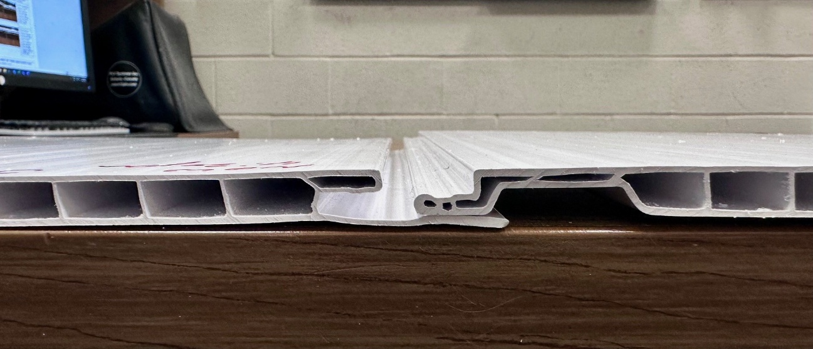

SNAP MUST ENGAGE SMOOTHY AND SIT FLUSH - NO EXCESSIVE FORCE

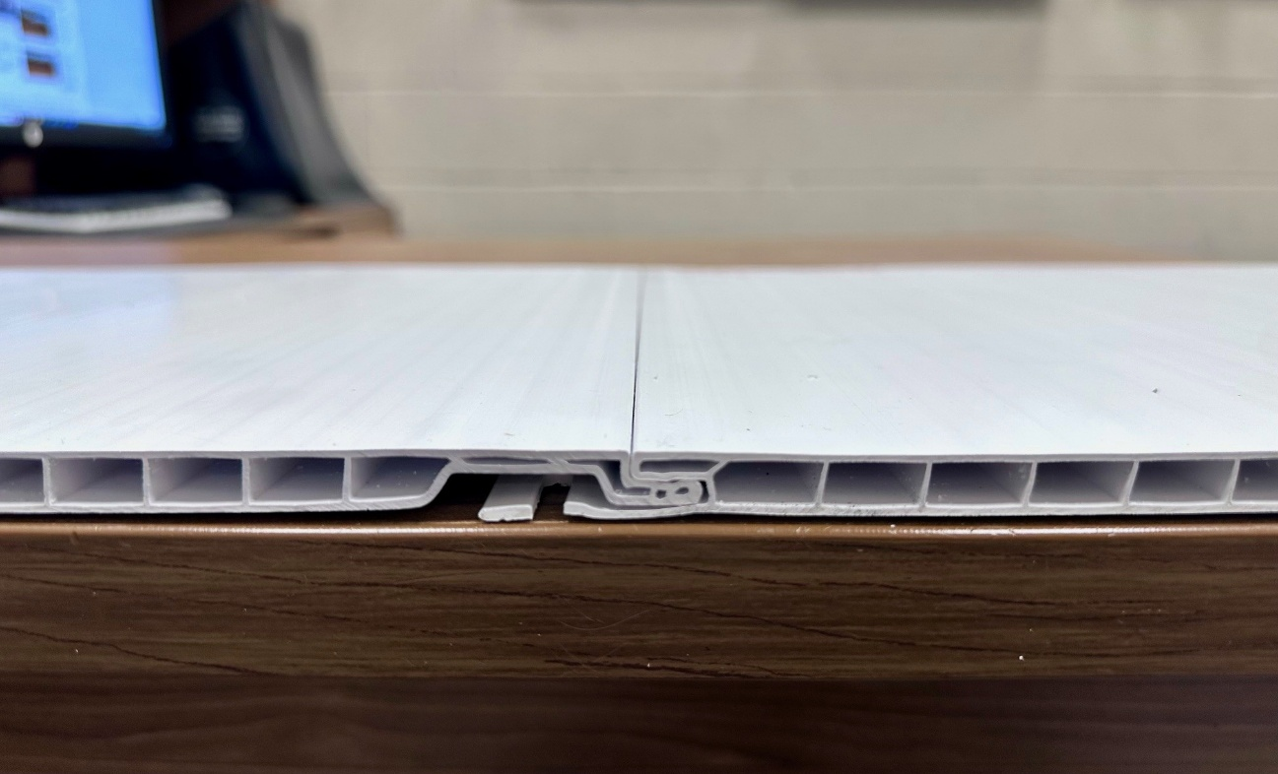

VERIFY SNAP ENGAGEMENT DURING ASSEMBLY; PANELS MUST LOCK EASILY, BE FULLY ENGAGED AND FREE OF VISIBLE GAP.

BY SIGNING BELOW, YOU ACKNOWLEDGE THE PROBLEM ABOVE AND AGREE TO MONITOR THIS ISSUE IN FUTURE PRODUCTION RUNS.
DAY SHIFT |  | AFTERNOON SHIFT |  | NIGHT SHIFT
NAME | SIGNATURE | NAME | SIGNATURE | NAME | SIGNATURE
F-006: Quality Alert | Eff.Date: 05/03/2025 | CC# 25-046 | Rev.0

