
QUALITY ALERT

Customer: AmeriLux Date: Feb 06, 2026
Die: 15191, 15192 Colour: All
Type of Complaint: Customer REJECTED

Q.A # 26-013 NCR: 075 RMA#: 473

Description: Customer reported significant debris contamination on and between panels, creating multiple dimples/dents throughout the panel surface. REPEATING ISSUE

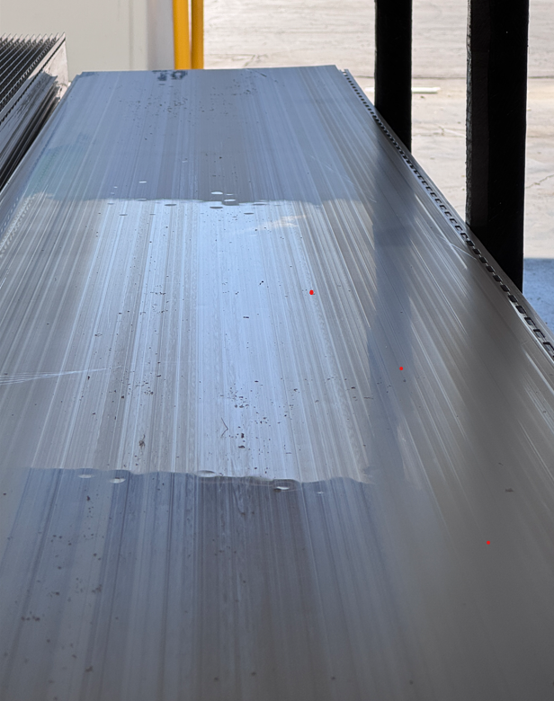
Panels must be cleaned!


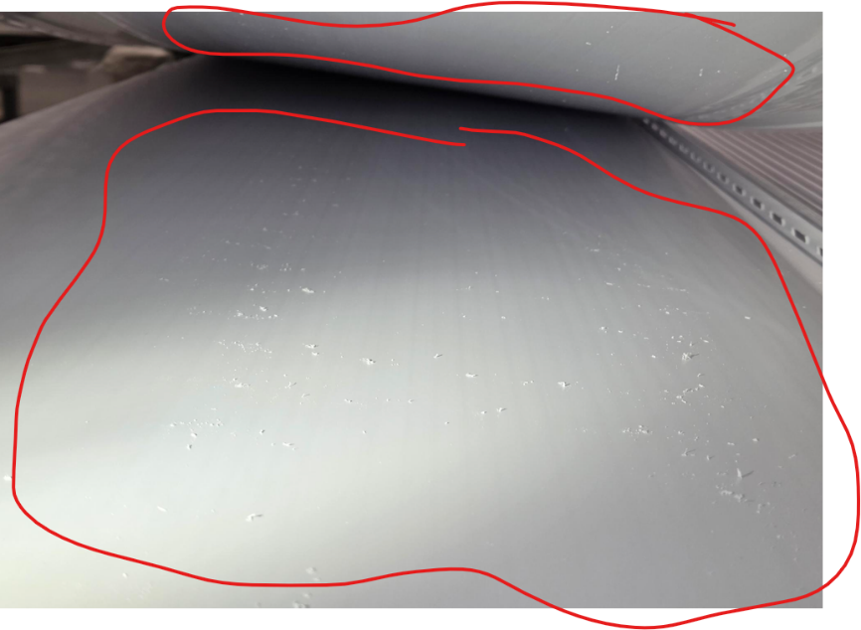

Saw dust and residues cause dimps

Make sure the panels are clean and free of debris and/or sawdust.

BY SIGNING BELOW, YOU ACKNOWLEDGE THE PROBLEM ABOVE AND AGREE TO MONITOR THIS ISSUE IN FUTURE PRODUCTION RUNS.
DAY SHIFT |  | AFTERNOON SHIFT |  | NIGHT SHIFT
NAME | SIGNATURE | NAME | SIGNATURE | NAME | SIGNATURE
F-006: Quality Alert | Eff.Date: 05/03/2025 | CC# 25-046 | Rev.0

