
QUALITY ALERT

Customer: Soft-Lite Date: March 5, 2019
Die: 15238 / 15191 / 15192 Colour: ALL
Type of Complaint: HPAC REJECTED

Q.A # Q.I.R # CUSTOMER NCR #

Description: HPAC Rejected due saw cut not straight making it not flush on the trim/floor
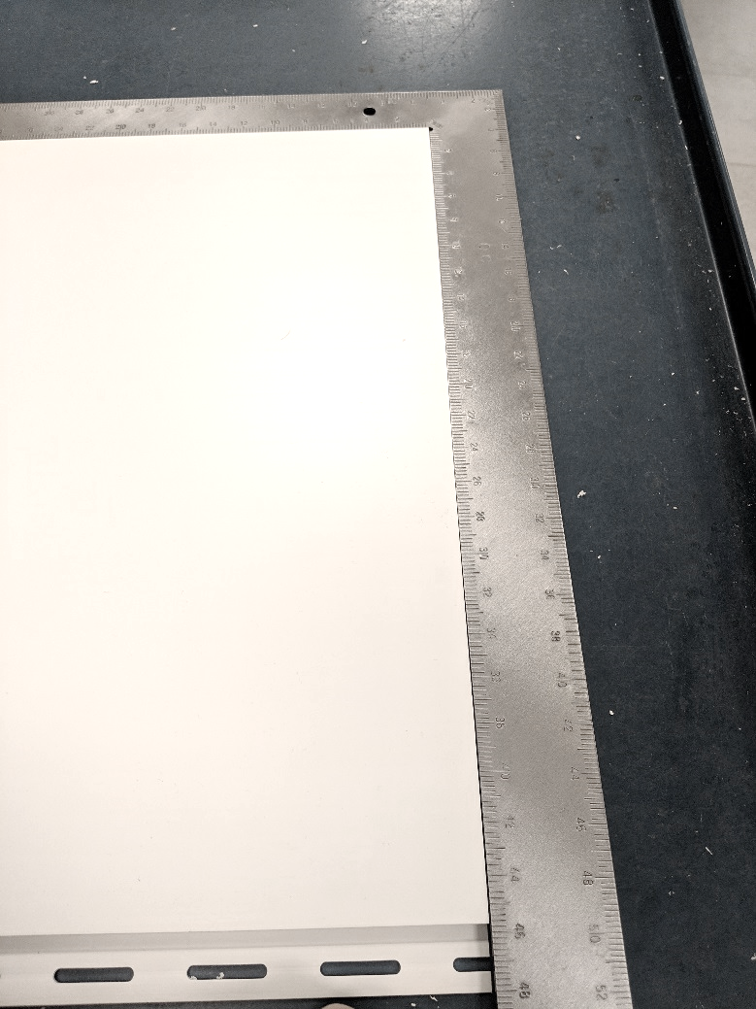

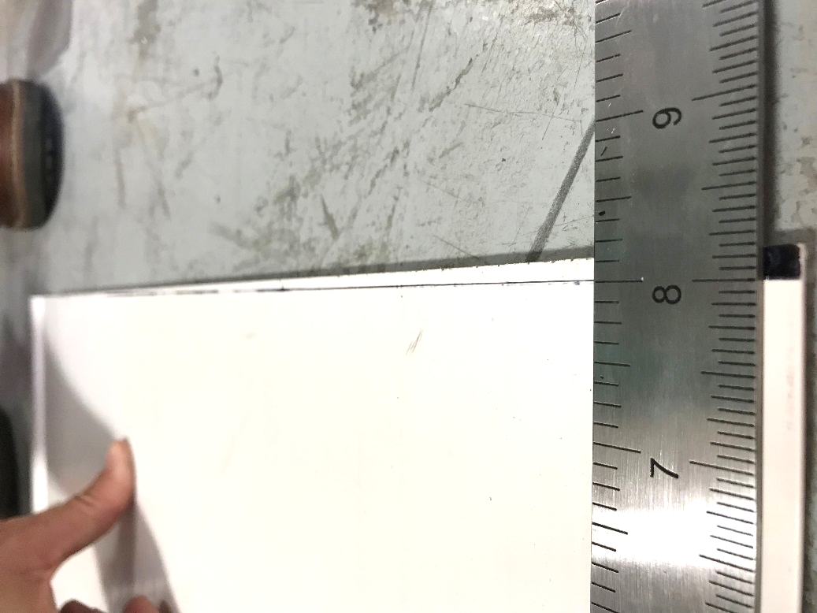

MAKE SURE
REJECT
SAMPLE
GAP NOT
TOO WIDE

GOOD

BY SIGNING BELOW, YOU ACKNOWLEDGE THE PROBLEM ABOVE AND AGREE TO MONITOR THIS ISSUE IN FUTURE PRODUCTION RUNS.
DAY SHIFT |  | AFTERNOON SHIFT |  | NIGHT SHIFT
NAME | SIGNATURE | NAME | SIGNATURE | NAME | SIGNATURE

