DIE# 15191 Lime – HPAC (EXTRUDER SIDE)
LIME Buggy (240’ ONLY)
Wrap arms with cardboard
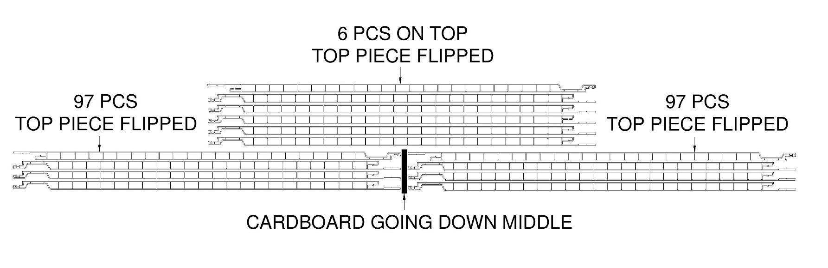
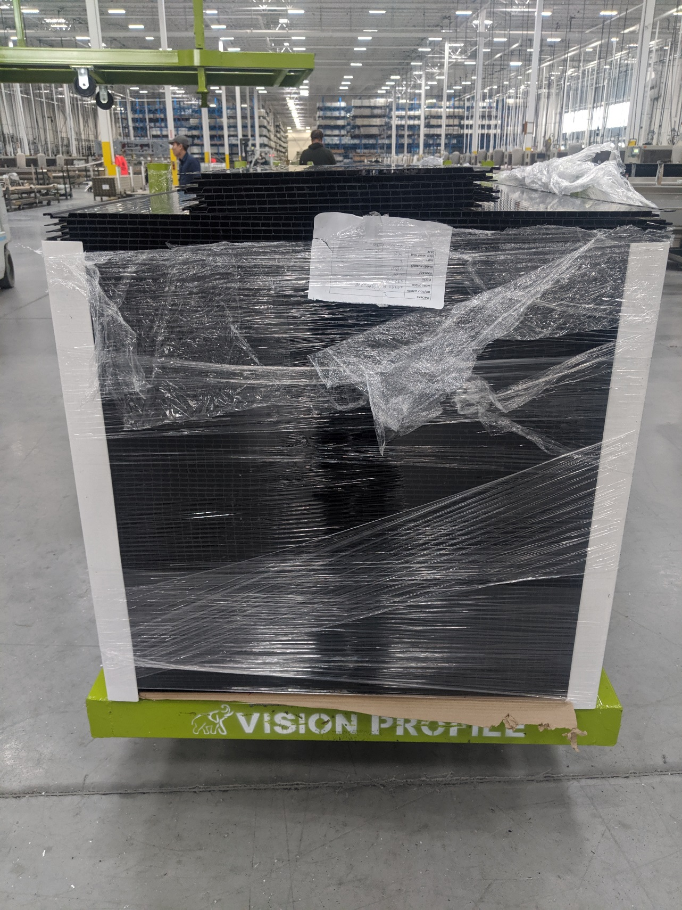
USE FOAM AS NEEDED

