DIE# 15199 – H-PAC (EXTRUDER SIDE)
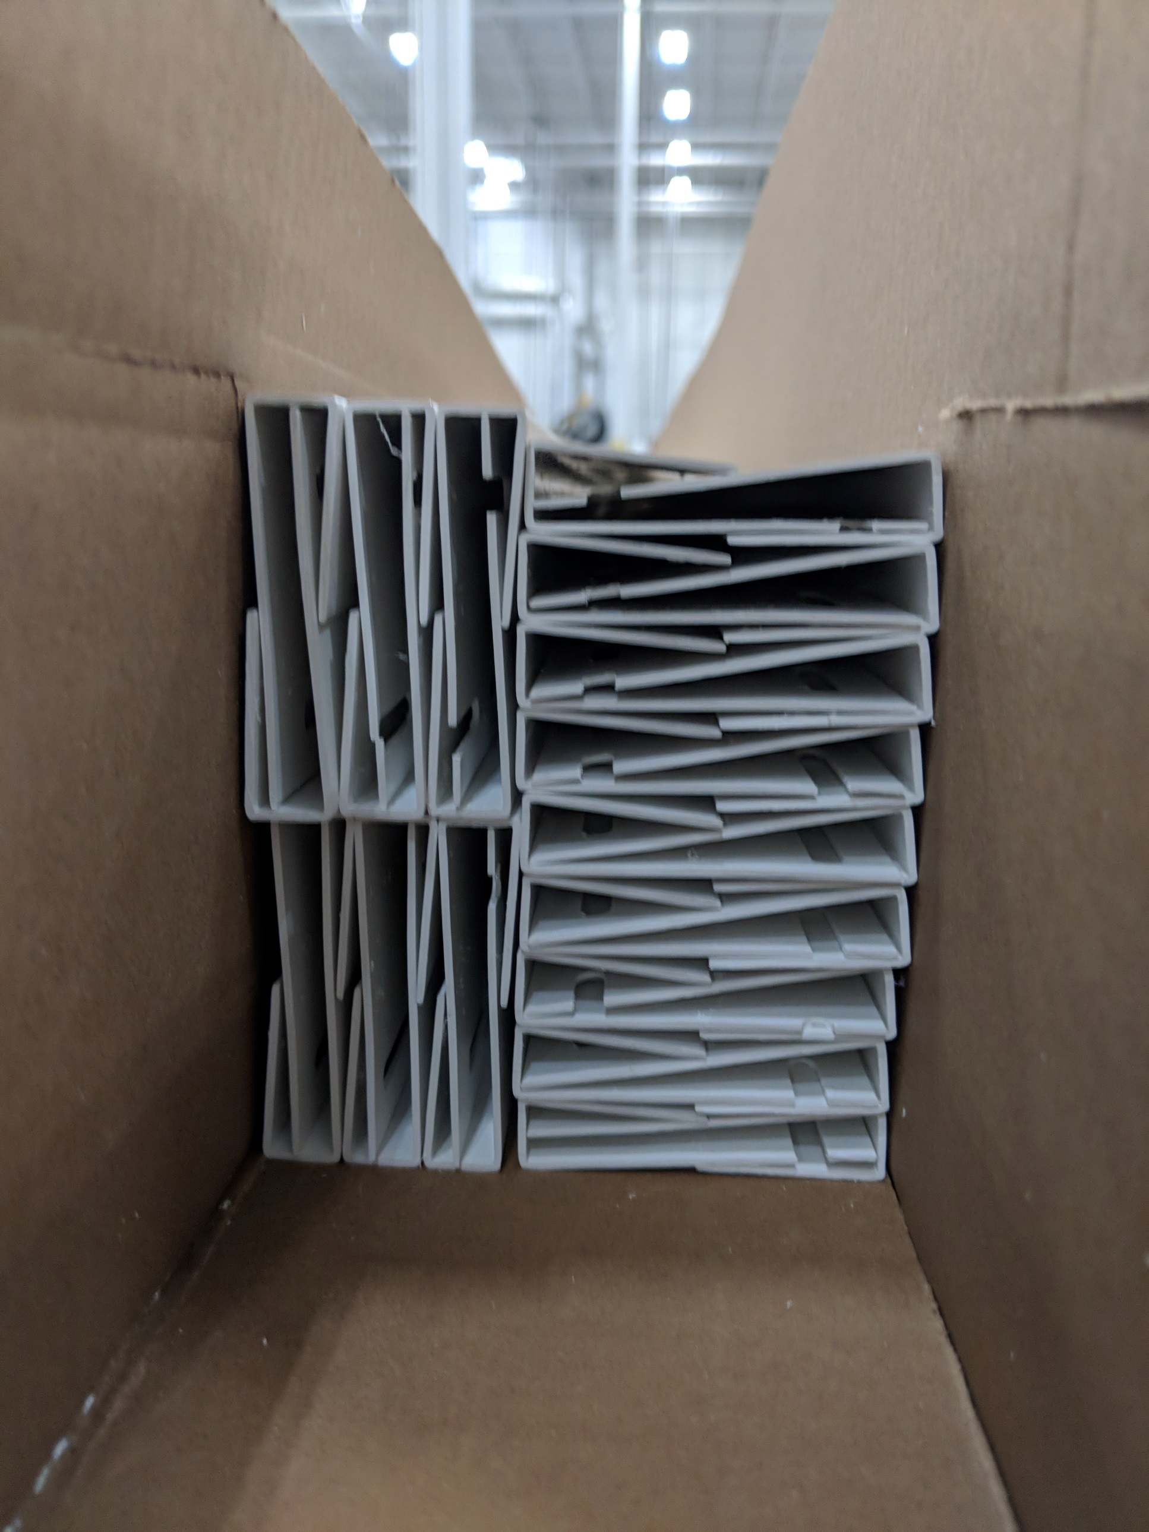
30 pcs – Small Box

