DIE# 15200 – H-PAC (EXTRUDER SIDE)
20 pcs – Medium Box
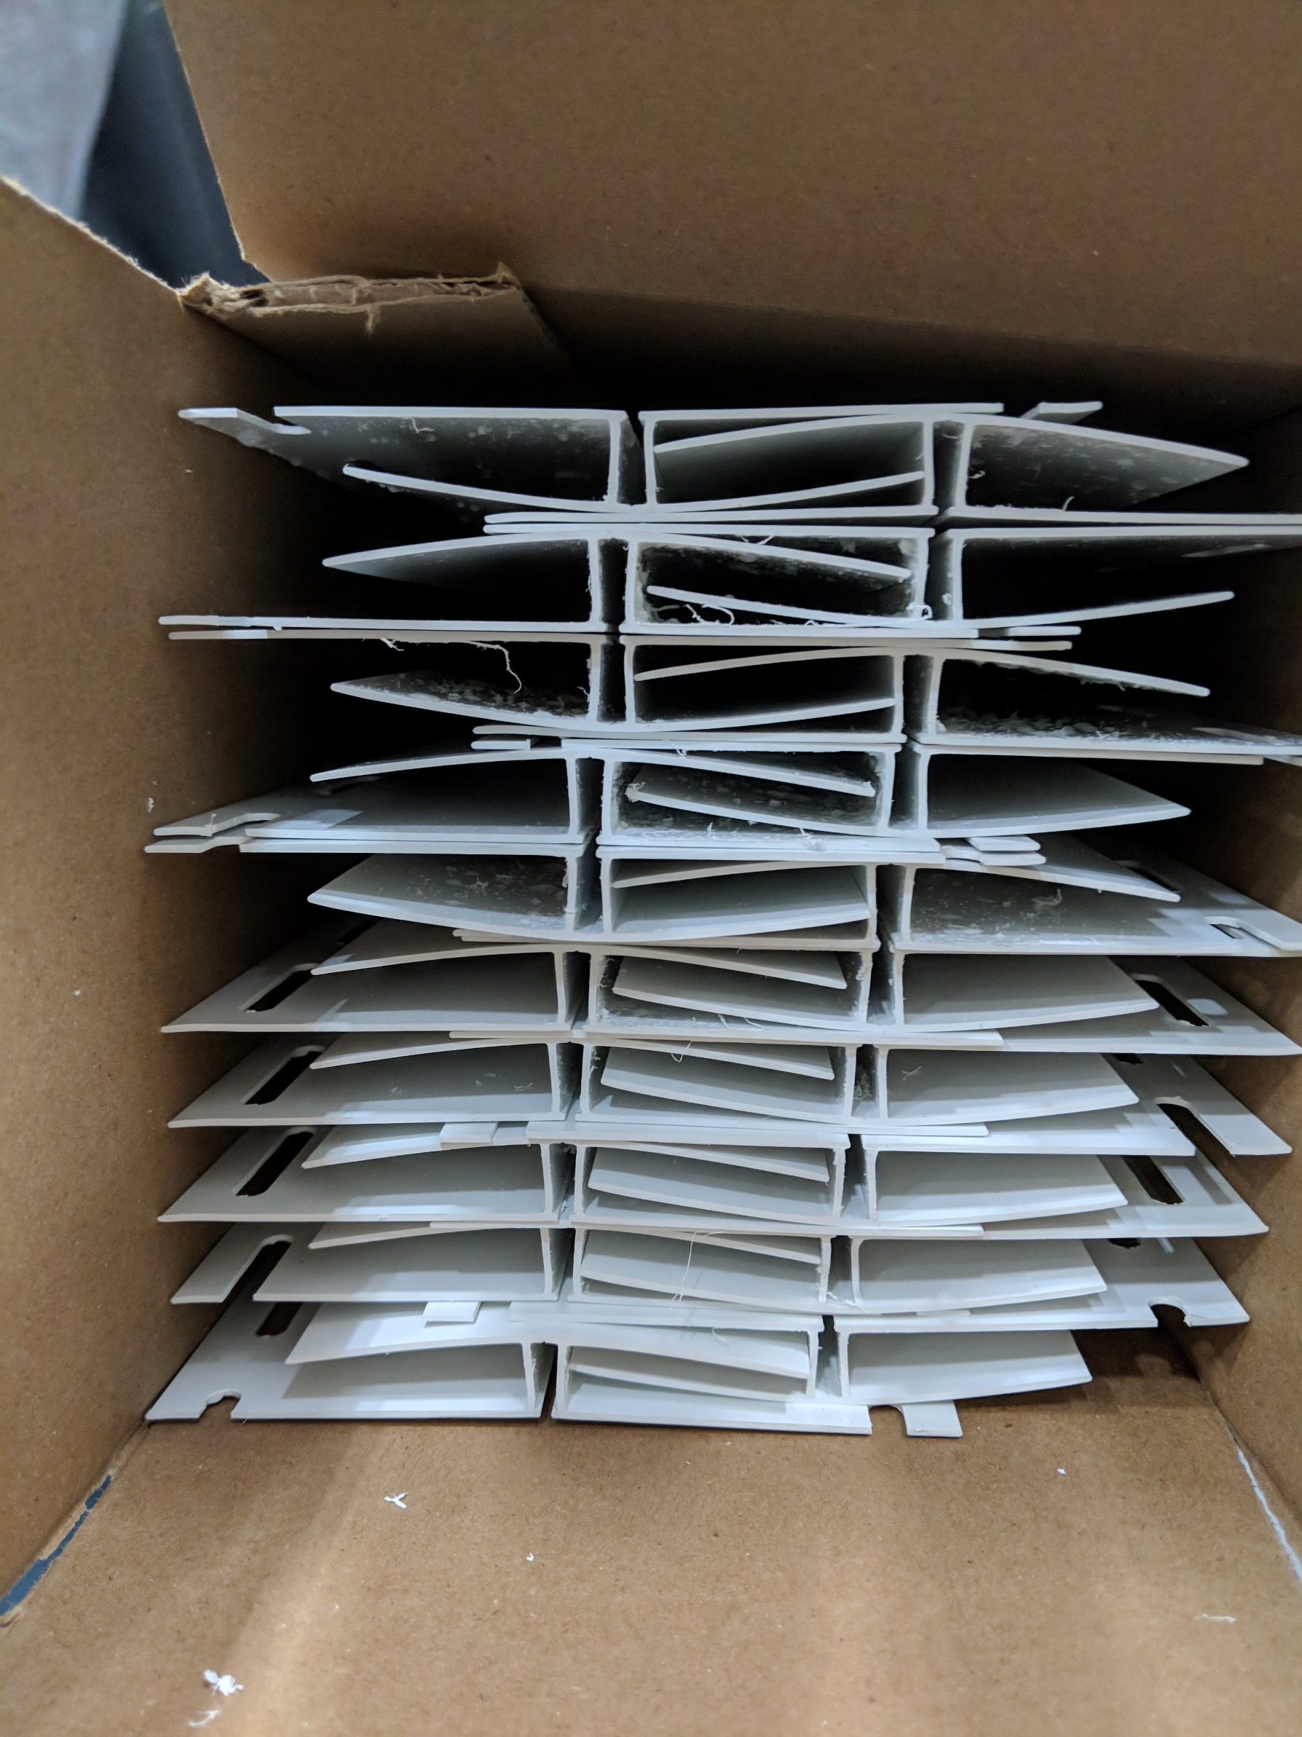
1 piece flip over to slide into another

