
QUALITY ALERT

Customer: Amerilux Date: July 17, 2025
Die: 15202 Colour: Any
Type of Complaint: Customer REJECTED

Q.A # 25-022 NCR: 184 RMA#: 438

Description: Customer REJECTED due to excessive bending and warping. This deformation compromises fit, assembly alignment, and overall product quality..
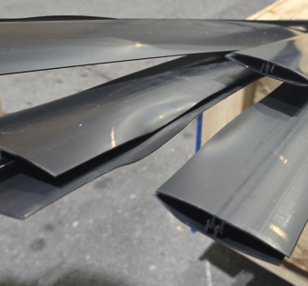
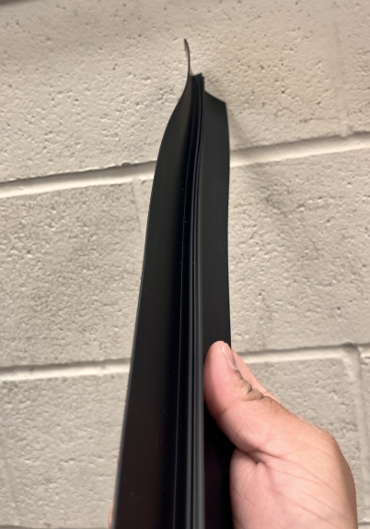

ENSURE PROFILES ARE STRAIGHT AND FREE FROM WARPING BEFORE PACKAGING OR SHIPPING. IMPLEMENT PROPER HANDLING AND STORAGE TO PREVENT BENDING.

Ask ChatGPT

Ask ChatGPT

Ask ChatGPT

BY SIGNING BELOW, YOU ACKNOWLEDGE THE PROBLEM ABOVE AND AGREE TO MONITOR THIS ISSUE IN FUTURE PRODUCTION RUNS.
DAY SHIFT |  | AFTERNOON SHIFT |  | NIGHT SHIFT
NAME | SIGNATURE | NAME | SIGNATURE | NAME | SIGNATURE
F-006: Quality Alert | Eff.Date: 05/03/2025 | CC# 25-046 | Rev.0

