DIE# 15223 – Morrison (EXTRUDER SIDE)
Pack on Orange Buggy – Wrap arms in cardboard
Small Foam on 1 side
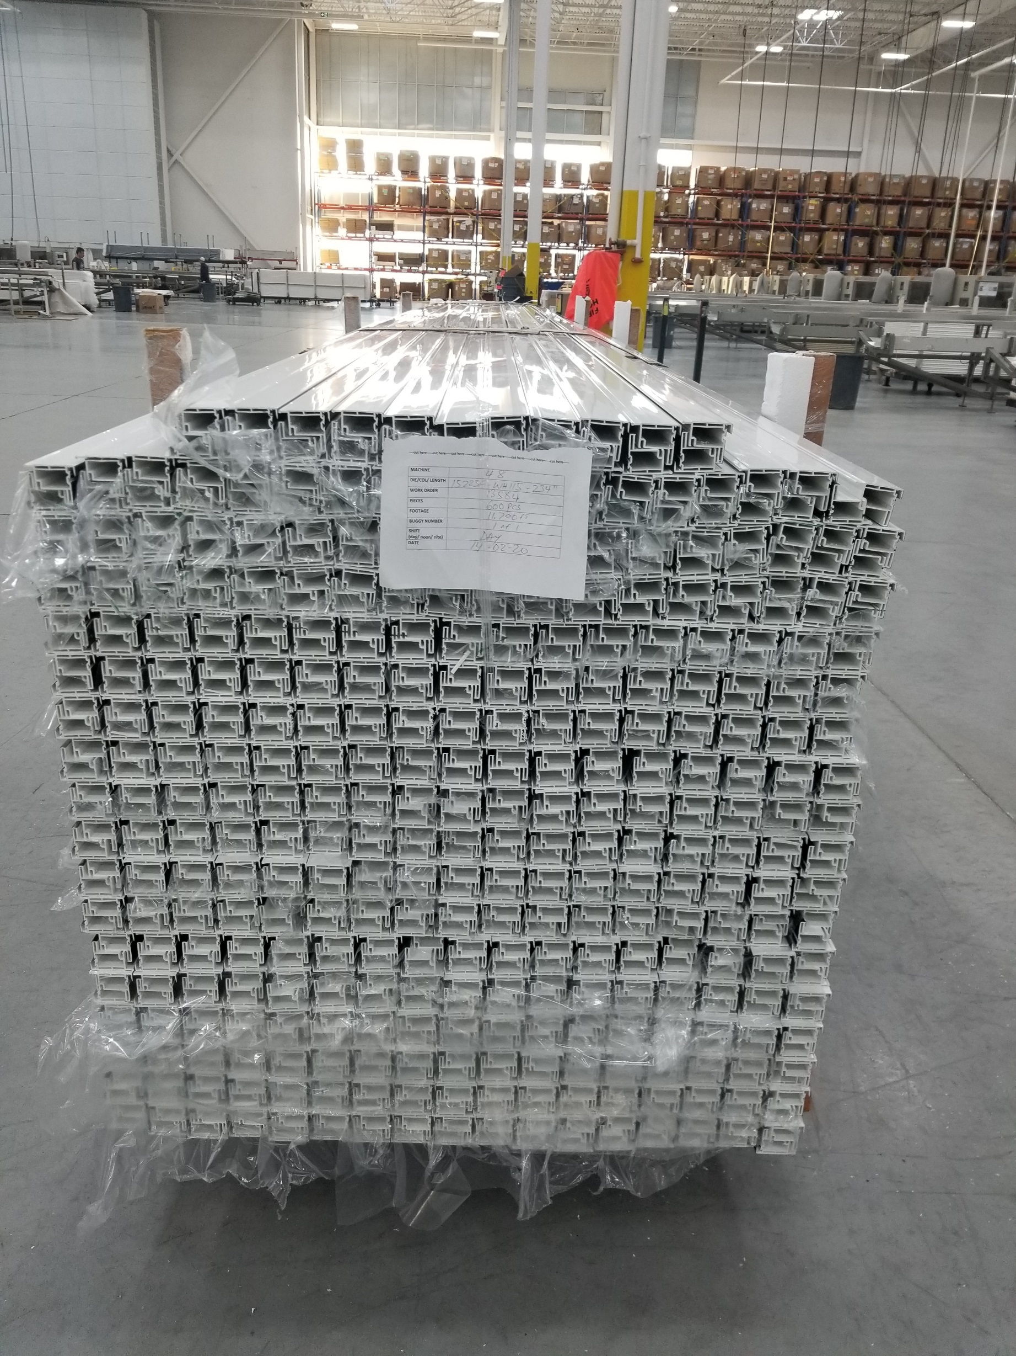
Cover Black Capstock with Poly sheet

